GENERIC EQUIPMENT MODEL (GEM) MANUAL for the VARIAN VIISion and E1000 ION IMPLANTATION SYSTEMS

Last Edited May 2002

1. General 9
1.1 SECS Channel, Circuit Block Diagram 9
1.1.1 E1000 9
1.1.2 VIISion 10
1.2 Installation 10
1.2.1 E1000 (refer to section 1.1.1 ) 10
1.2.2 VIISion (refer to sections 1.1.1 and 1.1.2) 10
2. User Interface 10
2.1 Configuration and Control 10
2.1.1 GEM Status/Control Detail Window 11
2.1.1.1 Communication Status 11
2.1.1.2 Control Status Block 12
2.1.1.3 Message Spooling Status 12
2.1.1.4 Transmit/Receive Display and Control Block 12
2.1.2 Equipment Constants Modification 13
2.1.3 Factory Automation 13
2.1.4 Communication Option 14
2.2 Host Messages 14
3. Streams and Functions Summary List 17
Table 1 Supported Streams and Functions4. Data Item Definitions 18
4. Data Item Definitions 19
5. Message Detail 146
5.1 Stream 1 Equipment Status 146
5.2 Stream 2 Equipment Control and Diagnostics 148
5.3 Stream 5 Exception Reporting 160
5.4 Stream 6 Data Collection 162
5.5 Stream 7 Process Program Management 165
5.6 Stream 9 System Errors 169
5.7 Stream 10 Terminal Services 171
6. Operating Scenarios 173
6.1 Operating Scenario: Operator Load Material 174
6.2 Operating Scenario: SMIF Load Material 175
6.2 Operating Scenario: SMIF Load Material 176
7. Message Scenarios 182
8. STATE DIAGRAMS 245
8.1 Purpose 245
8.2 Communication state 246
8.3 Control state 248
8.4 Process state 250
8.5 Limit state 253
8.6 Alarm state 254
8.7 Spooling State 255

Table 1 Supported Streams and Functions 18
Table 2 Item Formats 19
Table 3 Recipe Command Codes 31
Table 4 List Of Collection Event ID's 41
Table 5 Command Parameter Values 44
Table 6 Equipment Constants 62
Table 7 Process Parameter Definition 68
Table 8 Recipe Header Parameters 69
Table 9 Variable Types 88
Table 10 Variables Classification 88
Table 11 Variables List 94
Table 12 Variables List Continued 115
Table 13 LPT2200 SMIF Variables List 130
Table 14 ErgoSpeed II Smif Variables 136
Table 15 MID Variables List 144
Table 16 Spooled Streams and Functions 156
Table 17 Communication State Transition Table 247
Table 18 Control State Transition Table 249
Table 19 Processing State Transition Table 252
Table 20 Limit State Transition Table 253
Table 21 Alarm State Transition Table 254
Table 22 Spooling State Transition 256

Figure 1 Block Diagram of the SECS Channel 9
Figure 2 Communication State Model 246
Figure 3 Control State Model 248
Figure 4 Processing State Model 250
Figure 5 Limit State Model 253
Figure 6 Alarm State Model 254
Figure 7 Spooling State Model 255

Screen 1 Host System Configuration 11
Screen 2 Wafer Control Functions 15
Screen 3 Host Message 16
Screen 4 Recipe Control Screen Level 2 199

Revision History.
Revision | Description | Software Version
1 | First Release | 3.04.00
2 | Major rewrite of the manual. Documented additional features supported within GEM. Added corrections to the initial version. | 4.00.05
3 | The following features were added.  - Ceid’s 134 – 139, 106. | 4.01.00
4 | The following features were added  - Remote commands 25 - 29.  - New CEID’s 140 – 157.  - Add batch parameter to remote command 14.  - ECID’s 29 - 30. | 4.02.00
5 | The following features were added  - Y2K Host Compliance  - SMIF component. This component includes smif related remote commands, events, equipment constants and variables.  - MID component. This component includes fluorotrack related commands, events, equipment constants and variables.  - Remote command 21 for recipe selection.  - Equipment constants 31- 55. | 4.02.02
6 | The following features were added  - Remote command 30.  - Add new variables 7007-7009, 700E – 7014, 701B  Features included in software version 4.02.02 are not supported in this release. | 4.03.00
7 | The following features were added  - Y2K Host Compliance.  Features included in software version 4.02.02 are not supported in this release. | 5.00.00
8 | The following features were added  - Added IDELTA parameter to the recipe body.  This is the first release which merged all the features in 4.02.02 with 4.03.00 and 5.00.00 | 5.01.00
9 | The following features were added  - Bar Code Reader Support  - Addition of new BAR CODE option to MID parameter in MAIN  - Addition of new parameters bar code symbology, number of reads and depth of focus for BCR support  - SVIDs support for CTI on-board  - Step Complete CEID 0x701C | 5.10.00
10 | The following features were added  - Support for Ergospeed II  - Support for Smart Tag  - Equipment constants as discrete variables | 5.11.00 - 5.22.00
11 | Add a new value 11 to 500D, 500E, 500F. | 5.50.03

1. General
This document describes the functions of the host communication protocol, generic equipment model (GEM) as implemented on the Varian Ion Implant Systems VIISion and E1000 ion implanters.

1.1 SECS Channel, Circuit Block Diagram

1.1.1 E1000
Reference: Schematic Diagram, Main Controller, D102230001
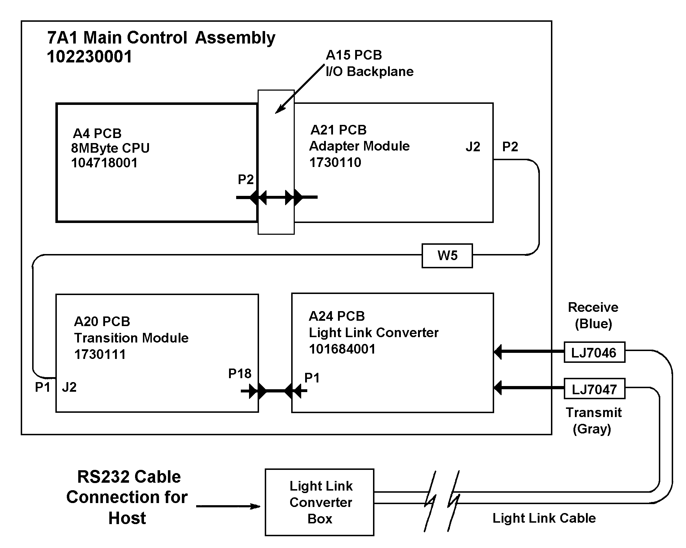
Figure 1 Block Diagram of the SECS Channel
The SECS Channel originates on the 8 Megabyte CPU Board (7A1A4) in the Main Controller Assembly (7A1). The CPU Plugs into the I/O Back plane (7A1A15) but the connection to the Adapter Module (7A1A21) is via a cable. The signal path leaves the Adapter Module on J2 and is connected to the Transition Module PCB (7A1A20) via a shielded ribbon cable (W5). The last internal connection for the Main Controller is from the Transition Module to the Light Link Converter PCB (7A1A24) via a cable link

1.1.2 VIISion
The diagram and descriptions in section 1.1.1 apply, except for the following changes:

LJ7046 becomes LJ6016
LJ7047 becomes LJ6017

1.2 Installation

1.2.1 E1000 (refer to section 1.1.1 )
Connect a light Link Cable between the LJ7046 and LJ7047 send and receive connectors, on the Main Controller (7A1A24), and the Light Link Converter Box. Then connect an RS 232 cable between the Light Link Converter Box and the Host Computer.

1.2.2 VIISion (refer to sections 1.1.1 and 1.1.2)
Connect a light Link Cable between the LJ6016 and LJ6017 send and receive connectors, on the Main Controller (7A1A24), and the Light Link Converter Box. Then connect an RS 232 cable between the Light Link Converter Box and the Host Computer.

2. User Interface

2.1 Configuration and Control
The GEM functionality is activated from the Select window icon “System Configuration/Host”. The following sections will outline the available user interface functionality. The user will utilize the System Configuration/Host select icon to activate any of the following functions.

- Gem Status and Control.
- Gem Equipment Constants.
- Factory Automation.
- Host Communication.
- Host Messages

To select any of these functions, the user will use the following procedure:
- The user will touch the select window icon labeled System Configuration.
- The detail window will present the user with several touch target. One touch target will be labeled Host. Touching this target will activate the Host configuration functions by displaying touch targets in the detail window (Ref. to Screen 1 for the available functions). The following sections will detail the functionality available under each one of the four touch targets.

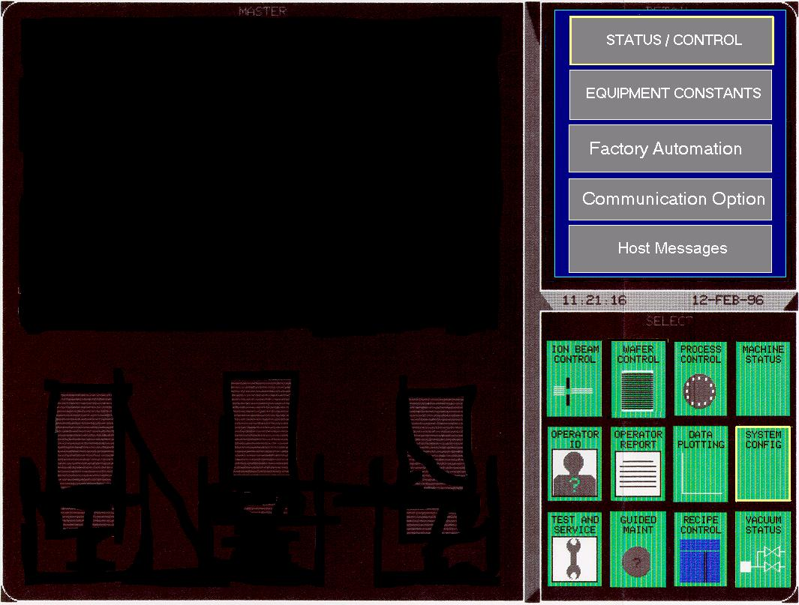
Screen 1 Host System Configuration

2.1.1 GEM Status/Control Detail Window
This user interface screen will allow the user to monitor status information and to activate control buttons of GEM defined communication and control states. To display this screen, the user will follow this procedure:
- The user will touch the select window icon labeled System Configuration.
- The user will touch the detail window touch target labeled Host.
- The detail window will present the user with several touch targets. One touch target will be labeled Gem Status/Control. Touching this target (Ref. to Screen 1 ) will display different touch targets in the master window as well as status information.

A user privilege Level 3 will be able to activate the functions available within this screen. However, a user with Level 2 privilege can view, but can not activate any of these functions.

2.1.1.1 Communication Status
This status block is displayed in the master window when the user touches GEM Status/Control. The current host communication status is displayed as:
ENABLED COMMUNICATING
or
ENABLED NOT COMMUNICATING
or
DISABLED
One touch control button will allow the operator to ENABLE and DISABLE host
communications. Control of this function will be available to an operator with level 3 access privilege only.

2.1.1.2 Control Status Block
This control block is displayed in the master window when the user touches GEM Status/Control The current equipment control state is displayed as:
HOST OFF-LINE
or
EQUIPMENT OFF-LINE
or
ATTEMPT ON-LINE
or
ON-LINE REMOTE
or
ON-LINE LOCAL
One touch control button will allow the operator to put the equipment in the ON-LINE or OFF-LINE state. Control of this function will be available to an operator with level 3 access privilege only.

One touch control button will allow the operator to put the equipment in the REMOTE or LOCAL control Sub-State. This button is not displayed if the equipment is in either the HOST OFFLINE state or the EQUIPMENT OFF-LINE state. Control of this function will be available to an operator with level 3 access privilege only.

2.1.1.3 Message Spooling Status
This control block is displayed in the master window when the user touches GEM Status/Control The spooling state ENABLED or DISABLED will be displayed. The spooling state is set via the S2F43 “Reset Spooling Streams and Functions” message from the host(spooling cannot be enabled or disabled via operator interface). If spooling is ENABLED, the number of messages currently spooled will be displayed. Initially the number of spooled message may be zero.

The values of the variables SpoolStartTime, and SpoolFullTime, including the year, month, day, hour, minute, and second , will be displayed. If spooling is DISABLED, these displays will be replaced by non-numeric characters: ‘##-###-####’ for date; ‘##:##:##’ for time.

2.1.1.4 Transmit/Receive Display and Control Block
This control block is displayed in the master window when the user touches GEM Status/Control This screen shall display the IDs, in the form SnFn, of each of the last few messages transmitted and received by the equipment. Also displayed will be the time, in the form HH:MM:SS, each message was transmitted. In addition, this control block will include different control buttons.

One touch control button will allow the operator to clear the message data displayed. Another touch control button will cause the equipment to send the S1F1 “Are You There” message to the host and the transaction is displayed.

One touch control button will cause the equipment to send the S2F17 Date and Time Request message to the host, and the transaction will be displayed. The equipment will set its internal clock equal to the S2F18 Date and Time Data received from the host. An operator with level 3 access privilege can activate these control buttons.

2.1.2 Equipment Constants Modification
This user interface screen will allow the user to view and modify GEM defined equipment constants. To display this screen, the user will follow this procedure:
- The user will touch the select window icon labeled System Configuration.
- The user will touch the detail window touch target labeled Host.
- The detail window will present the user with several touch targets . One touch target will be labeled Equipment Constants. Touching this target (Ref. to Screen 1 ) will display the equipment constants list in the master window.

Additional parameters have been added to the existing Equipment Constants Control screen available under SECS configuration. The user can change the parameter values by touching the current value. A window will be displayed in the detail section with touch targets for the valid values. The user can then touch the desired value in the detail window.

NOTE: Equipment constant values can be changed only by an operator with Level 3 access to the System Configuration screens. Current equipment constant values can be viewed by the operator in any operational level. An event reports will be generated whenever a SECS Equipment Constants is modified by the operator (CEID 101 Operator Equipment Constant Change event). An event report will be generated whenever the screen data is saved.

2.1.3 Factory Automation
This user interface screen will allow the user to view and modify the equipment automation interface to be used. To display this screen, the user will follow this procedure:
- The user will touch the select window icon labeled System Configuration.
- The user will touch the detail window touch target labeled Host.
- The detail window will present the user with several touch targets . One touch target will be labeled Factory Automation. Touching this target (Ref. to Screen 1 ) will display the factory automation options in the detail window. The currently selected automation option is displayed as well as touch control targets Direct AGV, SMIF or None. The touch control targets are provided to allow the operator to select any of the alternative automation options. Control of these touch targets will be available to an operator with level 3 access privilege only.

- Direct AGV option allows the equipment to control material loading and unloading with an AGV utilizing communications via the optical PIO (Parallel IO) interface.
- SMIF option allows the equipment to control material loading and unloading with a standard mechanical interface arm.

NOTE: Anytime the AGV/PIO interface is disabled, the Wafer Handling system automatically is
signaled to abort any current AGV/PIO activity.

2.1.4 Communication Option
This user interface screen will allow the user to view and modify the equipment host communication options GEM or SECS. To display this screen, the user will follow this procedure:
- The user will touch the select window icon labeled System Configuration.
- The user will touch the detail window touch target labeled Host.
- The detail window will present the user with several touch targets . One touch target will be labeled Communication Option. Touching this target (Ref. to Screen 1 ) will display the communication options in the detail window. The currently selected communication option is displayed as well as touch control targets GEM and SECS. The touch control targets are provided to allow the operator to select any of the alternative communication options. Control of these touch targets will be available to an operator with level 3 access privilege only. Another touch target will allow the operator to return to the main menu if no selection is desired

2.2 Host Messages
The purpose of this screen is to allow the user to send or retrieve host messages To activate this screen the user will follow this procedure (Ref. to Screen 2).
- An operator with level 2 access will touch the select window icon labeled Wafer Control.
- The operator will touch Host Messages in the master window of the Wafer Control screen.

A send message block will be used by the operator to send textual information to the host system. A receive block is used to display S10Fx textual messages from the host. An acknowledge touch target is also available to indicate to the host that a received message was recognized by the operator. An event is sent to the host when this touch target is activated.

Additional touch targets are available to clear the send and receive message blocks. The last touch target available is used to transmit the message entered by the operator in the send message control block. When this touch target is activated the textual information appearing in the send message block is structured in a stream 10 and sent to the host. An overlaid keyboard will be available to allow the user to enter the desired textual information (Ref. to Screen 3 ).
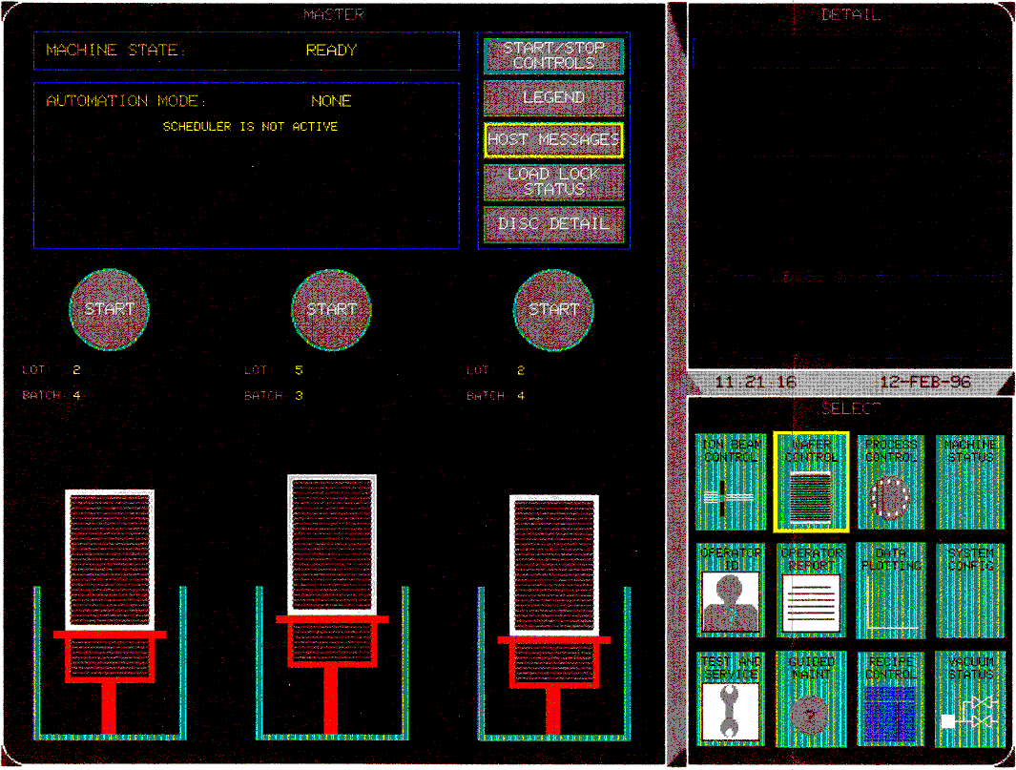
Screen 2 Wafer Control Functions
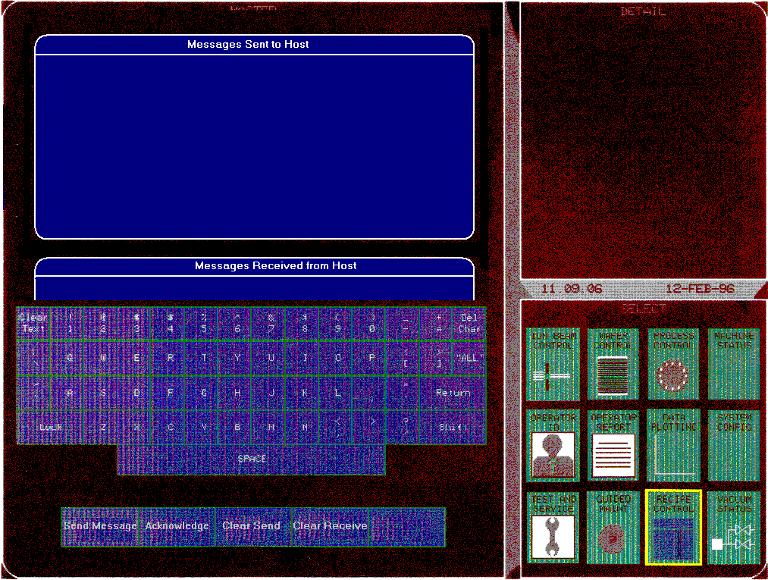
Screen 3 Host Message

3. Streams and Functions Summary List
This section outlines all the streams and functions supported within the GEM implementation.
Sn Fn | Reply | H<->E | Detail
SxF0 |  | ↔ | Abort Transaction
s1f1 | s1f2 | ↔ | Are You There Request
s1f3 | s1f4 | → | Selected Equipment Status Request
s1f11 | S1F12 | → | Status Variable Name List Request
s1f13 | S1F14 | ↔ | Establish Communication Request
s1f15 | S1F16 | → | Request OFF-LINE
s1f17 | S1F18 | → | Request ON-LINE
S2F13 | s2f14 | → | Equipment Constant Request
s2f15 | s2f16 | → | New Equipment Constant Send
s2f17 | s2f18 | ↔ | Date and Time Request
s2f23 | s2f24 | → | Trace Initialize Send
s2f29 | s2f30 | → | Equipment Constant NameList Request
s2f31 | s2f32 | → | Date and Time Set Request
s2f33 | s2f34 | → | Define Report
s2f35 | s2f36 | → | Link Event Report
s2f37 | s2f38 | → | Enable/Disable Event report
s2f39 | s2f40 | → | Multi-Block Inquire
s2f41 | s2f42 | → | Host Command Send
s2f43 | s2f44 | → | Reset Spooling Streams and Functions
s2f45 | s2f46 | → | Define Variable Limit Attribute  NOTE:CURRENTLY NOT IMPLEMENTED
s2f47 | s2f48 | → | Variable Limit Attribute Request  NOTE:CURRENTLY NOT IMPLEMENTED
s5f1 | s5f2 | ← | Alarm Request Send
s5f3 | s5f4 | → | Enable/Disable Alarm Send
s5f5 | s5f6 | → | Alarms Request  NOTE:CURRENTLY NOT IMPLEMENTED
s6f1 | s6f2 | ← | Trace Data Send
s6f5 | s6f6 | ← | Multi-Block Data Send Inquire
s6f11 | s6f12 | ← | Event Report Send
s6f15 | s6f16 | → | Event Report Request
s6f19 | s6f20 | → | Individual Report Request
s6f23 | s6f24 | → | Request Spooled Data
s7f1 | s7f2 | ↔ | Process Program Load Inquire
s7f3 | s7f4 | ↔ | Process Program Send
s7f5 | s7f6 | ↔ | Process Program Request
s7f17 | s7f18 | → | Delete Process Program Send
s7f19 | s7f20 | → | Current EPPD Request
s7f23 | s7f24 | ↔ | Formatted Process Program Send
s7f25 | s7f26 | ↔ | Formatted Process Program Request
s7f27 | s7f28 | ← | Process Program Verification Send
s7f29 | s7f30 | ← | Process Program Verification Inquire
s9f1 |  | ← | Unrecognized Device ID
s9f3 |  | ← | Unrecognized Stream Type
s9f5 |  | ← | Unrecognized Function Type
s9f7 |  | ← | Illegal Data
s9f9 |  | ← | Transaction Timer Time-out
s9f11 |  | ← | Data Too Long
s9f13 |  | ← | Conversation Time-out
s10f1 | S10F2 | ← | Terminal Request
s10f3 | S10F4 | → | Terminal Display, Single
s10f5 | S10F6 | → | Terminal Display, Multi-Block
s10f7 |  | ← | Multi-Block Not Allowed (Not Supported)

Table 1 Supported Streams and Functions

4. Data Item Definitions
This section defines some of the data items used in the SECS-II messages. The following definitions for data format are used throughout this document:

SYMBOL | DATA TYPE | OCTAL CODE
L | List | 00
B | Binary | 10
A | ASCII | 20
I8 | 8-Byte Signed Integer | 30
I1 | 1-Byte Signed Integer | 31
I2 | 2-Byte Signed Integer | 32
I4 | 4-Byte Signed Integer | 34
40 | 8-Byte Floating Point | 40
U8 | 8-Byte Unsigned Integer | 50
U1 | 1-Byte Unsigned Integer | 51
U2 | 2-Byte Unsigned Integer | 52
U4 | 4-Byte Unsigned Integer | 54
Table 2 Item Formats
ACKC5 Format: 10
Acknowledge code, 1 byte
0 = Accepted
>0 = Error, not accepted

Where used: S5F2, S5F4
ACKC6 Format: 10
Acknowledge code, 1 byte
0 = Accepted
>0 = Error, not accepted

Where used: S6F2, S6F12
ACKC7 Format: 10
Acknowledge code, 1 byte
0 = Accepted
1 = Permission not granted
2 = Length error
4 = PPID not found
64 = Cannot save to disk
65 = Invalid PPID
66 = Already have process program(recipe)
67 = No space
68 = Invalid data in recipe header
69 = Invalid data in recipe body
70 = Too many parameters in process program(recipe)
72 = Invalid CCODE

Where used: S7F4, S7F18, S7F24
ACKC7A Format: 51
Acknowledge code, 1 byte
0 = Accepted
1 = MDLN is inconsistent
2 = SOFTREV is inconsistent
3 = Invalid CCODE
4 = Invalid PPARM value
5 = Other error (described by ERRW7)

Where used: S7F27
ACKC10 Format: 10
Acknowledge code, 1 byte
0 = Accepted
1 = Will not display
2 = Specified terminal not available
64 = Invalid terminal ID
65 = No space
66 = Too many lines

Where used: S10F2, S10F4, S10F6
ALCD Format: 10
Alarm code, 1 byte
bit 8 = 1 means alarm set
bit 8 = 0 means alarm cleared
bit 7 - 1 not used

Where Used: S5F2, S5F6
ALED Format: 10
Alarm enable/disable code, 1 byte
bit 8 = 1 means enable alarm
bit 8 = 0 means disable alarm

Where Used: S5F3
ALID Format: 50
Alarm Identification. A unique number used to identify an error string.

As implemented the alarm identification byte designation is as follows:
byte 1 | byte 2 | byte 3 | byte 4 | byte 5 | byte 6 | byte 7 | byte 8

Byte Number | Error Designation | Format
1 | Unused | N/A
2 | Root Error | 51
3 - 4 | Function ID | 52
5 | Subsystem | 51
6 | Error Class | 51
7 | Error Type | 51
8 | Recovery/severity | 51

Byte 2: This byte is bit mapped to show whether the Scheduler was active when the error occurred, which level 3 control screens were up at the time, and whether the operator selected FAILURE or ASSIST to clear the message.

Bit Value | Bit Significance
0x80 | Failure Selected bit
0x40 | Assist Selected bit
0x20 | Fail Group bit
0x10 | Process Scheduler Active bit
0x08 | Wafer Control Module Active bit
0x04 | Tuning Module Active bit
0x02 | Maintenance Module Active bit
0x01 | Test and Service Module Active bit

Byte 3-4:: These two bytes (along with the subsystem ID) uniquely identifies the function ID’s that reported the error. For Main controller errors, the IDs are organized by module, as follows:

ID Range | Main Module
1000 - 1999 | Just_Op software module errors
2000 - 2999 | Vacuum Status software module errors
3000 - 3999 | Support software module errors
4000 - 4999 | Intel_Dbase software module errors
5000 - 5999 | Dload software module errors
6000 - 6999 | Process Control software module errors
7000 - 7999 | Machine Status software module errors
8000 - 8999 | Wafer Control software module errors
9000 - 9999 | Data Plotting software module errors
10000 - 10999 | System Configuration software module errors
11000 - 11999 | Operator Reports software module errors
12000 - 12999 | Recipe Control software module errors
13000 - 13999 | Beam Tuning software module errors
14000 - 14999 | Guided Maintenance software module errors
15000 - 15999 | Test and Service software module errors

Byte 5: This byte indicates the subsystem reporting the error.

Subsystem ID | Subsystem
1 | Source RDAC
2 | Terminal RDAC
3 | Facility RDAC
4 | Chamber RDAC
5 | Dose Controller
6 | Wafer Handler
7 | Main Controller
8 | (currently not used)
9 | I/OCPU

Byte 6: This byte indicates the error class.
Byte 7: This byte indicates the error type. The meaning of error type is dependent on the error class. Listed below are the error classes, each with its associated error types.

Error Type Code | Error Type Designation
1 | Timeout
2 | Wrong Value
3 | Exclusive
4 | Sequence
Error Class 1: Digital Errors

Error Type Code | Error Type Designation
1 | Timeout
2 | High Value
3 | Low Value
4 | Exclusive
5 | Sequence
Error Class 2: Analog Errors

Error Type Code | Error Type Designation
1 | Sequence
2 | Exclusive
3 | Timeout
4 | Illegal Parameter
5 | Math Error
6 | Subsystem Error
Error Class 3: Software Errors

Error Type Code | Error Type Designation (action that created the error)
1 | Spawn Process
2 | Activate Process
3 | Identify process
4 | Delete process
5 | Suspend process
6 | Resume process
7 | Change process priority
8 | Allocate memory segment
9 | Free memory segment
10 | Assign memory segment to another process
16 | Take ownership(grab) of a memory segment
18 | Send messages to all processes waiting at an exchange
19 | Put a message at the head of an exchange's message list
20 | Create a message exchange
21 | Find the ID of a message exchange
22 | Delete a message exchange
23 | Send a message to an exchange
24 | Read a message from an exchange
25 | Signal an event
26 | Wait for an event
27 | Get any pending events
30 | Get current date and time
31 | Set current date and time
35 | Create a partition of buffers
36 | Delete a partition of buffers
37 | Get a buffer from a partition
38 | Return a buffer to a partition
Error Class 4: pSOS Operating System Errors

Error Type Code | Error Type Designation (action that created the error)
1 | Initialize a volume
2 | Mount a volume
3 | Synchronize a volume
4 | UN-mount a volume
5 | Read a volume directly
6 | Write a volume directly
8 | Create a file
9 | Create a directory
10 | Delete a file
11 | Rename a file
12 | Set default directory
13 | Open a file
14 | Set current position within a file
15 | Read from a file
16 | Write to a file
17 | Add space to a file
18 | Lock a file
20 | Close a file
25 | Get file number
26 | Open a file by its file number
27 | Initialize an MSDOS volume
28 | Mount an MSDOS volume
Error Class 5: pHILE Disc Operating System Errors

Error Type Code | Error Type Designation
1 | Queue full
2 | Task already queued
Error Class 6: Operating System Errors

Error Type Code | Error Type Designation
1 | Timeout
2 | Transmitter not enabled
3 | Device not transmitting
4 | Device is sending breaks
5 | Checksum error
6 | ID error
7 | Bad message length
8 | Auto baud error
9 | Download error
10 | Communication down
11 | General communication error
Error Class 7: Communications Errors

Error Type Code | Error Type Designation
1 | Hardware interlock
2 | Software interlock
3 | Operator level too low
4 | Screen currently in use
5 | Scheduler interlock
6 | Status interlock
Error Class 8: Interlock Errors

Error Type Code | Error Type Designation
None | No types are defined for this class
Error Class 9: Illegal State Errors

Error Type Code | Error Type Designation
1 | Hardware
2 | Electrical
Error Class 10: Hardware Errors

Byte 8: This byte indicates the error recovery/severity code.

Code | Description
0 | Normal error, requires operator acknowledgment
1 | Same as code 0
2 | Same as code 0
3 | Requires YES or NO response from the operator
4 | Fatal to reporting subsystem, requires operator acknowledgment
5 | Fatal to all subsystems, requires operator acknowledgment
32 | Brief error display, no operator acknowledgment required

Note: In S5F3 messages, only ALID byte 8, the error recovery/severity code, is used. The following examples would be valid ALIDs in S5F3. Each example is in hexadecimal format:

ALID | Designation
0000000000000000 | Normal error, requires operator acknowledgment
0000000000000001 | same as above
0000000000000002 | same as above
0000000000000003 | Requires YES or NO response from the operator
0000000000000004 | Fatal to reporting subsystem
0000000000000005 | Fatal to all subsystems
0000000000000020 | Brief error display

Where Used: S5F1, S5F3, S5F6
ALTX Format: 20
Alarm text; 40 bytes maximum
Length can be configured to be fixed at 40 bytes, or to be a maximum of 40 bytes.

Where used: S5F1, S5F6
CCODE Format: 52
Each command code available on the equipment is used to set the values for a distinct recipe parameter. The command codes used to set the recipe parameters, range in values from 0000 - 6000 Hex. Command codes within the range of 0000 - 4FFF Hex has a set of 6 process parameter values associated with each code. However, command codes within the range of 6000-6FFF has only one process parameter. See PPARM definition for a list of process parameters.

The following is a list of the command codes.
CCODE | Recipe Parameter to Set
1001 | ARC CURRENT
1002 | ARC VOLTAGE PROGRAMMING
1003 | ARC VOLTAGE
1004 | FILAMENT CURRENT
1005 | FILAMENT LIMIT
1006 | FILAMENT PROGRAMMING
1007 | FILAMENT VOLTAGE
1008 | GAS FLOW
1009 | VAPORIZER TEMP
100A | VAPORIZER SETPOINT
100B | VAP OUTPUT VOLTAGE
100C | VAP OUTPUT CURRENT
100D | VAPORIZER PROG
100E | SOURCE AIR PRESSURE
100F | GAS HI PRESSURE
1010 | GAS LOW PRESSURE
1011 | NITROGEN HIGH PRESSURE
1012 | NITROGEN LOW PRESSURE
1013 | Gas Bottle 1
1014 | Gas Bottle 2
1015 | Gas Bottle 3
1016 | Gas Bottle 4
1017 | Vaporizer Crucible 1
1018 | Vaporizer Crucible 2
1019 | Vaporizer Crucible 3
101A | ARC CURRENT PROGRAMMING
101B | ARC 2 CURRENT
101C | ARC 2 PS VOLTAGEError: Reference source not found
101D | FILAMENT 2 CURRENTError: Reference source not found
101E | FILAMENT 2 VOLTAGEError: Reference source not found
101F | SOURCE MAGNET CURRENTError: Reference source not found
1020 | SOURCE MAGNET PROGRAMError: Reference source not found
1021 | SOURCE MAGNET VOLTAGEError: Reference source not found
1022 | INACTIVE CRUCIBLE TEMPError: Reference source not found
2001 | FINAL ENERGY
2002 | ACCEL SUPPLIES FOCUS
2003 | ACCEL 1 VOLTAGE(E1000)  ACCEL VOLTAGE(VIISion)
2004 | ACCEL 1 CURRENT
2005 | ACCEL 1 PROGRAMMING(E1000)  ACCEL PROGRAMMING(VIISion)
2006 | ACCEL 2 VOLTAGEError: Reference source not found
2007 | ACCEL 2 CURRENTError: Reference source not found
2008 | ACCEL 2 PROGRAMMINGError: Reference source not found
2009 | BEAMGATE FLOW
200A | DI FILTER FLOW
200B | DI RESISTIVITY
200C | DISK FLOW
200D | FACILITY AIR PRESSURE
200E | FARADAY FLOW
200F | none
2010 | HEAT EXCHANGER TEMP
2011 | MASS SLIT FLOW
2012 | ANALYZER COIL FLOW
2013 | BEAMLINE FLOW
2014 | SOURCE PUMP FLOW
2015 | SOURCE BUSHING FLOW
2016 | BEAMLINE PUMP FLOW
2017 | TURBO SPEED
2018 | TERMINAL DRY PUMP FLOW
2019 | BLINE AND SOURCE PUMP FLOW
201A | SOURCE FLANGE FLOW
201B | FAR BIAS2 EVENT COUNTError: Reference source not found
201C | FAR BIAS2 EVENT RATEError: Reference source not found
201D | TUBE SUPP EVENT COUNTError: Reference source not found
201E | TUBE SUPP EVENT RATEError: Reference source not found
201F | ACCEL 1 EVENT COUNT
2020 | ACCEL 1 EVENT RATE
2021 | ACCEL 2 EVENT COUNTError: Reference source not found
2022 | ACCEL 2 EVENT RATEError: Reference source not found
2023 | EXT SUPP EVENT COUNT
2024 | EXT SUPP EVENT RATE
3001 | ANALYZER MAGNET
3002 | ANALYSIS
3003 | ANALYZER PROGRAM VOLTAGE
3004 | ANALYZER PROGRAM CURRENT
3005 | ANALYZER PROGRAMMING
3006 | EXTRACTION VOLTAGE
3007 | EXTRACTION CURRENT
3008 | EXTRACTION PROGRAMMING
3009 | SUPPRESSION VOLTAGE
300A | SUPPRESSION CURRENT
300B | SUPPRESSION PROGRAMMING
300C | MANIPULATOR Z GAP
300D | MANIPULATOR X AXIS
300E | SLIT OPENINGError: Reference source not found
300F | ANALYZER SHIM 1Error: Reference source not found
3010 | ANALYZER SHIM 2Error: Reference source not found
3011 | SETUP BIAS VOLTAGEError: Reference source not found
3012 | SETUP BIAS CURRENTError: Reference source not found
3013 | none
3014 | SOURCE PRESSURE (IG1)
3015 | SOURCE 2TC1 PRESSURE
3016 | SOURCE TC2 PRESSURE
3017 | BEAM LINE PRESSURE (IG2)
3018 | TERMINAL 2TC3 PRESSURE
3019 | TERMINAL 2TC4 PRESSURE
301A | VARIABLE MASS SLITError: Reference source not found
301B | none
301C | ACCELERATION GAPError: Reference source not found
301D | BEAMLINE IG3 PRESSUREError: Reference source not found
302C | LENS1 VOLTAGE
302D | LENS1 CURRENTError: Reference source not found
302E | LENS1 VOLTAGE PROGRAMMINGError: Reference source not found
302F | LENS2 VOLTAGEError: Reference source not found
3030 | LENS2 CURRENTError: Reference source not found
3031 | LENS2 VOLTAGE PROGRAMMINGError: Reference source not found
4001 | BEAM CURRENT
4002 | SCAN SPEED
4003 | DISC SPIN SPEED
4004 | DISC IMPLANT ANGLE
4005 | FARADAY IMPLANT ANGLE
4006 | WAFER ORIENT ANGLE
4007 | TUBE SUPPRESSION VOLTAGE
4008 | TUBE SUPPRESSION CURRENTError: Reference source not found
4009 | TUBE SUPPRESS PROGRAMError: Reference source not found
400A | PRIMARY EMISSION I
400B | DISC BEAM CURRENT
400C | FLD GUN FILAMENT CURRENT
400D | FLD GUN FILAMENT VOLTAGE
400E | none
400F | EMISSION PROGRAMMING
4010 | EMISSION VOLTAGE
4011 | EFLOOD BIAS 1 VOLTAGEError: Reference source not found
4012 | EFLOOD BIAS 1 CURRENTError: Reference source not found
4013 | EFLOOD BIAS 2 VOLTAGEError: Reference source not found
4014 | EFLOOD BIAS 2 CURRENTError: Reference source not found
4015 | FARADAY GAS BLEED
4016 | SPIN/FLIP FARADAY ANGLE
4017 | CHAMBER PRESSURE (IG3)
4018 | CRYO ROUGH PRESSURE
4019 | CHAMBER 6TC1 PRESSURE
401A | CHAMBER 4TC2 PRESSURE
401B | CRYO1 TEMPERATURE
401C | CRYO2 TEMPERATURE
401D | CRYO3 TEMPERATURE
401E | CRYO4 TEMPERATURE
401F | CRYO5 TEMPERATURE
4020 | CHAMBER AIR PRESSURE
4021 | COMPRESSOR 1 FLOW
4022 | COMPRESSOR 2 FLOW
4023 | HEAT EXCHANGER FLOW
4024 | CHAMBER DRY PUMP FLOW
4025 | CURRENT SOURCE
4026 | CURRENT RANGE
4027 | ION CHARGE
4028 | LOADLOCK 1 PRESSURE
4029 | LOADLOCK 2 PRESSURE
402A | LOADLOCK 3 PRESSURE
402B | MANIFOLD PRESSURE
402C | SOLAR CELL OUTPUT
402D | MONITOR CELL OUTPUT
402E | TACTILE SENSE
402F | WAFER SIZE
4030 | BEAM SIZE
4031 | BEAM OFFSET
4032 | THROUGHPUT
4033 | PLASMA FLOOD ARC CURRENT
4034 | PFG ARC CURRENT PROG
4035 | PLASMA FLOOD ARC VOLTAGE
4036 | PFG FILAMENT CONTROL VLT
4037 | PFG FILAMENT CURRENT
4038 | PLASMA EXTRACTION CURRENT
4039 | PEAK BEAM DENSITY
403A | none
403B | none
403C | POST IMPLANT PRIMARY EMIS
403D | POST IMPLANT GAS BLEED
403E | POST IMPLANT PFG ARC CUR
403F | BEAM QUALITY
4040 | AVERAGE BEAM CURRENT
4041 | GAS BLD HI PRESSURE
4042 | GAS BLD LO PRESSURE
4043 | MAX DOSE MAP CURRENT
4044 | DOSE MAP BEAM QUALITY
4045 | NET DISK CURRENT
4046 | TURBO IG PRESSURE
4047 | TURBO CG PRESSUREError: Reference source not found
4048 | NUMBER OF SCANS (desired scans)
4049 | WAFER ORIENT ANGLE2  (used in Multi-tilt/quad mode implants)
404A | HYT BIN 1 COUNT
404B | HYT BIN 2 COUNT
404C | HYT BIN 3 COUNT
404D | HYT BIN 4 COUNT
404E | HYT BIN 5 COUNT
404F | HYT TOTAL BIN COUNT
4050 | Inner Scan Extension
4051 | Outer Scan Extension
4052 | TUNING PARTICLE COUNT
4053 | LOAD PARTICLE COUNT
4054 | FLIP PARTICLE COUNT
4055 | IMPLANT PARTICLE COUNT
4056 | HYT STRAY LIGHT
4057 | LASER DIAGNOSTIC VALUE
6005 | OPERATOR NAME
6007 | RECIPE NAME
600C | IMPLANT DOSE
600E | WAFER SIZE
6011 | Source Feed
6012 | SPECIES
6014 | ELECTRON FLOOD
6015 | ENERGY MODE
6016 | AMU
6017 | ENERGY
6018 | MULTI-STEP COUNT
6019 | DOSE SCALER
601A | MULTI-TILT IMPLANT OPTION
601B | I DELTA
Table 3 Recipe Command Codes
Where used: S7F23, S7F26
CEED Format: 10
Collection event enable/disable code, 1 byte
FALSE = Disable
TRUE = Enable

Where used: S2F37
CEID Format: 52
Collection Event ID

The following is a list of supported Collection Event ID.
CEID | EVENT
1 | Batch(Normal Implant) Complete
2 | Test Implant Complete
3 | Batch(Normal Implant) Aborted
4 | Test Implant Aborted
5 | Batch(Normal Implant) Stopped
6 | Test Implant Stopped
7 | Batch(Normal Implant) Started
8 | Test Implant Started
9 | unused
10 | unused
11 | Wafer Exchange Start
12 | Wafer Exchange End
13 | Auto Source Setup Start
14 | Auto Source Setup End (successful, error, or abort)
15 | Preimplant Check Start
16 | Preimplant Check End
17 | Port 1 Material Received
18 | Port 2 Material Received
19 | Port 3 Material Received
20 | Port 1 Material Removed
21 | Port 2 Material Removed
22 | Port 3 Material Removed
23 | Loadlock 1 Ready to Receive Material
24 | Loadlock 2 Ready to Receive Material
25 | Loadlock 3 Ready to Receive Material
26 | Loadlock 1 Ready to Remove Material
27 | Loadlock 2 Ready to Remove Material
28 | Loadlock 3 Ready to Remove Material
29 | Equipment Off-Line
30 | Control State Local
31 | Control State Remote
32 | Host Communication Enabled
33 | unused
34 | Equipment Scheduler Status Change
35 | Alarm Generated
36 | Alarm Cleared
37 | Ready Cassette 1 Start
38 | Ready Cassette 2 Start
39 | Ready Cassette 3 Start
40 | Ready Cassette 1 End
41 | Ready Cassette 2 End
42 | Ready Cassette 3 End
43 | Close Door/Jar 1 Start
44 | Close Door/Jar 2 Start
45 | Close Door/Jar 3 Start
46 | Close Door/Jar 1 End
47 | Close Door/Jar 2 End
48 | Close Door/Jar 3 End
49 | Open Door/Jar 1 Start
50 | Open Door/Jar 2 Start
51 | Open Door/Jar 3 Start
52 | Open Door/Jar 1 End
53 | Open Door/Jar 2 End
54 | Open Door/Jar 3 End
55 | Rough Loadlock/Jar 1 Start
56 | Rough Loadlock/Jar 2 Start
57 | Rough Loadlock/Jar 3 Start
58 | Rough Loadlock/Jar 1 End
59 | Rough Loadlock/Jar 2 End
60 | Rough Loadlock/Jar 3 End
61 | Hivac Loadlock/Jar 1 Start
62 | Hivac Loadlock/Jar 2 Start
63 | Hivac Loadlock/Jar 3 Start
64 | Hivac Loadlock/Jar 1 End
65 | Hivac Loadlock/Jar 2 End
66 | Hivac Loadlock/Jar 3 End
67 | Cassette 1 Wafer Mapping Start
68 | Cassette 2 Wafer Mapping Start
69 | Cassette 3 Wafer Mapping Start
70 | Cassette 1 Wafer Mapping End
71 | Cassette 2 Wafer Mapping End
72 | Cassette 3 Wafer Mapping End
73 | Return Cassette 1 Start
74 | Return Cassette 2 Start
75 | Return Cassette 3 Start
76 | Return Cassette 1 End
77 | Return Cassette 2 End
78 | Return Cassette 3 End
79 | Vent Loadlock/Jar 1 Start
80 | Vent Loadlock/Jar 2 Start
81 | Vent Loadlock/Jar 3 Start
82 | Vent Loadlock/Jar 1 End
83 | Vent Loadlock/Jar 2 End
84 | Vent Loadlock/Jar 3 End
85 | Spooling Activated
86 | Spooling Deactivated
87 | Spool Transmit Failed
88 | Host Command Received
89 | Host Command Started
90 | Host Command Complete
91 | Process Program Changed
92 | Process Program Selected
93 | Host Message Recognized, TID = 0(Operator Screen)
94 | Host Message Recognized, TID = 1(Service Screen)
95 | Operator Command Issued(Operator Screen)
96 | Operator Command Issued(Service Screen)
97 | Operator Command Complete(Operator Screen)
98 | Operator Command Complete(Service Screen)
99 | Operator Equipment Constant Change(Operator Screen)
100 | Operator Equipment Constant Change(Service Screen)
101 | GEM Mode Enabled
102 | GEM Mode Disabled
103 | Processing Started
104 | Processing Paused
105 | Processing Aborted
106 | Processing Complete
107 | Process State Change
108 | Batch(Normal Implant) Resumed
109 | Test Implant Resumed
110 | Signal Tower State Change
111 | AGV Clear Successful(AGV activity stopped)
112 | AGV Clear Unsuccessful(AGV activity not stopped)
113 | Automation Option(NONE, AGV, SMIF) Change
114 | Successful Operator Login (Operator Screen)
115 | Successful Operator Login (Service Screen)
116 | Unsuccessful Operator Login(Operator Screen)
117 | Unsuccessful Operator Login(Service Screen)
118 | Operator Logoff (Operator Screen)
119 | Operator Logoff (Service Screen)
120 | Equipment Mode Change
121 | Disk Moved to Implant Position
122 | Disk Moved to Load/unload Position
123 | First Wafer in Batch Loaded to Disc
124 | Last Wafer in Batch Loaded to Disc
125 | First Wafer in Batch Unloaded from Disc
126 | Last Wafer in Batch Unloaded from Disc
127 | Operator Screen Select Window Process Activated
128 | Service Screen Select Window Process Activated
129 | The equipment requires more wafers to continue processing
130 | unused
131 | unused
132 | Processing Ready
133 | Processing Idle
134 | First Wafer from Loacklock 1 Loaded to Disc
135 | First Wafer from Loacklock 2 Loaded to Disc
136 | First Wafer from Loacklock 3 Loaded to Disc
137 | Last Wafer from Loadlock 1 Unloaded from Disc
138 | Last Wafer from Loadlock 2 Unloaded from Disc
139 | Last Wafer from Loadlock 3 Unloaded from Disc
140 | Tilter 1 In Start
141 | Tilter 2 In Start
142 | Tilter 3 In Start
143 | Tilter 1 In End
144 | Tilter 2 In End
145 | Tilter 3 In End
146 | Tilter 1 Out Start
147 | Tilter 2 Out Start
148 | Tilter 3 Out Start
149 | Tilter 1 Out End
150 | Tilter 2 Out End
151 | Tilter 3 Out End
152 | Loadlock 1 Move In Complete
153 | Loadlock 2 Move In Complete
154 | Loadlock 3 Move In Complete
155 | Dummy Exchange Start
156 | Dummy Exchange End
157 | Maximum Dummy Implant Count Reached
158 | SMIF No Control Mode
159 | SMIF Parallel Control Mode
160 | SMIF Serial Control Mode
161 | SMIF 1 Powered Up
162 | SMIF 2 Powered Up
163 | SMIF 3 Powered Up
164 | SMIF 1 Communications State Change
165 | SMIF 2 Communications State Change
166 | SMIF 3 Communications State Change
167 | SMIF 1 Pod Placed
168 | SMIF 2 Pod Placed
169 | SMIF 3 Pod Placed
170 | SMIF 1 Pod Removed
171 | SMIF 2 Pod Removed
172 | SMIF 3 Pod Removed
173 | SMIF 1 Load Start
174 | SMIF 2 Load Start
175 | SMIF 3 Load Start
176 | SMIF 1 Load Complete
177 | SMIF 2 Load Complete
178 | SMIF 3 Load Complete
179 | SMIF 1 Load Aborted
180 | SMIF 2 Load Aborted
181 | SMIF 3 Load Aborted
182 | SMIF 1 Pre Load Start1
183 | SMIF 2 Pre Load Start1
184 | SMIF 3 Pre Load Start1
185 | SMIF 1 Pre Load Complete1
186 | SMIF 2 Pre Load Complete1
187 | SMIF 3 Pre Load Complete1
188 | SMIF 1 Pre Load Aborted1
189 | SMIF 2 Pre Load Aborted1
190 | SMIF 3 Pre Load Aborted1
191 | SMIF 1 Unload Start
192 | SMIF 2 Unload Start
193 | SMIF 3 Unload Start
194 | SMIF 1 Unload Complete
195 | SMIF 2 Unload Complete
196 | SMIF 3 Unload Complete
197 | SMIF 1 Unload Aborted
198 | SMIF 2 Unload Aborted
199 | SMIF 3 Unload Aborted
200 | SMIF 1 Pre Unload Start¹
201 | SMIF 2 Pre Unload Start1
202 | SMIF 3 Pre Unload Start1
203 | SMIF 1 Pre Unload Complete1
204 | SMIF 2 Pre Unload Complete1
205 | SMIF 3 Pre Unload Complete1
206 | SMIF 1 Pre Unload Aborted1
207 | SMIF 2 Pre Unload Aborted1
208 | SMIF 3 Pre Unload Aborted1
209 | SMIF 1 Pod Locked
210 | SMIF 2 Pod Locked
211 | SMIF 3 Pod Locked
212 | SMIF 1 Pod Unlocked
213 | SMIF 2 Pod Unlocked
214 | SMIF 3 Pod Unlocked
215 | SMIF 1 Disabled [NOTE: for future use only]
216 | SMIF 2 Disabled [NOTE: for future use only]
217 | SMIF 3 Disabled [NOTE: for future use only]
218 | SMIF 1 Enabled [NOTE: for future use only]
219 | SMIF 2 Enabled [NOTE: for future use only]
220 | SMIF 3 Enabled [NOTE: for future use only]
221 | Not Used
222 | Not Used
223 | Not Used
224 | SMIF 1 Switched to Manual Mode (Teach Pendant Attached) 1
225 | SMIF 2 Switched to Manual Mode (Teach Pendant Attached)
226 | SMIF 3 Switched to Manual Mode (Teach Pendant Attached) 1
227 | SMIF 1 Switched to Auto Mode (Teach Pendant Removed) 1
228 | SMIF 2 Switched to Auto Mode (Teach Pendant Removed) 1
229 | SMIF 3 Switched to Auto Mode (Teach Pendant Removed) 1
230 | SMIF 1 Auto-Home Start1
231 | SMIF 2 Auto-Home Start1
232 | SMIF 3 Auto-Home Start1
233 | SMIF 1 Auto-Home Complete1
234 | SMIF 2 Auto-Home Complete1
235 | SMIF 3 Auto-Home Complete1
236 | SMIF 1 Auto-Home Aborted1
237 | SMIF 2 Auto-Home Aborted1
238 | SMIF 3 Auto-Home Aborted1
239 | SMIF 1 Cassette Released
240 | SMIF 2 Cassette Released
241 | SMIF 3 Cassette Released
242 | SMIF 1 Port Lock/Unlock Failed
243 | SMIF 2 Port Lock/Unlock Failed
244 | SMIF 3 Port Lock/Unlock Failed
245 | SMIF 1 Cleared from Tool During Load1
246 | SMIF 2 Cleared from Tool During Load1
247 | SMIF 3 Cleared from Tool During Load1
248 | SMIF 1 Cleared from Tool During Unload1
249 | SMIF 2 Cleared from Tool During Unload1
250 | SMIF 3 Cleared from Tool During Unload1
251 | SMIF 1 Load Continue2
252 | SMIF 2 Load Continue2
253 | SMIF 3 Load Continue2
254 | SMIF 1 Load Step Done2
255 | SMIF 2 Load Step Done2
256 | SMIF 3 Load Step Done2
257 | SMIF 1 Unload Continue2
258 | SMIF 2 Unload Continue2
259 | SMIF 3 Unload Continue2
260 | SMIF 1 Unload Step Done
261 | SMIF 2 Unload Step Done2
262 | SMIF 3 Unload Step Done2
263 | SMIF 1 Initialization Start2
264 | SMIF 2 Initialization Start2
265 | SMIF 3 Initialization Start2
266 | SMIF 1 Initialization Complete2
267 | SMIF 2 Initialization Complete2
268 | SMIF 3 Initialization Complete2
269 | SMIF 1 Initialization Abort2
270 | SMIF 2 Initialization Abort2
271 | SMIF 3 Initialization Abort2
272 | SMIF 1 Cassette Picked2
273 | SMIF 2 Cassette Picked2
274 | SMIF 3 Cassette Picked2
275 | SMIF 1 Arm Retracted2
276 | SMIF 2 Arm Retracted2
277 | SMIF 3 Arm Retracted2
278 | SMIF 1 Local Control2
279 | SMIF 2 Local Control2
280 | SMIF 3 Local Control2
281 | SMIF 1 Remote Control2
282 | SMIF 2 Remote Control2
283 | SMIF 3 Remote Control2
284 | SMIF 1 LLX Complete2
285 | SMIF 2 LLX Complete2
286 | SMIF 3 LLX Complete2
287 | SMIF1 Tag Lot ID Available
288 | SMIF2 Tag Lot ID Available
289 | SMIF3 Tag Lot ID Available
290 | SMIF 1 Tag File Data Available
291 | SMIF 2 Tag File Data Available
292 | SMIF 3 Tag File Data Available
293 | SMIF 1 Tag Battery Status Available
294 | SMIF 2 Tag Battery Status Available
295 | SMIF 3 Tag Battery Status Available
296-300 | Not Used.
301 | MID 1 SMIF Map Available
302 | MID 2 SMIF Map Available
303 | MID 3 SMIF Map Available
304 | MID 1 EMID Available
305 | MID 2 EMID Available
306 | MID 3 EMID Available
307 | MID 1 EMID Read Abort
308 | MID 2 EMID Read Abort
309 | MID 3 EMID Read Abort
310 | MID 1 Discard Job
311 | MID 2 Discard Job
312 | MID 3 Discard Job
313 | MID 1 SMIF Map Validate Fail
314 | MID 2 SMIF Map Validate Fail
315 | MID 3 SMIF Map Validate Fail
316 | MID 1 EMID Validate Fail
317 | MID 2 EMID Validate Fail
318 | MID 3 EMID Validate Fail
319 | MID 1 Wafer ID Available
320 | MID 2 Wafer ID Available
321 | MID 3 Wafer ID Available
322 | MID 1 Wafer ID Read Abort
323 | MID 2 Wafer ID Read Abort
324 | MID 3 Wafer ID Read Abort
325 | MID 1 Wafer ID Validate Fail
326 | MID 2 Wafer ID Validate Fail
327 | MID 3 Wafer ID Validate Fail
328 | MID 1 Equipment Map Validate Fail
329 | MID 2 Equipment Map Validate Fail
330 | MID 3 Equipment Map Validate Fail
331 | MID 1 SMIF Map Read Abort
332 | MID 2 SMIF Map Read Abort
333 | MID 3 SMIF Map Read Abort
334 | MID 1 Reject POD
335 | MID 2 Reject POD
336 | MID 3 Reject POD
337 | MID 1 SMIF Map Validate Pass
338 | MID 2 SMIF Map Validate Pass
339 | MID 3 SMIF Map Validate Pass
340 | MID 1 EMID Validate Pass
341 | MID 2 EMID Validate Pass
342 | MID 3 EMID Validate Pass
343 | MID 1 Wafer ID Validate Pass
344 | MID 2 Wafer ID Validate Pass
345 | MID 3 Wafer ID Validate Pass
346 | MID 1 Equipment Map Validate Pass
347 | MID 2 Equipment Map Validate Pass
348 | MID 3 Equipment Map Validate Pass
1 Applicable to LPT220 Smif only.
2 Applicable to ErgoSpeed II only.
Table 4 List Of Collection Event ID's

Where used: S2F35, S2F37, S6F11, S6F15

COMMACK Format: 10
Establish communications acknowledge code, 1 byte
0 = Accepted
1 = Denied, try again

Where used: S1F14
CPACK Format: 10
Command parameter acknowledge code, 1 byte
1 = Parameter name (CPNAME) does not exist
2 = Illegal value specified for CPVAL
3 = Illegal format specified for CPVAL

Where used: S2F42
CPNAME Format: 20
Command Parameter Name. Choices are
'Batch'
'Blue'
'Buzzer'
‘CasWafers’
‘FILEID’
‘FILEDATA’
'Green'
‘LCDMSG’
‘LED STATE’
‘LEDTIME’
‘LINENUM’
‘LOADLOCK’
‘Lot’
'MID'
‘PPID’
'Red'
'SlotMap'
‘TIMEOUT’
'WaferCnt'
'WaferID'
'Yellow'

See data item definition RCMD for CPNAME usage.

Where used: S2F41, S2F42
CPVAL Format: 20, 51
Command parameter value. Choices are:

CPNAME | Format | CPVALUE
BATCH | 20 | 18 bytes maximum of ASCII characters.
BLUE | 51 | Signal tower blue light  0 = constant off  1 = constant on  2 = intermittent
BUZZER | 51 | Signal tower buzzer  0 = constant off  1 = constant on  2 = intermittent
CAS WAFERS | 51 | expected number of wafers in a cassette. It must not exceed cassette capacity. If zero, it is ignored by the equipment.
FILEID | 20 | File name to be written to the smart-tag.  12 bytes maximum of ASCII characters.
FILEDATA | 20 | File data to be written to the smart-tag.  32767 bytes maximum of ASCII characters.
GREEN | 51 | Signal tower green light  0 = constant off  1 = constant on  2 = intermittent
LCDMSG | 20 | Smart-tag LCD Message.  244 bytes maximum of ASCII characters.
LEDSTATE | 51 | Smart-tag LED state.  0 = OFF  1 = ON  2 = FLASH  3-255 = NOT ALLOWED
LEDTIME | 52 | Smart-tag LED timeout period.  Range: 1-600 seconds
LINENUM | 51 | Smart-tag LED line number, 4 through 8.
LOADLOCK | 51 | 1= Left Load Lock; 2 = Center Load Lock; 3 = Right Load Lock. The load lock positions are viewed with the operator facing the equipment.
LOT | 20 | 18 bytes maximum of ASCII characters.
MID | 20 | 18 bytes maximum of ASCII characters.
PPID | 20 | The process program name to use, up to 25 bytes maximum.  The name is formed from a group name and a recipe name  separated by a slash:  <GROUP NAME>/<RECIPE NAME>
RED | 51 | Signal tower red light  0 = constant off  1 = constant on  2 = intermittent
SlotMap | 10 | <B [26] b….b>  The first Boolean b is for slot 1, the second for slot 2 … etc. For each b, 0=absent, 1=present.
TIMEOUT | 51 | Smart-tag LCD timeout period.  Range: 1-255  0 – Illegal.  255 – Forever.
WaferCnt | 51 | <U1 N> where N=0~26.
WaferID | 00 | <L [26]  <A[20] "WafID1">  …  …  <A[20] "WafIDn">  >  The first wafer ID is for slot 1, the second for slot 2 … etc. When there is no expected wafer id for a slot, the wafer id is <A[0]>.
YELLOW | 51 | Signal tower yellow light  0 = constant off  1 = constant on  2 = intermittent
Table 5 Command Parameter Values
Where used: S2F41
DATAID Format: 52
Data ID

This is a user defined value used to keep track of SECS messages. For example, if two S1F3 messages were sent down, the DATAIDs of the two messages should be different so that the user can determine which returning message (S1F4, in this case) went with which request.

Where used: S2F33, S2F35, S2F39, S6F5, S6F11, S6F16
DATALENGTH Format: 54
Total bytes to be sent

Where used: S2F39, S6F5
DRACK Format: 10
Define report acknowledge code, 1 byte
0 = Accepted
1 = Denied. Insufficient space
2 = Denied. Invalid format
3 = Denied. At least one RPTID already exists.
4 = Denied. At least one VID does not exist.

Where Used: S2F34
DSPER Format: 20
Data sample period
‘HHMMSS’, 6 bytes maximum

Where used: S2F23
EAC Format: 10
Equipment Acknowledge Code
0 = Accepted
1 = Denied. At least one unknown ECID
2 = Undefined
3 = Denied. At least one ECV invalid

Where used: S2F16
ECDEF Format: 52
Equipment constant default value

See ECID definitions for ECDEF values

Where used: S2F30
ECID Format: 52
Equipment Constant ID
All equipment constant values can be changed by the host via the S2F15 New Equipment Constant Send message OR an operator via the operator interface. The following is a list of available equipment constants.
EQUIPMENT CONSTANTS
Constant | T1, Inter-character Timeout
ECNAME | ‘T1’
ECID | 1
Description | Detects an interruption between characters
ECV Format | 52
ECV Units | msec
ECMIN | 100(0.1 sec.)
ECMAX | 10000(10 sec.)
ECDEF | 500(0.5 sec.)
ECV Resolution | 100(0.1 sec.)
Constant | T2, Protocol Timeout
ECNAME | ‘T2’
ECID | 2
Description | Detects a lack of protocol response
ECV Format | 52
ECV Units | msec
ECMIN | 200(0.2 sec.)
ECMAX | 25000(25 sec.)
ECDEF | 10000(10 sec.)
ECV Resolution | 200(0.2 sec.)
Constant | T3, Reply Timeout
ECNAME | ‘T3’
ECID | 3
Description | Detects a lack of reply message - transaction Timeout
ECV Format | 52
ECV Units | sec.
ECMIN | 1
ECMAX | 120
ECDEF | 45
ECV Resolution | 1
Constant | T4, Inter-block Timeout
ECNAME | ‘T4’
ECID | 4
Description | Detects an interruption in a Multi-block message
ECV Format | 52
ECV Units | sec.
ECMIN | 1
ECMAX | 120
ECDEF | 45
ECV Resolution | 1
Constant | RTY, Retry Limit
ECNAME | ‘RTY’
ECID | 5
Description | The maximum number of send retries allowed
ECV Format | 52
ECV Units | none
ECMIN | 0
ECMAX | 31
ECDEF | 3
ECV Resolution | 1
Constant | CTIME, Conversation Timeout
ECNAME | ‘CTIME’
ECID | 6
Description | Detects a Timeout associated with an application conversation
ECV Format | 52
ECV Units | sec.
ECMIN | 1
ECMAX | 255
ECDEF | 100
ECV Resolution | 1
Constant | BAUD, Baud Rate
ECNAME | ‘BAUD’
ECID | 7
Description | Sets serial line speed
ECV Format | 52
ECV Units | bits/sec
ECVs | 300, 600, 1200, 2400, 4800, 9600, 19200
ECDEF | 9600
ECV Resolution | does not apply
Constant | DEVID, Device ID
ECNAME | ‘DEVID’
ECID | 8
Description | Identifier assigned to the equipment
ECV Format | 52
ECV Units | none
ECMIN | 0
ECMAX | 32767
ECDEF | 1
ECV Resolution | 1
Constant | ECTIME, Establish Communications Timeout
ECNAME | ‘ECTIME’
ECID | 10
Description | The time the equipment waits between attempts to establish  communications with the Host
ECV Format | 52
ECV Units | sec.
ECMIN | 0
ECMAX | 999
ECDEF | 15
ECV Resolution | 1
Constant | CommunicationsStateDefault
ECNAME | ‘CommunicationsStateDefault’
ECID | 11
Description | Communications enabled or disabled at equipment startup
ECV Format | 52
ECV Units | none
ECVs | 1 = Enabled; 0 = Disabled
ECDEF | 1(Enabled)
ECV Resolution | does not apply
Constant | ControlStateDefault
ECNAME | ‘ControlStateDefault’
ECID | 12
Description | Mode of communications at equipment startup
ECV Format | 52
ECV Units | none
ECVs | 1 = OFF-LINE/Equipment OFF-LINE  2 = OFF-LINE/Attempt ON-LINE  3 = OFF-LINE/Host OFF-LINE  4 = Equipment ON-LINE
ECDEF | 4
ECV Resolution | does not apply
Constant | ControlSubstateDefault
ECNAME | ‘ControlSubstateDefault’
ECID | 13
Description | Mode of equipment control at startup
ECV Format | 52
ECV Units | none
ECVs | 0 = Remote
 | 1 = Local
ECDEF | 0(Remote)
ECV Resolution | does not apply
Constant | OnLineFailDefault
ECNAME | ‘OnLineFailDefault’
ECID | 14
Description | Mode of communication upon occurrence of Attempt-On-Line failure
ECV Format | 52
ECV Units | none
ECVs | 1 = OFF-LINE/Equipment OFF-LINE  3 = OFF-LINE/Host OFF-LINE
ECDEF | 1 (OFF-LINE/Equipment OFF-LINE)
ECV Resolution | does not apply
Constant | MaxSpoolLimit
ECNAME | ‘MaxSpoolLimit’
ECID | 15
Description | The maximum number of messages the equipment will spool when spooling is enabled and active.
ECV Format | 52
ECV Units | none
ECMIN | 10
ECMAX | 500
ECDEF | 150
ECV Resolution | 1
Constant | MaxSpoolTransmit
ECNAME | ‘MaxSpoolTranmit’
ECID | 16
Description | The maximum number of messages the equipment will transmit from the spool in response to an S6F23 request. If set to zero, no limit is placed on the number of messages sent from the spool.
ECV Format | 52
ECV Units | none
ECMIN | 0
ECMAX | 500
ECDEF | 0
ECV Resolution | 1
Constant | OverWriteSpool
ECNAME | ‘OverWriteSpool’
ECID | 17
Description | Indicates whether the equipment will overwrite spooled data, or will stop spooling when the spool size limit is exceeded
ECV Format | 52
ECV Units | none
ECVs | 0 (No) = Stop spooling when limit is exceeded  1 (Yes) = Overwrite spooled data
ECDEF | 0 (No)
ECV Resolution | does not apply
Constant | ProcessProgramTransferFormat
ECNAME | ‘ProcessProgramTransferFormat’
ECID | 18
Description | Determines the type of process program transfer from the Equipment to the host. Both types are available from the host to the equipment
ECV Format | 52
ECV Units | none
ECVs | 0 = Unformatted  1 = Formatted
ECDEF | 1 (Formatted)
ECV Resolution | does not apply
Constant | WBitS5
ECNAME | ‘WBitS5’
ECID | 19
Description | Controls whether the alarm report is sent with a W-bit of 0 or 1
ECV Format | 52
ECV Units | none
ECVs | 0,1
ECDEF | 1
ECV Resolution | does not apply
Constant | WBitS6
ECNAME | ‘WBitS6’
ECID | 20
Description | Controls whether the event report is sent with a W-bit of 0 or 1
ECV Format | 52
ECV Units | none
ECVs | 0,1
ECDEF | 1
ECV Resolution | does not apply
Constant | WBitS10
ECNAME | ‘WBitS10’
ECID | 21
Description | Determines whether the W-bit is set for the S10F1 message  from the equipment. If the W-bit is 1, the equipment will ignore the S10F2.
ECV Format | 52
ECV Units | none
ECVs | 0,1
ECDEF | 1
ECV Resolution | does not apply
Constant | HeartBeat
ECNAME | ‘HeartBeat’
ECID | 22
Description | Length of delay in seconds between the S1F1 being sent to the host
ECV Format | 52
ECV Units | sec.
ECMIN | 0
ECMAX | 99
ECDEF | 60
ECV Resolution | 1
Constant | EquipmentID
ECNAME | ‘EquipmentID’
ECID | 23
Description | Used by the host to identify a particular machine
ECV Format | 52
ECV Units | none
ECMIN | 0
ECMAX | 32767
ECDEF | 1
ECV Resolution | 1
Constant | ReadyStateWait
ECNAME | ‘ReadyStateWait’
ECID | 25
Description | Controls whether or not the equipment will wait for the operator or host start before entering the Executing state (implant). This constant is checked after a disk is loaded with wafers and ready for implant.
ECV Format | 52
ECV Units | None
ECVs | 1 = Yes; Host or Operator must initiate a start command to start implant.  0 = No; Implant starts automatically.
ECDEF | 1 (Yes)
ECV Resolution | does not apply
Constant | ALTXFormat
ECNAME | ‘ALTXFormat’
ECID | 27
Description | The format of the ALTX sent to the host
ECV Format | 52
ECV Units | none
ECVs | 0 = Fixed 40-byte length, NULL padded  1 = Fixed 40-byte length, ASCII space padded  2 = Variable length, 40-byte maximum
ECDEF | 0
ECV Resolution | does not apply
Constant | Manual Close Door
ECNAME | ‘ManualCloseDoor’
ECID | 29
Description | If set to “Yes”, the equipment display a ‘touch to close’ red arrow above each load lock on the level 2 Wafer Control screen when a cassette is placed inside the load lock. The equipment will not close the load lock door until the corresponding arrow is pressed, even if lot and batch ids have been entered. Refer to Section 6 Operating Scenarios.
ECV Format | 52
ECV Units | None
ECVs | 1 = Yes; 0 = No
ECDEF | 1 (Yes)
ECV Resolution | Does not apply
Constant | Auto Start
ECNAME | ‘AutoStart’
ECID | 30
Description | If set to “Disabled”, then after LOT and BATCH IDs are given, the equipment will wait for explicit “Start Process” command (via a button at equipment GUI or this Host remote command) before starting to ready a cassette. Refer to Section 6 Operating Scenarios.
ECV Format | 52
ECV Units | None
ECVs | 1 = Enabled; 0 = Disabled
ECDEF | 1 (Enabled)
ECV Resolution | Does not apply
Constant | SMIF Timeout
ECNAME | ‘SMIFTimeout’
ECID | 31
Description | Time (in seconds) allowed for SMIF load and unload commands.
ECV Format | 52
ECV Units | Seconds
ECMIN | 60
ECMAX | 255
ECDEF | 90
ECV Resolution | 1
Constant | SMIF Auto Pod Lock
ECNAME | ‘SMIFAutoPodLock’
ECID | 32
Description | If set to Enabled, then the SMIF automatically locks a Pod when it is received.
ECV Format | 52
ECV Units | None
ECVs | 1 = Enabled; 0 = Disabled
ECDEF | 0 (Disabled)
ECV Resolution | Does not apply
Constant | SMIF Auto Cassette Load
ECNAME | ‘SMIFAutoCassLoad’
ECID | 33
Description | If set to Enabled, then the SMIF automatically loads a cassette after the Pod is locked.
ECV Format | 52
ECV Units | None
ECVs | 1 = Enabled; 0 = Disabled
ECDEF | 0 (Disabled)
ECV Resolution | Does not apply
Constant | SMIF Auto Pre Load
ECNAME | ‘SMIFAutoPreLoad’
ECID | 34
Description | [NOTE: Currently not available.]  If set to Enabled, then the SMIF automatically moves to pre load position after the pod is locked.
ECV Format | 52
ECV Units | None
ECVs | 1 = Enabled; 0 = Disabled
ECDEF | 1 (Enabled)
ECV Resolution | Does not apply
Constant | SMIF Auto Cassette Unload
ECNAME | ‘SMIFAutoCassUnload’
ECID | 35
Description | If set to Enabled, then the SMIF automatically unloads a cassette after it has been returned and the load lock door is opened.
ECV Format | 52
ECV Units | None
ECVs | 1 = Enabled; 0 = Disabled
ECDEF | 1 (Enabled)
ECV Resolution | Does not apply
Constant | SMIF Cassette Slot Map
ECNAME | ‘SMIFCassetteSlotMap’
ECID | 36
Description | If set to Enabled, then the SMIF automatically reads the cassette slot map after load complete. If read failed, then reject pod and discard job.
ECV Format | 52
ECV Units | None
ECVs | 1 = Enabled; 0 = Disabled
ECDEF | 0 (Disabled)
ECV Resolution | Does not apply
Constant | Operator EMID Input
ECNAME | ‘OperatorEMIDInput’
ECID | 37
Description | When the MID reader fails, if this Equipment Constant is set to:  - Disabled, then the pod is rejected.  - Enabled, then the operator will be prompted to manually enter a MID or reject pod.
ECV Format | 52
ECV Units | None
ECVs | 1 = Enabled; 0 = Disabled
ECDEF | 0 (Disabled)
ECV Resolution | Does not apply
Constant | Operator EMID Ignore
ECNAME | ‘OperatorEMIDIgnore’
ECID | 38
Description | [NOTE: Currently not available.]  When the MID reader fails, if this Equipment Constant is set to:  - Disabled, then the pod is rejected.  - Enabled, then the operator will be given a choice to continue or reject the pod.
ECV Format | 52
ECV Units | None
ECVs | 1 = Enabled; 0 = Disabled
ECDEF | 0 (Disabled)
ECV Resolution | Does not apply
Constant | Validate SMIF Slot Map
ECNAME | ‘ValidateSMIFSlotMap’
ECID | 39
Description | If set to Enabled, then the equipment automatically validates the cassette slot map after all of the following conditions are satisfied:  - SMIF cassette slot map available,  - host sent PP Select Remote Command with slot map data,  - load completed.  If validation failed, then reject pod and discard job.
ECV Format | 52
ECV Units | None
ECVs | 1 = Enabled; 0 = Disabled
ECDEF | 0 (Disabled)
ECV Resolution | Does not apply
Constant | Validate Equipment Slot Map
ECNAME | ‘ValidateEquipSlotMap’
ECID | 40
Description | [NOTE: Currently not available.]
ECV Format | 52
ECV Units | None
ECVs | 1 = Enabled; 0 = Disabled
ECDEF | 0 (Disabled)
ECV Resolution | Does not apply
Constant | Check Material ID
ECNAME | ‘CheckMaterialID’
ECID | 41
Description | If set to Enabled, then equipment automatically compares EMID and MID. If comparison failed, then the pod is rejected.
ECV Format | 52
ECV Units | None
ECVs | 1 = Enabled; 0 = Disabled
ECDEF | 0 (Disabled)
ECV Resolution | Does not apply
Constant | Operator WID Reader Fail Input
ECNAME | ‘OperWIDRdrFailInput’
ECID | 42
Description | [NOTE: Currently not available.]  When the WID reader fails, if this Equipment Constant is set to:  - Disabled, then the job is deleted.  - Enabled, then the operator will be prompted to manually enter a WID.
ECV Format | 52
ECV Units | None
ECVs | 1 = Enabled; 0 = Disabled
ECDEF | 0 (Disabled)
ECV Resolution | Does not apply
Constant | Operator WID Reader Fail Override
ECNAME | ‘OperWIDRdrFailOverride’
ECID | 43
Description | [NOTE: Currently not available.]  When the WID reader fails, if this Equipment Constant is set to:  - Disabled, then the job is deleted.  - Enabled, then the operator will be given a choice to continue or delete the job.
ECV Format | 52
ECV Units | None
ECVs | 1 = Enabled; 0 = Disabled
ECDEF | 0 (Disabled)
ECV Resolution | Does not apply
Constant | Compare WID
ECNAME | ‘CompWID’
ECID | 44
Description | [NOTE: Currently not available.]
ECV Format | 52
ECV Units | None
ECVs | 1 = Enabled; 0 = Disabled
ECDEF | 0 (Disabled)
ECV Resolution | Does not apply
Constant | Wafer Cross Check
ECNAME | ‘WaferCrossCheck’
ECID | 45
Description | If set to Enabled, then the equipment compares the slot map and WID fields in PP Select Remote Command.  If set to Disabled, then:  - generate slot map if only given WID in PP Select Remote Command,  - no action if only given slot map in PP Select Remote Command (WID remains empty),  - reject the PP Select Remote Command if both slot map and WID fields have data, or both empty.  If comparison failed, then reject the PP Select Remote Command.
ECV Format | 52
ECV Units | None
ECVs | 1 = Enabled; 0 = Disabled
ECDEF | 0 (Disabled)
ECV Resolution | Does not apply
Constant | MID Wait For Job
ECNAME | ‘MIDWaitForJob’
ECID | 46
Description | Specifies when a job must be received for processing to continue.
ECV Format | 52
ECV Units | None
ECVs | 0 = Do not wait  1 = Wait at SMIF  2 = Wait at loadlock
ECDEF | 1 (Wait at SMIF)
ECV Resolution | Does not apply
Constant | MID Wizard
ECNAME | ‘MIDWizard’
ECID | 47
Description | If set to Enabled, then help messages, when appropriate, will be shown on Equipment GUI to instruct the operators.
ECV Format | 52
ECV Units | None
ECVs | 1 = Enabled; 0 = Disabled
ECDEF | 1 (Enabled)
ECV Resolution | Does not apply
Constant | Operator EMID Validation Fail Override
ECNAME | ‘OperEMIDValFailOverride’
ECID | 48
Description | [NOTE: Currently not available.]  When EMID validation fails, if this Equipment Constant is set to  - Disabled, then the job is deleted.  - Enabled, then the operator will be given a choice to continue or delete the job.
ECV Format | 52
ECV Units | None
ECVs | 1 = Enabled; 0 = Disabled
ECDEF | 0 (Disabled)
ECV Resolution | Does not apply
Constant | Operator WID Validation Fail Override
ECNAME | ‘OperWIDValFailOverride’
ECID | 49
Description | [NOTE: Currently not available.]  When WID validation fails, if this Equipment Constant is set to  - Disabled, then the job is deleted.  - Enabled, then the operator will be given a choice to continue or delete the job.
ECV Format | 52
ECV Units | None
ECVs | 1 = Enabled; 0 = Disabled
ECDEF | 0 (Disabled)
ECV Resolution | Does not apply
Constant | Operator SMIF Map Validation Fail Override
ECNAME | ‘OperSMIFMapValFailOverride’
ECID | 50
Description | [NOTE: Currently not available.]  When SMIF slot map validation fails, if this Equipment Constant is set to  - Disabled, then the job is deleted.  - Enabled, then the operator will be given a choice to continue or delete the job.
ECV Format | 52
ECV Units | None
ECVs | 1 = Enabled; 0 = Disabled
ECDEF | 0 (Disabled)
ECV Resolution | Does not apply
Constant | Operator Equipment Map Validation Fail Override
ECNAME | ‘OperEquipMapValFailOverride’
ECID | 51
Description | [NOTE: Currently not available.]  When equipment slot map validation fails, if this Equipment Constant is set to  - Disabled, then the job is deleted.  - Enabled, then the operator will be given a choice to continue or delete the job.
ECV Format | 52
ECV Units | None
ECVs | 1 = Enabled; 0 = Disabled
ECDEF | 0 (Disabled)
ECV Resolution | Does not apply
Constant | Operator ID Input
ECNAME | ‘OperatorIDInput’
ECID | 52
Description | If set to Disabled, then the operators will not be able to enter LOT/BATCH IDs on Level 2 Wafer Control screen.
ECV Format | 52
ECV Units | None
ECVs | 1 = Enabled; 0 = Disabled
ECDEF | 1 (Enabled)
ECV Resolution | Does not apply
Constant | Operator Start
ECNAME | ‘OperatorStart’
ECID | 53
Description | If set to Disabled, then the operators will not be able to press the START buttons on Level 2 Wafer Control screen.
ECV Format | 52
ECV Units | None
ECVs | 1 = Enabled; 0 = Disabled
ECDEF | 1 (Enabled)
ECV Resolution | Does not apply
Constant | Event Notification Timeout
ECNAME | ‘EventNotificationTimeout’
ECID | 54
Description | [NOTE: Currently not available.]
ECV Format | 52
ECV Units | Sec.
ECMIN | 90
ECMAX | 255
ECDEF | 255
ECV Resolution | Does not apply
Constant | Time Format
ECNAME | ‘TimeFormat’
ECID | 55
Description | Determines the format to report date/time in S2F18, S2F31, and S6F1 messages.
ECV Format | 52
ECV Units | None
ECVs | 0 = Non-Y2K 12-digit format (YYMMDDHHMMSS)  1 = Y2K 16-digit format (YYYYMMDDHHMMSSCC)
ECDEF | 0 = Non-Y2K 12-digit format (YYMMDDHHMMSS)
ECV Resolution | Does not apply
Constant | Enable Control Mode Change
ECNAME | ‘TimeFormat’
ECID | 56
Description | Determines whether control mode (ONLINE LOCAL - TO ONLINE REMOTE and VV) can be changed via remote commands.
ECV Format | 52
ECV Units | None
ECVs | 0 = Disabled  1 = Enabled
ECDEF | 0 = Disabled
ECV Resolution | Does not apply
Constant | Bar Code Reader State
ECNAME | ‘BCRState’
ECID | 56
Description | Describes the control state of all individual bar code scanners.
ECV Format | 52
ECV Units | None
ECVs | 0 – All Disabled  1 – LL1 Enabled  2 – LL2 Enabled  3 – LL1 & LL2 Enabled  4 – LL3 Enabled  5 – LL1 & LL3 enabled  6 – LL2 & LL3 enabled  7 – All Enabled
ECDEF | 0 = Disabled
ECV Resolution | Does not apply
Constant | BCR Wait Door Close
ECNAME | ‘BCRWaitDoorClose’
ECID | 58
Description | Determines whether to wait for LL door close before reading cassette ID
ECV Format | 52
ECV Units | None
ECVs | 0 = Disabled  1 = Enabled
ECDEF | 0 = Disabled
ECV Resolution | Does not apply
Constant | SMIF Load Level
ECNAME | SMIFLoadLevel
ECID | 59
Description | Configures Smif load level
ECV Format | 31
ECV Units | None
ECVs | 0 - 3
ECDEF | 0
ECV Resolution | 1
Constant | SMIF Init Level
ECNAME | SMIFInitLevel
ECID | 60
Description | Configures smif init level
ECV Format | 31
ECV Units | None
ECVs | 1 - 3
ECDEF | 1
ECV Resolution | 1
Constant | SMIF DEVCE ID
ECNAME | SMIFDEVID
ECID | 61
Description | Configures Smif Device ID
ECV Format | 31
ECV Units | None
ECVs | 0 - 32767
ECDEF | 100
ECV Resolution | 1
Constant | Local Load Unload Type
ECNAME | LocalLoadUnloadType
ECID | 62
Description | Configures allowed Load/unload
ECV Format | 31
ECV Units | None
ECVs | 1 - 3
ECDEF | 3
ECV Resolution | 1
Table 6 Equipment Constants
Where used: S2F13, S2F15, S2F29, S2F30
ECMAX Format: 52
Equipment constant maximum value

See ECID definitions for ECMAX values

Where used: S2F30
ECMIN Format: 52
Equipment constant minimum value

See ECID definitions for ECMIN values

Where used: S2F30
ECNAME Format: 20
Equipment constant name, 30 bytes maximum

See ECID definitions for ECNAME values

Where used: S2F30
ECV Format: 52
Equipment constant value

See ECID definitions for ECV values

Where used: S2F14, S2F15
EDID Format: 10, 20
Expected data identification. Format depends on message in error.

Where used: S9F13
ERACK Format: 10
Enable/Disable Event report acknowledge code
0 = Accepted
1 = Denied. At least one CEID does not exist.
64 = Insufficient space
66 = Multiple CEIDs in message

Where used: S2F38
ERRW7 Format: 20
A text string describing error found in process program.

The following is a list of text strings.
- Parameter not found
- Invalid 'LOG' field
- Invalid 'ERROR' field
- Inconsistent set or range value
- Set value too low
- Set value too high
- Low limit value too low
- High limit value too low
- Low limit value too high
- High limit value too high

Where used: S7F27
FCNID Format: 51
Function identification

Where used: S2F43, S2F44
GRANT Format: 10
Grant code, 1 byte
0 = Permission granted
2 = No space available
4 = Busy, try later

Where used: S2F40
GRANT6 Format: 10
Permission to send, 1 byte
0 = Permission granted
>0 = Permission denied

Where used: S6F6
HCACK Format: 10
Host command parameter acknowledge code, 1 byte
0 = Acknowledge, command has been performed
1 = Command does not exist
2 = Cannot perform now
3 = At least one parameter is invalid
4 = Acknowledge, command will be performed with completion signaled
later by an event
5 = Rejected, already in desired condition
64 = Too few parameters for RCMD
- = Too many parameters for RCMD

The followings apply to SMIF:
0 = Acknowledge, command has been performed
1 = Command does not exist
2 = Cannot perform now
6 = Mode error
7 = Command failed
8 = Equipment busy
- = Message failed
64 = LPT in manual mode
65 = No Pod in place
- = Host not ready
- = Limit not reached
- = LPT already in desired state

The following apply to smart-tag:
Acknowledgement code for tag data writes:
00 –completed or done
01 –Denied. At least one constant does not exist
02 –Denied. At least one constant is invalid
03 –Tag read/write failure
04 –File already exists
05 –File not found
06 –No files present in the tag
07 –Insufficient space for file
08 – Invalid Tag serial number. Returned only if
HIINTEG mode is enabled.
09 – Denied- At least one constant format is wrong
0A - Denied- RESET not allowed because RESETENA is not set.
0B - Invalid Date/Time specified
0C – File larger than 32768 bytes

Acknowledgement codes for Tag LCD writes:
00 –Completed or done
01 –Wrong data format
02 –Wrong Line number
03 –Wrong Time-out Value
04 –Not enough memory
05 –No static LCD data
06 – Wrong font width
07 – Wrong font height
08 – Invalid Tag serial number. Returned only if HIINTEG mode is enabled.
09 – Wrong font selection
0A – Invalid font data
0B – Invalid CHARSPACE or LINESPACE

Where used: S2F42
LENGTH Format: 52
Length of the process program in bytes.

Where used: S7F1, S7F29
LIMITACK Format: 10
Acknowledgment code for variable limit attribute set, 1 byte
1 = LIMITID does not exist
2 = UPPERDB > LIMITMAX
3 = LOWERDB < LIMITMIN
4 = UPPERDB < LOWERDB
5 = Illegal format specified for UPPERDB or LOWERDB
6 = ASCII value cannot be translated to numeric
7 = Duplicate limit definition for this variable

Where used: S2F46
LIMITID Format: 10
The identifier of a specific limit in the set of limits (as defined by UPPERDB and LOWERDB) for a variable to which the corresponding limit attributes refer, 1 byte. Seven limits (1 - 7) per variable will be available from the equipment, the host need not use all of them.

Where used: S2F45, S2F46, S2F48
LIMITMAX Format: 40
The maximum allowed value for the limit values of a specific variable. Each monitored variable in the equipment has its own LIMITMAX. See VID section for a list of these variables and their associated limit.

Where used: S2F48
LIMITMIN Format: 40
The minimum allowed value for the limit values of a specific variable. Each monitored variable in the equipment has its own LIMITMIN. See VID section for a list of these variables and their associated limit.

Where used: S2F48
LOWERDB Format: 40
A variable limit attribute which defines the lower boundary of the dead band of a limit. The value applies to a single limit (LIMITID) for a specified VID. Thus, UPPERDB and LOWERDB as a pair define a limit.

Where used: S2F45, S2F48
LRACK Format: 10
Link report acknowledge code, 1 byte
0 = Accepted
1 = Denied. Insufficient space.
2 = Denied. Invalid Format.
3 = Denied. At least one CEID link already defined.
4 = Denied. At least one CEID does not exist.
5 = Denied. At least one RPTID does not exist.
73 = Denied. List file is in use. Try later.

Where used: S2F36
LVACK Format: 10
Variable Limit Definition Acknowledge Code. Defines the error with the limit attributes for the referenced VID, 1 byte.
1 = Variable does not exist
2 = Variable has no limits capability
3 = Variable repeated in message
4 = Limit value error as described in LIMITACK

Where used: S2F46
MDLN Format: 20
Equipment model type, 6 bytes maximum. Possibilities are
‘E-1000’
‘VII-80’ (VIISion 80 Kev machine)
‘VII-100’ (VIISion 100 Kev machine)

Where used: S1F2, S1F13, S1F14, S7F23, S7F26
MEXP Format: 20
Message expected in the form ‘SxxFyy’ where xx is the stream and yy is the function.

Where used: S9F13
MHEAD Format: 10
SECS message block header associated with message block in error.

Where used: S9F1, S9F3, S9F5, S9F7, S9F11
OFLACK Format: 10
Acknowledge code for OFF-LINE request, 1 byte
0 = OFF-LINE accepted

Where used: S1F16
ONLACK Format: 10
Acknowledge code for ON-LINE request, 1 byte
0 = ON-LINE accepted
1 = ON-LINE not allowed
2 = Equipment already ON-LINE

Where used: S1F18
PPARM Format: 20
Process Parameter
The process parameter is a SECS list data item with 6 values associated with each recipe command code. The following table details the process parameter list values.
Item position on List | Item Name | Item Format | Values | Description
1 | Units | 20 | See Table 11 Variables List | Recipe parameter unit identical to the VID units
2 | Log | 20 | P = Printer  D = Disk  R = RS232 | Identifies media for recipe logging. Parameter values can be concatenated. Ex ’PD’
3 | Error | 20 | L = Log  W = Warning  F = Fixed  C =Critical | Recipe action when the parameter deviates out of the specified window (High, Low). Up to 3 of the values can be concatenated. Ex. ‘LW’
4 | Value | 20 | See Table 11 Variables List | Desired value of recipe parameter.
5 | Low | 20 | See Table 11 Variables List | Low limit for the recipe parameter.
6 | High | 20 | See Table 11 Variables List | High limit for the recipe parameter.
Table 7 Process Parameter Definition
All of the six process parameter values are required to be specified for command codes within the range 0000 - 4FFF. While command codes between 6000 - 6FFF only the fourth item (desired value of recipe parameter) is required and the others should have zero length items.

Where used: S7F23, S7F26

PPBODY Format: 20
Process program body
The PPBODY item is a long string of ASCII characters with a maximum length of 6650. The body of a recipe is divided into a header and 4 sections. The body is organized as follows:
1. Recipe Header, 12, 13 or 14 parameters.
2. Section. Each recipe can have one or more section included in the body. The section parameters are always preceded by section name. Available ASCII section names are :
a) SOURCE SECTION
b) FACILITY SECTION
c) TUNING SECTION
d) PROCESS SECTION
3. Parameters within a section. Each recipe section can have one or more parameter included in that section. Parameter’s name are the same as Status Variable names.
4. Parameter Data. Each parameter can have six data values associated with it. The data values for each parameter are identical to the data item “Process Parameter”.
The recipe header should be the first part of the recipe body. The header is composed of 12, 13 or 14 parameters depending on individual recipes. Each section or parameter within each of the four sections have an ASCII format. The following table identifies each parameter within the header.
Header Parameter | Header Position | Parameter Length | Range of Value
RECIPE NAME | 1 | 12 | See VID 6007
ENGINEER | 2 | 12 | N/A
EFLOOD | 3 | 12 | See VID 6014
SOURCE FEED | 4 | 12 | See VID 6011
ENERGY | 5 | 12 | 0 - 200
DOSE | 6 | 12 | See VID 600C
AMU | 7 | 12 | 0 - 200
MODE | 8 | 12 | See VID 6015
WAFER SIZE | 9 | 12 | See VID 600E
SPECIES | 10 | 12 | See VID 6012
STEP COUNT | 11 | 12 or 6 | See VID 6018
DOSE SCALER | 12 | 7 | See VID 6019
TILT IMPLANT | 13 | 6 | See VID 601A
IDELTA | 14 | 6 | See VID 601B
Table 8 Recipe Header Parameters
Each header parameter, section, section parameter, and section data values are separated by the ASCII null character.

Where used: S7F3, S7F6
The following is a Structured S7F3 messages with 14 parameter header.
<L
<A 'GEMTEST/UNPP2'>
<A 'UNPP2' 0x00 'MUKUL' 0x00 'OPEN LOOP' 0x00 'BOTTLE' 0x00 '20' 0x00
'25' 0x00 '75' 0x00 'NORMAL' 0x00 '8 in.' 0x00 'As+' 0x00 '1' 0x00
'0.6000' 0x00 '0' 0x00 '15.0' 0x00 'SOURCE' 0x00 'GAS FLOW' 0x00
'sccm' 0x00 'PD' 0x00 'W' 0x00 '10.00' 0x00 '9.00' 0x00 '11.00' 0x00
'FACILITY' 0x00 'ENERGY' 0x00 'kEV' 0x00 'PD' 0x00 'W' 0x00 '20.0' 0x00
'19.5' 0x00 '20.5' 0x00 'TUNING' 0x00 'X AXIS' 0x00 '%' 0x00 'PD' 0x00
'W' 0x00 '30.0' 0x00 '27.0' 0x00 '33.0' 0x00 'PROCESS' 0x00
'BEAM CURRENT' 0x00 ' mA' 0x00 'PD' 0x00 'W' 0x00 '5.50' 0x00 '4.95’0x00
'6.60' 0x00 >
>.

PPGNT Format: 10
Process program grant status, 1 byte
0 = OK
1 = Already have process program(recipe)
2 = No space
3 = Invalid PPID
4 = Busy, try later (SECSII interface is busy)
5 = Will not accept

Where used: S7F2, S7F30
PPID Format: 20
Recipe (process program) ID, 25 bytes maximum. Format is group name and recipe name
separated by a slash:

<GROUP NAME>/<RECIPE NAME>

NOTE: The GEM specification allows 80 bytes maximum for a PPID. On VIISion/E1000, the system used for hard drive access allows directory and file names to be 12 bytes maximum each. See data item VID for GROUP NAME and RECIPE NAME details.

Where used: S7F1, S7F3, S7F5, S7F6, S7F23, S7F26
RCMD Format: 20
Remote command code, 8 bytes maximum

The following table is a list of available remote commands

REMOTE COMMANDS
Command | Start Scheduler
<RCMD> | ‘1’
<CPNAME(s)> | none
<CPVAL(s)> | none
Description | Start the Scheduler if it is not already active.
Command | Stop Scheduler
RCMD | ‘2’
<CPNAME(s)> | none
<CPVAL(s)> | none
Description | Stop the Scheduler if it is active.
Command | Start Implant
<RCMD> | ‘3’
<CPNAME(s)> | none
<CPVAL(s)> | none
Description | Start the implant when the equipment is in the ReadyWait state (implant also can be started via the operator interface). Note that the Start Implant command is accepted by the equipment whether or not the process scheduler is running. If the implant is stopped (paused), use the Restart Implant command.
Command | Stop Implant
<RCMD> | ‘4’
<CPNAME(s)> | none
CPVAL(s) | none
Description | Stop the implant if it is in progress (not stopped (paused)).
Command | Abort Implant
<RCMD> | ‘5’
<CPNAME(s)> | none
<CPVAL(s)> | none
Description | Abort the implant if it is in progress or stopped(paused). If the implant is in progress, it first is stopped, then aborted.
Command | Restart(resume) Implant
<RCMD> | ‘6’
<CPNAME(s)> | none
<CPVAL(s)> | none
Description | Restart a stopped implant if the scheduler is active and waiting for an implant restart. These conditions are met when the implant was started by the scheduler, and stopped by one of the following methods:  −The host stopped the implant via an S2F41 command.  −The operator stopped the implant from the process control screen.  −The dose controller stopped the implant.  −Process control stopped the implant because the disc RPM was too low.  For other case, implant start/restart should be handled through the scheduler.
Command | Ion Beam Standby
<RCMD> | ‘7’
<CPNAME(s)> | none
<CPVAL(s)> | none
Description | Put the beam in standby mode using the current Dopant.
Exceptions | This command is not accepted if the Scheduler is running, or if an implant is in progress or stopped(paused).
Command | Source Idle
<RCMD> | ‘8’
<CPNAME(s)> | none
<CPVAL(s)> | none
Description | Put the source in idle mode using the recipe with PPID ‘PROTECTED/Source Idle’
Exceptions | This command is not accepted if the Scheduler is running, or if an implant is in progress or stopped(paused).
Command | Shutdown Beam
<RCMD> | ‘9’
<CPNAME(s)> | none
<CPVALs(s)> | none
Description | Perform ion beam shutdown. The filament power supply is left on to keep the filament “warm”.
Exceptions | This command is not accepted if the Scheduler is in progress or if an implant is in progress or stopped(paused).
Command | Shutdown Terminal
<RCMD> | ‘10’
<CPNAME(s)> | none
<CPVALs(s)> | none
Description | Perform terminal shutdown. Terminal vacuum is lost. The filament power supply is turned off.
Exceptions | This command is not accepted if the Scheduler is in progress or if an implant is in progress or stopped(paused).
Command | Clear Alarm
<RCMD> | ‘11’
<CPNAME(s)> | none
<CPVAL(s)> | none
Description | If an alarm is displayed and waiting to be cleared(acknowledged), this command will clear it. It is equivalent to the operator touching the button on the screen labeled ’YES’.
Command | Vent Loadlock and Open Door(HP end station)  Vent and Open Jar(bell-jar end station)
<RCMD> | ‘12’
<CPNAME> | ‘LOADLOCK’
<CPVALs> | 1, 2, or 3. Format 51
Exceptions | This command is not accepted if the scheduler is in progress, and the  cassette is flagged for exchange. Only one Loadlock can be specified per  command.
Command | Stop Scheduler and Perform Ion Beam Shutdown
<RCMD> | ‘13’
<CPNAME> | None
<CPVALs> | None
Description | Remote commands #2 (or #4) and #9 can be combined to get equivalent results.  THIS COMMAND IS EXECUTED BY THE EQUIPMENT UNCONDITIONALLY, WHETHER OR NOT AN IMPLANT IS IN PROGRESS OR STOPPED
Command | Initiate Processing
<RCMD> | ‘14’
<CPNAMEs> | LOADLOCK | Identifies load lock number. This parameter is required.
 | LOT | Identifies the LOT ID. This parameter is required.
 | BATCH | Identifies the BATCH ID. This parameter is optional.
 | CAS WAFERS | Identifies the number of wafers to process. This parameter is optional.
<CPVALs> | LOADLOCK | Values 1, 2 and 3. See Data Item CPVAL.
 | LOT | Any ASCII string of 18 character or less. See Data Item CPVAL.
 | BATCH | Any ASCII string of 18 character or less. See Data Item CPVAL.
 | CAS WAFERS | 26 or less ( 26 wafers is an option); 25 is the normal value for the number of wafers to process). If the CPVAL is ‘0’, this parameter will not be used and this parameter is discarded. See Data Item CPVAL.
Description | This command feeds processing information to the equipment. For processing actually to occur, the Scheduler must be running. The Scheduler may be started (by using the Start Scheduler remote command), either before or after the Initiate Processing command is sent. Processing information for a Loadlock is accepted by the equipment only if that Loadlock has no processing information already. Refer to Section 6 Operating Scenarios.
Exceptions | - Only one Loadlock can be specified per command.  - This command is not allowed if both of the following conditions are met: (1) the BATCH parameter is not used, and (2) the Matrix Schedule is being edited on either the operator or service screen.  - If use both Process Program Select remote command (RCMD 21) and this command to select a recipe, then this command can only be sent with only the two required parameters. In another word, use RCMD 21 to specify PPID, and use this command to specify LOADLOCK and LOT.  - If do not use Process Program Select remote command (RCMD 21) and only use this command to select a recipe, then BATCH becomes a required parameter for this command. In another word, use this command to specify LOADLOCK, LOT, and BATCH.
Command | Return Cassette
<RCMD> | ‘15’
<CPNAME> | ‘LOADLOCK’
<CPVALs> | 1, 2, or 3. Format 51
Description | Wait until none of the cassette's wafers are in use (on the disc or pick) and until the cassette is not flagged for exchange. Then return the cassette if it has not already been returned.
Exceptions | Only one Loadlock can be specified per command.
Command | Ready Cassette
<RCMD> | ‘16’
<CPNAME> | ‘LOADLOCK’
<CPVALs> | 1, 2, or 3. Format 51
Description | Ready the cassette if it has not already been readied, and has not been flagged for exchange.
Exceptions | Only one Loadlock can be specified per command.
Command | Close Door(HP end station)  Lower Jar(bell-jar end station)
<RCMD> | ‘17’
<CPNAME> | ‘LOADLOCK’
<CPVALs> | 1, 2, or 3. Format 51
Exceptions | Only one Loadlock can be specified per command.
Command | Close door, and rough and Hivac Loadlock(HP end station)  Lower, rough, and Hivac jar(bell-jar end station)
<RCMD> | ‘18’
<CPNAME> | ‘LOADLOCK’
<CPVALs> | 1, 2, or 3. Format 51
Exceptions | Only one Loadlock can be specified per command.
Command | Resume AGV
<RCMD> | ‘19’
<CPNAME(s)> | none
<CPVAL(s)> | none
Description | This command is equivalent to the operator pressing the button on the screen labeled ‘YES’ when a PIO-related alarm occurs. It causes the AGV to continue in recovery mode.
Command | Abort AGV
<RCMD> | ‘20’
<CPNAME(s)> | none
<CPVAL(s)> | none
Description | This command is equivalent to the operator pressing the button on the screen labeled ‘NO’ when a PIO-related alarm occurs. It causes the AGV to abort operation.
Command | Process Program Select
<RCMD> | ‘21’
<CPNAMEs> | PPID | Process program name in the format of  <Group Name>/<Recipe Name>
 | MID | Material ID of a cassette
 | SlotMap | Slot map of a cassette
 | WaferID | A list of wafer ID's, one for each wafer in a cassette
 | Loadlock | Loadlock number
 | WaferCnt | Number of wafers in a cassette
<CPVALs> | PPID | <A [25]>
 | MID | <A [18]>
 | SlotMap | <B [26] b…b>  The first Boolean b is for slot 1, the second for slot 2 … etc. For each b, 0=absent, 1=present.
 | WaferID | <L [26]  <A [20] "WafID1">  …  …  <A [20] "WafIDn">  >  The first wafer ID is for slot 1, the second for slot 2 … etc. When there is no expected wafer ID for a slot, the wafer ID is <A[0]>.
 | Loadlock | <U1 1> for left loadlock,  <U1 2> for center loadlock, and  <U1 3> for right loadlock.
 | WaferCnt | <U1 N> where N=0~26.
Description | This command sends processing information to the equipment. All 6 parameters are case insensitive, and the order of the parameters in the message is irrelevant. Refer to Section 6 Operating Scenarios.
Exceptions | - Parameter "PPID" is always required.  - If only specify parameter "PPID", then need to send a subsequent Initiate Processing remote command (RCMD 14) to specify LOADLOCK number and LOT ID. If other parameters are also specified, then no other subsequent remote commands are needed, and the following rules (3-9) must be followed.  - If EC "Validate SMIF Slot Map" (ECID 39) is ENABLED, then either parameter "SlotMap" or parameter "WaferID" must be present.  - If EC "Wafer Cross Check" (ECID 45) is ENABLED, then both parameters "SlotMap" and "WaferID" must be present.  - If EC "Wafer Cross Check" (ECID 45) is DISABLED, then only one of parameters "SlotMap" and "WaferID" can be present.  - If EC "Check MID" (ECID 41) is ENABLED, then parameter "MID" must be present.  - If not configured for reader, then parameter "Loadlock" must be present.  - If configured for reader, then either parameter "Loadlock" or parameter "MID" must be present.  - If parameter "Loadlock" is not present, then parameter "MID" must be present. The information will be queued in the system until the loadlock number is known. NOTE: only two PPSelect remote commands can be queued; system rejects further PPSelect remote commands.
Command | Start Auto Source Setup
<RCMD> | ‘22’
<CPNAME> | ‘PPID’ (optional)
<CPVAL> | <PPID> (not needed if CPNAME is not included)
Description | Start the auto source setup process. If a PPID is specified in the command, auto source setup will use the specified process program. Otherwise, the currently selected process program, if any, will be used to set up the source. If no PPID is specified, and no process program already has been selected, an error will be returned.
Command | Initialize Tilter
<RCMD> | ‘25’
<CPNAME> | ‘ID’
<CPVAL> | 1, 2, or 3. Format 51
Description | Initialize the specified tilter.
Exceptions | Only one load lock can be specified per command.
Command | Tilter In
<RCMD> | ‘26’
<CPNAME> | ‘ID’
<CPVAL> | 1, 2, or 3. Format 51
Description | Pull the specified tilter inside the load lock.
Exceptions | Only one load lock can be specified per command.
Command | Tilter Out
<RCMD> | ‘27’
<CPNAME> | ‘ID’
<CPVAL> | 1, 2, or 3. Format 51
Description | Extend the specified tilter out of the load lock.
Exceptions | Only one load lock can be specified per command.
Command | Dummy Wafer Exchange
<RCMD> | ‘28’
<CPNAME> | ‘LOADLOCK’
<CPVAL> | 1, 2, or 3. Format 51
Description | Starts dummy wafer exchange process.
Exceptions | Only one load lock can be specified per command.
Command | Start Process
<RCMD> | ‘29’
<CPNAME> | ‘LOADLOCK’
<CPVAL> | 1, 2, or 3. Format 51
Description | If Equipment Constant “Auto Start” is set to “Disabled”, then after LOT and BATCH IDs are given, the equipment will wait for explicit “Start Process” command (via a button at equipment GUI or this Host remote command) before starting to ready a cassette. This remote command would also start Sdcheduler if it has not been activated yet. Refer to Section 6 Operating Scenarios.
Exceptions | This command is only available if the Equipment Constant “Auto Start” is set to “Disabled”. Only one load lock can be specified per command.
Command | Set Signal Tower
<RCMD> | ‘30’
<CPNAME> | ‘RED’, ‘GREEN’, ‘BLUE’, ‘YELLOW’, ‘BUZZER’
<CPVAL> | 0 = constant off  1 = constant on  2 = intermittent
Description | This command sets the signal tower lights and buzzer. Multiple parameters are allowed in a single command. The order and case of these parameters are irrelevant.
Exceptions | No duplicate parameters are allowed in a single command.
Command | SMIF Load
<RCMD> | ‘31’
<CPNAME> | ‘SMIF’
<CPVAL> | 1, 2, or 3. Format 51.
Description | Initiate SMIF load operation.
Exceptions | Only one SMIF can be specified per command.
Command | SMIF Pre Load
<RCMD> | ‘32’
<CPNAME> | ‘SMIF’
<CPVAL> | 1, 2, or 3. Format 51.
Description | Initiate SMIF pre load operation.
Exceptions | Applicable to LPT2200 Smif only.  Only one SMIF can be specified per command.
Command | SMIF Unload
<RCMD> | ‘33’
<CPNAME> | ‘SMIF’
<CPVAL> | 1, 2, or 3. Format 51.
Description | Initiate SMIF unload operation.
Exceptions | Only one SMIF can be specified per command.
Command | SMIF Port (pod) Lock
<RCMD> | ‘34’
<CPNAME> | ‘SMIF’
<CPVAL> | 1, 2, or 3. Format 51.
Description | Initiate SMIF pod lock operation.
Exceptions | Only one SMIF can be specified per command.
Command | SMIF Port (pod) Unlock
<RCMD> | ‘35’
<CPNAME> | ‘SMIF’
<CPVAL> | 1, 2, or 3. Format 51.
Description | Initiate SMIF pod unlock operation.
Exceptions | Only one SMIF can be specified per command.
Command | Blink POD in Place LED (Serial Mode only)
<RCMD> | ‘36’
<CPNAME> | ‘SMIF’
<CPVAL> | 1, 2, or 3. Format 51.
Description | Initiate SMIF blink pod in place LED operation.
Exceptions | Only one SMIF can be specified per command.
Command | SMIF Stop
<RCMD> | ‘37’
<CPNAME> | ‘SMIF’
<CPVAL> | 1, 2, or 3. Format 51.
Description | Initiate SMIF stop operation. This command will halt SMIF operation and may be dangerous.
Exceptions | Only one SMIF can be specified per command.
Command | SMIF Home
<RCMD> | ‘38’
<CPNAME> | ‘SMIF’
<CPVAL> | 1, 2, or 3. Format 51.
Description | Initiate SMIF home operation.
Exceptions | Applicable to LPT2200 Smif only.  Only one SMIF can be specified per command.
Command | SMIF Pre Unload
<RCMD> | ‘39’
<CPNAME> | ‘SMIF’
<CPVAL> | 1, 2, or 3. Format 51.
Description | Initiate SMIF pre unload operation.
Exceptions | Applicable to LPT2200 Smif only.  Only one SMIF can be specified per command.
Command | SMIF Continue
<RCMD> | ‘40’
<CPNAME> | ‘SMIF’
<CPVAL> | 1, 2, or 3. Format 51.
Description | Initiate SMIF continue operation. This command is used to resume a sequence run.
Exceptions | Applicable to ErgoSpeed II SMIF only.  Only one SMIF can be specified per command.
Command | SMIF Break
<RCMD> | ‘41’
<CPNAME> | ‘SMIF’
<CPVAL> | 1, 2, or 3. Format 51.
Description | Initiate SMIF break operation. This command is used to abort a halted or resumed sequence command.
Exceptions | Applicable to ErgoSpeed II SMIF only.  Only one SMIF can be specified per command.
Command | SMIF Initialize
<RCMD> | ‘42’
<CPNAME> | ‘SMIF’
<CPVAL> | 1, 2, or 3. Format 51.
Description | Initiate SMIF initialize operation. This command is used to move all the Smif components to a pre-determined position.
Exceptions | Applicable to ErgoSpeed II SMIF only.  Only one SMIF can be specified per command.
Command | SMIF Unblink LED
<RCMD> | ‘43’
<CPNAME> | ‘SMIF’
<CPVAL> | 1, 2, or 3. Format 51.
Description | Initiate SMIF Un-blink pod in place LED operation.
Exceptions | Applicable to ErgoSpeed II SMIF only.  Only one SMIF can be specified per command.
Command | SMIF Low Load to Home
<RCMD> | ‘44’
<CPNAME> | ‘SMIF’
<CPVAL> | 1, 2, or 3. Format 51.
Description | Initiate SMIF low load to home position operation.
Exceptions | Applicable to ErgoSpeed II SMIF only.  Only one SMIF can be specified per command.
Command | SMIF Clear Job
<RCMD> | '45'
<CPNAME> | ‘LOADLOCK’, ‘QUEUE ‘
<CPVAL> | 1, 2, or 3. Format 51
Description | This command clears all jobs issued but not yet started. Use parameter load lock when the job is already assigned to a load lock. Use parameter QUEUE when the job is not assigned to a specific load lock.
Exceptions | Only one load lock can be specified per command.
Command | HOST GO LOCAL
<RCMD> | '46'
<CPNAME> | ‘’
<CPVAL>
Description | This command changes control state to local mode.
Command | HOST GO REMOTE
<RCMD> | '47'
<CPNAME> | ‘’
<CPVAL>
Description | This command changes control state to remote mode.
Command | SMART-TAG READ LOTID
<RCMD> | '48'
<CPNAME> | ‘SMIF’
<CPVAL> | 1 or 3. Format 51
Description | This command reads lotid from the smart-tag
Exceptions | Only one smif can be specified per command.
Command | SMART-TAG WRITE LOTID
<RCMD> | ‘49’
<CPNAMEs> | SMIF | Identifies the SMIF. Required parameter.
 | LOT | LotID to be written to smart-tag. Required parameter.
<CPVALs> | SMIF | Format 51, Value 1 or 3
 | MID | Format 20, 18 bytes maximum
Description | This command writes a lot id into the smart tag.
______________________________________________________________________________

Command | SMART-TAG READ FILEID
<RCMD> | ‘50’
<CPNAMEs> | SMIF | Identifies the SMIF. Required parameter.
 | FILEID | File to be written to smart-tag. Required parameter.
<CPVALs> | SMIF | Format 51, Value 1 or 3
 | FILEID | Format 20, 12 bytes maximum
Description | This command writes read a data file from the smart tag..
______________________________________________________________________________

Command | SMART-TAG WRITE FILEID
<RCMD> | ‘51’
<CPNAMEs> | SMIF | Identifies the SMIF. Required parameter.
 | FILEID | File to be written to smart-tag. Required parameter.
 | FILEDATA | File data to be written to smart-tag. Required parameter.
<CPVALs> | SMIF | Format 51, Value 1 or 3.
 | FILEID | Format 20, 12 bytes maximum.
 | FILEDATA | Format 20, 32767 bytes maximum.
Description | This command writes writes a data file into the smart tag..
______________________________________________________________________________

Command | SMART-TAG LED CONTROL
<RCMD> | ‘52’
<CPNAMEs> | SMIF | Identifies the SMIF. Required parameter.
 | LEDSTATE | LED State. Required parameter.
 | LEDTIME | Time out period. Required parameter.
<CPVALs> | SMIF | Format 51, Value 1 or 3.
 | LEDSTATE | Format 51, 1 byte.  0 = OFF, 1 = ON, 2 = FLASH, >2 = NOT ALLOWED
 | LEDTIME | Format 52, 2 bytes. Range: 1-600
Description | This command controls the smart tag LED.
______________________________________________________________________________

Command | SMART-TAG WRITE TEMPORARY LCD MESSAGE
<RCMD> | ‘53’
<CPNAMEs> | SMIF | Identifies the SMIF. Required parameter.
 | TIMEOUT | Timeout Period. Required parameter.
 | LCDMSG | LCD Message. Required parameter.
<CPVALs> | SMIF | Format 51, Value 1 or 3.
 | TIMEOUT | Format 51, 1 byte. Range 1-255  0 – Illegal, 255 - Forever
 | LCDMSG | Format 20, 244 bytes maximum
Description | This command writes a temporary message on the smart tag.
______________________________________________________________________________

Command | SMART-TAG DISPLAY LCD MESSAGE
<RCMD> | ‘54’
<CPNAMEs> | SMIF | Identifies the SMIF. Required parameter.
 | LINENUM | Line Number on LCD to display message. Required parameter.
 | LCDMSG | Time out period. Required parameter.
<CPVALs> | SMIF | Format 51, Value 1 or 3.
 | LINENUM | Format 51, 1 byte. Range 1-255  0 – Illegal, 255 - Forever
 | LCDMSG | Format 20, 244 bytes maximum
Description | This command displays a message at a location on the smart tag.
______________________________________________________________________________

Command | SMART-TAG DELETE FILE
<RCMD> | ‘55’
<CPNAMEs> | SMIF | Identifies the SMIF. Required parameter.
 | FILEID | File to be deleted on smart-tag. Required parameter.
<CPVALs> | SMIF | Format 51, Value 1 or 3
 | FILEID | Format 20, 12 bytes maximum
Description | This command deletes a data file on the smart tag.
______________________________________________________________________________

Command | SMART-TAG DSIPLAY FILE
<RCMD> | ‘56’
<CPNAMEs> | SMIF | Identifies the SMIF. Required parameter.
 | FILEID | File on smart-tag to be designated as display. Required parameter.
<CPVALs> | SMIF | Format 51, Value 1 or 3
 | FILEID | Format 20, 12 bytes maximum
Description | This command display a data file on the smart tag.
Where used: S2F41
REPGSZ Format: 52
Reporting group size.

Where used: S2F23
RPTID Format: 54
Report ID is a user defined number which identifies a user defined report.

Where used: S2F33, S2F35, S6F11, S6F16, S6F19
RSDA Format: 10
Request spool data acknowledge code, 1 byte
0 = OK
1 = Denied, busy try later
2 = Denied, spooled data does not exist
64 = Denied, invalid RSDC

Where used: S6F24
RSDC Format: 51
Request spool data code.
0 = Transmit Spooled Messages
1 = Purge spooled messages

Where used: S6F23
RSPACK Format: 10
Reset Spooling Acknowledge, 1 byte
0 = Acknowledge, spooling setup accepted
1 = Spooling setup rejected
64 = Too many stream IDs
65 = No space

Where used: S2F44
SEQNUM Format: 52
Command Number

A value which identifies a unique process program command by its position in the list of commands relative to the first. For the first command of the process program, SEQNUM is 1.

Where used: S7F27
SHEAD Format: 10
Stored header related to the transaction timer

Where used: S9F9
SMPLN Format: 52
Sample number

Where used: S6F1
SOFTREV Format: 20
Software revision code, 6 bytes maximum
This actually is the revision code of the “Just_Op” software module. Just_Op contains the SECS/GEM software on VIISion and E1000.

example: ‘080306’, which translates to revision 08.03.06

Where used: S1F2, S1F13, S1F14, S7F23, S7F26
STIME Format: 20
Sample time. 12 or 16 bytes:
12 byte format is ‘YYMMDDHHMMSS’
16 byte format is ‘YYYYMMDDHHMMSSCC’

Where used: S6F1
STRACK Format: 10
Spool stream acknowledge, 1 byte
1 = Spooling not allowed for stream (I.e., Stream 1)
2 = Stream unknown
3 = Unknown function specified for this stream
4 = Secondary function specified for this stream
65 = Too many function IDs specified for stream ID

Where used: S2F44
STRID Format: 51
Stream identification

Where used: S2F43, S2F44
SV Format: 20, 40, 51, 52
Status variable value. See data item VID for a listing of status variables and their formats.

Where used: S1F4, S6F1
SVID Format: 54
Status variable ID. See data item VID for a list of all available variable IDs.

Where used: S1F3, S1F11, S1F12, S2F23
SVNAME Format: 20
Status variable name, 25 bytes maximum. Currently valid for process program(recipe) parameters only. See VID definitions for a list of all status variable names.

Where used: S1F12
TEXT Format: 20
A single line of characters

Where used: S10F1, S10F3, S10F5
TIAACK Format: 10
Equipment acknowledgment code, 1 byte
0 = Accepted
64 = Denied. VID not found.
65 = Cannot start trace. Try later.

Where used: S2F24
TIACK Format: 10
Time Acknowledge Code, 1 byte
0 = Accepted
1 = Denied. Invalid date or time.

Where used: S2F32
TID Format: 10
Terminal number, 1 byte

0 = The operator control terminal; this is the terminal on the operator side of the equipment.
1 = The service control screen; this is the terminal on the service side of the equipment.

Where used: S10F1, S10F3, S10F5
TIME Format: 20
Time of day, 12 or 16 bytes:
12 byte format is ‘YYMMDDHHMMSS’
16 byte format is ‘YYYYMMDDHHMMSSCC’

Where used: S2F18
TOTSMP Format: 52
Total samples to be made.

Where used: S2F23
TRID Format: 52
Trace Request ID.

Where used: S2F23, S6F1
UNITS Format: 20
Units identifier, 12 bytes maximum. Currently valid for process program(recipe) parameters only.
See VID definitions for a list for of parameter units.

Where used: S1F12, S2F30, S2F48, S7F3, S7F6, S7F23, S7F26
UPPERDB Format: 40
A variable limit attribute which defines the upper boundary of the dead band of a limit. The value applies to a single limit (LIMITID) for a specified VID. Thus, UPPERDB and LOWERDB as a pair define a limit.

Where used: S2F45, S2F48
V Format: 20, 3(), 40, 5()
Variable data.

Where used: S6F11, S6F16, S6F20
VID Format: 54

Variable ID.
Variables reported by the equipment are classified into three categories as follows.
Variable Types | Purpose
Equipment Constants | These variables are used for equipment configuration and setup.
Status Variables | These variables are continuously updated by the equipment and can be used in limits monitoring.
Discrete Variables | These variables are updated after an occurrence of an event or a specific machine state.
Table 9 Variable Types
All variables reported by the equipment are divided into two classes.
- Base Type
- Derived Type

The variable ID’s which can be reported to the host consists of 4 bytes where the first two bytes would indicate the variable base ID. The derived type variables, are formed by adding a multiple of 10000Hex to the base ID in the two most significant bytes. Some base Variables do not have an associated derived type as indicated in the variable table list. The variable ID’s and their derived types are the following:
Variable ID’s (HEX) | Variable Name | Variable Type
xxxx0000 - xxxxFFFF | Current Equipment Value ( All Base VID’s) | Status Variable
xxx10000 - xxx1FFFF | Monitored Minimum Value | Discrete Variable
xxx20000 - xxx2FFFF | Monitored Maximum Value | Discrete Variable
xxx30000 - xxx3FFFF | Monitored Average Value | Discrete Variable
xxx40000 - xxx4FFFF | Monitored Standard Deviation | Discrete Variable
xxx50000 - xxx5FFFF | Recipe Set Value | Discrete Variable
xxx60000 - xxx6FFFF | Recipe Minimum Value | Discrete Variable
xxx70000 - xxx7FFFF | Recipe Maximum Value | Discrete Variable
xxx80000 - xxx8FFFF | End of Implant | Discrete Variable
Table 10 Variables Classification
Note that some variables are valid only for certain hardware configurations.
There are three possible implanter types:
1. E1000 (all E1000 implanters are 200KeV machines)
2. VIISion 80KeV
3. VIISion 200KeV

Any implanter type can have one of two end station types:
1. Bell jar
2. HP (load lock doors, dummy wafers in 7-slotted fixed “cassettes” under each cassette platform)

Variables that are hardware-dependent are identified as
Valid for all E1000 only
OR
Valid for all VIISion only(80KV and 200KV)
OR
Valid for all E1000, and VIISion 200KV only
OR
Valid for HP end station only; all implanter types
<SVID> | Equipment Variable Name | Derived VIDs | SV Format | <UNITS>
1001 | ARC CURRENT | 1xxxx - 7xxxx | 40 | A
1002 | ARC VOLTAGE PROGRAMMING | 1xxxx - 7xxxx | 40 | V
1003 | ARC VOLTAGE | 1xxxx - 7xxxx | 40 | V
1004 | FILAMENT CURRENT | 1xxxx - 7xxxx | 40 | A
1005 | FILAMENT LIMIT | 1xxxx - 7xxxx | 40 | A
1006 | FILAMENT PROGRAMMING | 1xxxx - 7xxxx | 40 | A
1007 | FILAMENT VOLTAGE | 1xxxx - 7xxxx | 40 | V
1008 | GAS FLOW | 1xxxx - 7xxxx | 40 | sccm
1009 | VAPORIZER TEMP | 1xxxx - 7xxxx | 40 | C
100A | VAPORIZER SETPOINT | 1xxxx - 7xxxx | 40 | C
100B | VAP OUTPUT VOLTAGE | 1xxxx - 7xxxx | 40 | V
100C | VAP OUTPUT CURRENT | 1xxxx - 7xxxx | 40 | A
100D | VAPORIZER PROG | 1xxxx - 7xxxx | 40 | C
100E | SOURCE AIR PRESSURE | 1xxxx - 7xxxx | 40 | PSI
100F | GAS HI PRESSURE | 1xxxx - 7xxxx | 40 | PSI, PSIA
1010 | GAS LOW PRESSURE | 1xxxx - 7xxxx | 40 | HG, PSI
1011 | NITROGEN HIGH PRESSURE | 1xxxx - 7xxxx | 40 | PSI
1012 | NITROGEN LOW PRESSURE | 1xxxx - 7xxxx | 40 | PSI
1013 | Gas Bottle 1 | no derived value | 40 | (see below)
1014 | Gas Bottle 2 | no derived value | 40 | (see below)
1015 | Gas Bottle 3 | no derived value | 40 | (see below)
1016 | Gas Bottle 4 | no derived value | 40 | (see below)
Status Variable ID’s 1013 - 1016 can have different SVNAME to indicates which Dopant is associated with the specific bottle(or delivery system). The choices are
‘NONE’
‘ARGON’
‘ARSINE’
‘BORON TRIFLUORIDE’
‘PHOSPHINE’
‘NITROGEN’
‘HYDROGEN’
‘OXYGEN’
‘CARBON DIOXIDE’
‘GERMANIUM TETRAFLUORIDE’
‘SILICON TETRAFLUORIDE’
The status variable value for the currently available Gas bottle are: 1.0(Gas Bottle 1),
- (Gas Bottle 2), 3.0(Gas Bottle 3), 4.0(Gas Bottle 4), 0.0(none). The units
actually are the atomic or molecular symbols of the possible dopants:
‘Ar’, ‘AsH3’, ‘BF3’, ‘PH3’, ‘N2’, ‘H2’, ‘O2’, ‘CO2’, ‘GeF4’, ‘SiF4’

1017 | Vaporizer Crucible 1 | no derived value | 40 | (see below)
1018 | Vaporizer Crucible 2 | no derived value | 40 | (see below)
1019 | Vaporizer Crucible 3 | no derived value | 40 | (see below)
Status Variable ID’s 1017 - 1019 can have different SVNAME to indicates which Dopant is associated with the specific crucible. The choices are
‘NONE’
‘ARSENIC’
‘ANTIMONY’
‘INDIUM’
The status variable value for the currently available crucibles are: 1.0 (Crucible 1), 2.0 (Crucible 2), 3.0 (Crucible 3), or 0.0 for none.
Note that the units actually are the atomic symbols of the possible dopants:
‘As’, ‘Sb’, ‘In’

101A | ARC CURRENT PROGRAMMING | 1xxxx - 7xxxx | 40 | A
101B | ARC 2 CURRENT | 1xxxx - 7xxxx | 40 | A
101C | ARC 2 PS VOLTAGEError: Reference source not found | 1xxxx - 7xxxx | 40 | V
101D | FILAMENT 2 CURRENTError: Reference source not found | 1xxxx - 7xxxx | 40 | A
101E | FILAMENT 2 VOLTAGEError: Reference source not found | 1xxxx - 7xxxx | 40 | V
101F | SOURCE MAGNET CURRENTError: Reference source not found | 1xxxx - 7xxxx | 40 | A
1020 | SOURCE MAGNET PROGRAMError: Reference source not found | 1xxxx - 7xxxx | 40 | V
1021 | SOURCE MAGNET VOLTAGEError: Reference source not found | 1xxxx - 7xxxx | 40 | V
1022 | INACTIVE CRUCIBLE TEMPError: Reference source not found | 1xxxx - 7xxxx | 40 | C
2001 | FINAL ENERGY | 1xxxx - 7xxxx | 40 | kev
2002 | ACCEL SUPPLIES FOCUS | 1xxxx - 7xxxx | 40 | %
2003 | ACCEL 1 VOLTAGE(E1000)  ACCEL VOLTAGE(VIISion) | 1xxxx - 7xxxx | 40 | kV
2004 | ACCEL 1 CURRENT | 1xxxx - 7xxxx | 40 | mA
2005 | ACCEL 1 PROGRAMMING(E1000)  ACCEL PROGRAMMING(VIISion) | 1xxxx - 7xxxx | 40 | kV
2006 | ACCEL 2 VOLTAGEError: Reference source not found | 1xxxx - 7xxxx | 40 | kV
2007 | ACCEL 2 CURRENTError: Reference source not found | 1xxxx - 7xxxx | 40 | mA
2008 | ACCEL 2 PROGRAMMINGError: Reference source not found | 1xxxx - 7xxxx | 40 | kV
2009 | BEAMGATE FLOW | 1xxxx - 7xxxx | 40 | gpm
200A | DI FILTER FLOW | 1xxxx - 7xxxx | 40 | gpm
200B | DI RESISTIVITY | 1xxxx - 7xxxx | 40 | M ohm
200C | DISK FLOW | 1xxxx - 7xxxx | 40 | gpm
200D | FACILITY AIR PRESSURE | 1xxxx - 7xxxx | 40 | psi
200E | FARADAY FLOW | 1xxxx - 7xxxx | 40 | gpm
200F | none
2010 | HEAT EXCHANGER TEMP | 1xxxx - 7xxxx | 40 | ‘C
2011 | MASS SLIT FLOW | 1xxxx - 7xxxx | 40 | gpm
2012 | ANALYZER COIL FLOW | 1xxxx - 7xxxx | 40 | gpm
2013 | BEAMLINE FLOW | 1xxxx - 7xxxx | 40 | gpm
2014 | SOURCE PUMP FLOW | 1xxxx - 7xxxx | 40 | gpm
2015 | SOURCE BUSHING FLOW | 1xxxx - 7xxxx | 40 | gpm
2016 | BEAMLINE PUMP FLOW | 1xxxx - 7xxxx | 40 | gpm
2017 | TURBO SPEED | 1xxxx - 7xxxx | 40 | no units
2018 | TERMINAL DRY PUMP FLOW | 1xxxx - 7xxxx | 40 | gpm
2019 | BLINE AND SOURCE PUMP FLOW | 1xxxx - 7xxxx | 40 | gpm
201A | SOURCE FLANGE FLOW | 1xxxx - 7xxxx | 40 | gpm
201B | FAR BIAS2 EVENT COUNT⁴ | 1xxxx - 7xxxx | 40 | #
201C | FAR BIAS2 EVENT RATE⁴ | 1xxxx - 7xxxx | 40 | #
201D | TUBE SUPP EVENT COUNT⁵ | 1xxxx - 7xxxx | 40 | #
201E | TUBE SUPP EVENT RATE⁵ | 1xxxx - 7xxxx | 40 | #
201F | ACCEL 1 EVENT COUNT | 1xxxx - 7xxxx | 40 | #
2020 | ACCEL 1 EVENT RATE | 1xxxx - 7xxxx | 40 | #
2021 | ACCEL 2 EVENT COUNT⁴ | 1xxxx - 7xxxx | 40 | #
2022 | ACCEL 2 EVENT RATE⁴ | 1xxxx - 7xxxx | 40 | #
2023 | EXT SUPP EVENT COUNT | 1xxxx - 7xxxx | 40 | #
2024 | EXT SUPP EVENT RATE | 1xxxx - 7xxxx | 40 | #
3001 | ANALYZER MAGNET | 1xxxx - 7xxxx | 40 | kG
3002 | ANALYSIS | 1xxxx - 7xxxx | 40 | AMU
3003 | ANALYZER PROGRAM VOLTAGE | 1xxxx - 7xxxx | 40 | V
3004 | ANALYZER PROGRAM CURRENT | 1xxxx - 7xxxx | 40 | A
3005 | ANALYZER PROGRAMMING | 1xxxx - 7xxxx | 40 | kG
3006 | EXTRACTION VOLTAGE | 1xxxx - 7xxxx | 40 | kV
3007 | EXTRACTION CURRENT | 1xxxx - 7xxxx | 40 | mA
3008 | EXTRACTION PROGRAMMING | 1xxxx - 7xxxx | 40 | kV
3009 | SUPPRESSION VOLTAGE | 1xxxx - 7xxxx | 40 | kV
300A | SUPPRESSION CURRENT | 1xxxx - 7xxxx | 40 | mA
300B | SUPPRESSION PROGRAMMING | 1xxxx - 7xxxx | 40 | kV
300C | MANIPULATOR Z GAP | 1xxxx - 7xxxx | 40 | %
300D | MANIPULATOR X AXIS | 1xxxx - 7xxxx | 40 | %
300E | SLIT OPENINGError: Reference source not found | 1xxxx - 7xxxx | 40 | %
300F | ANALYZER SHIM 1Error: Reference source not found | 1xxxx - 7xxxx | 40 | µ
3010 | ANALYZER SHIM 2Error: Reference source not found | 1xxxx - 7xxxx | 40 | µ
3011 | SETUP BIAS VOLTAGEError: Reference source not found | 1xxxx - 7xxxx | 40 | kV
3012 | SETUP BIAS CURRENTError: Reference source not found | 1xxxx - 7xxxx | 40 | mA
3013 | none
3014 | SOURCE PRESSURE (IG1) | 1xxxx - 7xxxx | 40 | Torr
3015 | SOURCE 2TC1 PRESSURE | 1xxxx - 7xxxx | 40 | Torr
3016 | SOURCE TC2 PRESSURE | 1xxxx - 7xxxx | 40 | Torr
3017 | BEAM LINE PRESSURE (IG2) | 1xxxx - 7xxxx | 40 | Torr
3018 | TERMINAL 2TC3 PRESSURE | 1xxxx - 7xxxx | 40 | Torr
3019 | TERMINAL 2TC4 PRESSURE | 1xxxx - 7xxxx | 40 | Torr
301A | VARIABLE MASS SLITError: Reference source not found | 1xxxx - 7xxxx | 40 | %
301B | none |  | 40
301C | ACCELERATION GAPError: Reference source not found | 1xxxx - 7xxxx | 40 | %
301D | BEAMLINE IG3 PRESSUREError: Reference source not found | 1xxxx - 7xxxx | 40 | Torr
302C | LENS1 VOLTAGEError: Reference source not found | 1xxxx - 7xxxx | 40 | kV
302D | LENS1 CURRENTError: Reference source not found | 1xxxx - 7xxxx | 40 | mA
302E | LENS1 VOLTAGE PROGRAMError: Reference source not found | 1xxxx - 7xxxx | 40 | kV
302F | LENS2 VOLTAGEError: Reference source not found | 1xxxx - 7xxxx | 40 | kV
3030 | LENS2 CURRENTError: Reference source not found | 1xxxx - 7xxxx | 40 | mA
3031 | LENS2 VOLTAGE PROGRAMError: Reference source not found | 1xxxx - 7xxxx | 40 | kV
4001 | BEAM CURRENT | 1xxxx - 7xxxx | 40 | uA, mA
4002 | SCAN SPEED | 1xxxx - 7xxxx | 40 | in./s
4003 | DISC SPIN SPEED | 1xxxx - 7xxxx | 40 | rpm
4004 | DISC IMPLANT ANGLE | 1xxxx - 7xxxx | 40 | deg.
4005 | FARADAY IMPLANT ANGLE | no derived value | 40 | deg
4006 | WAFER ORIENT ANGLE | 1xxxx - 7xxxx | 40 | deg
4007 | TUBE SUPPRESSION VOLTAGE | 1xxxx - 7xxxx | 40 | kV
4008 | TUBE SUPPRESSION CURRENTError: Reference source not found | 1xxxx - 7xxxx | 40 | mA
4009 | TUBE SUPPRESS PROGRAMError: Reference source not found | 1xxxx - 7xxxx | 40 | V
400A | PRIMARY EMISSION I | 1xxxx - 7xxxx | 40 | mA
400B | DISC BEAM CURRENT | 1xxxx - 7xxxx | 40 | uA, mA
400C | FLD GUN FILAMENT CURRENT | 1xxxx - 7xxxx | 40 | A
400D | FLD GUN FILAMENT VOLTAGE | 1xxxx - 7xxxx | 40 | V
400E | none
400F | EMISSION PROGRAMMING | 1xxxx - 7xxxx | 40 | mA
4010 | EMISSION VOLTAGE | 1xxxx - 7xxxx | 40 | V
4011 | EFLOOD BIAS 1 VOLTAGEError: Reference source not found | 1xxxx - 7xxxx | 40 | kV
4012 | EFLOOD BIAS 1 CURRENTError: Reference source not found | 1xxxx - 7xxxx | 40 | mA
4013 | EFLOOD BIAS 2 VOLTAGEError: Reference source not found | 1xxxx - 7xxxx | 40 | kV
4014 | EFLOOD BIAS 2 CURRENTError: Reference source not found | 1xxxx - 7xxxx | 40 | mA
4015 | FARADAY GAS BLEED | 1xxxx - 7xxxx | 40 | sccm
4016 | SPIN/FLIP FARADAY ANGLE | 1xxxx - 7xxxx | 40 | deg
4017 | CHAMBER PRESSURE (IG3) | 1xxxx - 7xxxx | 40 | Torr
4018 | CRYO ROUGH PRESSURE | 1xxxx - 7xxxx | 40 | Torr
4019 | CHAMBER 6TC1 PRESSURE | 1xxxx - 7xxxx | 40 | Torr
401A | CHAMBER 4TC2 PRESSURE | 1xxxx - 7xxxx | 40 | Torr
401B | CRYO1 TEMPERATURE | 1xxxx - 7xxxx | 40 | µK
401C | CRYO2 TEMPERATURE | 1xxxx - 7xxxx | 40 | µK
401D | CRYO3 TEMPERATURE | 1xxxx - 7xxxx | 40 | µK
401E | CRYO4 TEMPERATURE | 1xxxx - 7xxxx | 40 | µK
401F | CRYO5 TEMPERATURE | 1xxxx - 7xxxx | 40 | µK
4020 | CHAMBER AIR PRESSURE | 1xxxx - 7xxxx | 40 | psi
4021 | COMPRESSOR 1 FLOW | 1xxxx - 7xxxx | 40 | gpm
4022 | COMPRESSOR 2 FLOW | 1xxxx - 7xxxx | 40 | gpm
4023 | HEAT EXCHANGER FLOW | 1xxxx - 7xxxx | 40 | gpm
4024 | CHAMBER DRY PUMP FLOW | 1xxxx - 7xxxx | 40 | gpm
4025 | CURRENT SOURCE  10 bytes maximum. Choices are ‘HI’, ’10uA Int’ (Int stands for Internal), ‘1mA Int’, ‘10mA Int’, ‘PROFILE’, ‘DISC’, ‘GATE’, ‘SETUP’, ‘BYE’ | no derived value | 20 | no units
4026 | CURRENT RANGE  10 bytes maximum. Choices are ‘1uA’, 3uA’, ‘10uA’, ‘30uA’, ‘100uA’, ‘300uA’, ‘1mA’, ‘3mA’, ‘10mA’, ‘30mA’,‘100mA’, ‘NONE’ | no derived value | 20 | no units
4027 | ION CHARGE  10 bytes maximum. Choices are ‘+’, ‘++’, ‘+++’, ‘2+’ | no derived value | 20 | no units
4028 | LOADLOCK 1 PRESSURE | 1xxxx - 7xxxx | 40 | Torr
4029 | LOADLOCK 2 PRESSURE | 1xxxx - 7xxxx | 40 | Torr
402A | LOADLOCK 3 PRESSURE | 1xxxx - 7xxxx | 40 | Torr
402B | MANIFOLD PRESSURE | 1xxxx - 7xxxx | 40 | Torr
402C | SOLAR CELL OUTPUT | no derived value | 40 | counts
402D | MONITOR CELL OUTPUT | no derived value | 40 | counts
402E | TACTILE SENSE | no derived value | 40 | counts
402F | WAFER SIZE | no derived value | 40 | mm, inch
4030 | BEAM SIZE | 8xxxx Only | 40 | inch
4031 | BEAM OFFSET | 8xxxx Only | 40 | +/-
4032 | THROUGHPUT | no derived value | 40 | wafers/hr
4033 | PLASMA FLOOD ARC CURRENT | 1xxxx - 7xxxx | 40 | A
4034 | PFG ARC CURRENT PROG | 1xxxx - 7xxxx | 40 | A
4035 | PLASMA FLOOD ARC VOLTAGE | 1xxxx - 7xxxx | 40 | V
4036 | PFG FILAMENT CONTROL VLT | 1xxxx - 7xxxx | 40 | V
4037 | PFG FILAMENT CURRENT | 1xxxx - 7xxxx | 40 | A
4038 | PLASMA EXTRACTION CURRENT | 1xxxx - 7xxxx | 40 | mA
4039 | PEAK BEAM DENSITY | 1xxxx - 7xxxx | 40 | uA, mA
403A | none
403B | none
403C | POST IMPLANT PRIMARY EMIS | 1xxxx - 7xxxx | 40 | mA
403D | POST IMPLANT GAS BLEED | 1xxxx - 7xxxx | 40 | sccm
403E | POST IMPLANT PFG ARC CUR | 1xxxx - 7xxxx | 40 | A
403F | BEAM QUALITY | 1xxxx - 7xxxx | 40 | no units
4040 | AVERAGE BEAM CURRENT | 1xxxx - 7xxxx | 40 | uA, mA
4041 | GAS BLD HI PRESSURE | no derived value | 40 | PSI
4042 | GAS BLD LO PRESSURE | no derived value | 40 | Hg
4043 | MAX DOSE MAP CURRENT | no derived value | 40 | uA, mA
4044 | DOSE MAP BEAM QUALITY | no derived value | 40 | no units
4045 | NET DISK CURRENT | no derived value | 40 | uA, mA
4046 | TURBO IG PRESSURE | 1xxxx - 7xxxx | 40 | Torr
4047 | TURBO CG PRESSUREError: Reference source not found | 1xxxx - 7xxxx | 40 | Torr
4048 | NUMBER OF SCANS (desired scans) | 1xxxx - 7xxxx | 40 | no units
4049 | WAFER ORIENT ANGLE2  (used in Multi-tilt/quad mode implants) | 1xxxx - 7xxxx | 40 | deg
404A | HYT BIN 1 COUNT | 1xxxx - 7xxxx | 40 | #
404B | HYT BIN 2 COUNT | 1xxxx - 7xxxx | 40 | #
404C | HYT BIN 3 COUNT | 1xxxx - 7xxxx | 40 | #
404D | HYT BIN 4 COUNT | 1xxxx - 7xxxx | 40 | #
404E | HYT BIN 5 COUNT | 1xxxx - 7xxxx | 40 | #
404F | HYT TOTAL BIN COUNT | 1xxxx - 7xxxx | 40 | #
4050 | INNER SCAN EXTENSION | 1xxxx - 7xxxx | 40 | Inch
4051 | OUTER SCAN EXTENSION | 1xxxx - 7xxxx | 40 | Inch
4052 | TUNING PARTICLE COUNT | 1xxxx - 7xxxx | 40 | #
4053 | LOAD PARTICLE COUNT | 1xxxx - 7xxxx | 40 | #
4054 | FLIP PARTICLE COUNT | 1xxxx - 7xxxx | 40 | #
4055 | IMPLANT PARTICLE COUNT | 1xxxx - 7xxxx | 40 | #
4056 | HYT STRAY LIGHT | 1xxxx - 7xxxx | 40 | #
4057 | LASER DIAGNOSTIC VALUE | 1xxxx - 7xxxx | 40 | #
Table 11 Variables List

<SVID> | Equipment Variable Name | Derived VIDs | SV Format | <UNITS>
5001 | EQUIPMENT PROCESS STATUS | no derived value | 51 | no units
The status variable values that could be reported are the following:
2 = Ready. None of the conditions for Busy, Stop, or Error is true.
4 = Busy. One of the following is true:
− Implant is in progress
− Wafer exchange, reorient, load, or unload is in progress
− An auto tuning process is in progress.
− Ready cassette is in progress.
− Touch cassette is in progress.
− Initialize elevator is in progress.
5 = Stop. One of the following is true:
− Implant is stopped.
− The wafer handler was suspended while a wafer exchange,
reorient, load, or unload was in progress.
− An auto tuning process is suspended.
6 = Error. One of the following is true:
− A wafer exchange, load, or unload failed.
− An auto tuning process failed.

5002 | AUTO BEAM SETUP PROCESS | no derived value | 51 | no units
The status variable values that could be reported are the following:
0 = Source startup
1 = Production setup
2 = Ion beam standby
3 = Argon beam idle
4 = Optimize beam current
5 = Ion beam shutdown
6 = Terminal shutdown
10 = Auto Beam Adjust
11 = Auto Re-Tune Beam
90 = None

5003 | AUTO BEAM SETUP STATUS | no derived value | 51 | no units
The status variable values that could be reported are the following:
0 = Start. Auto tuning process is in progress.
1 = Successful completion. Auto tuning is not in progress.
2 = Suspended
3 = Error
4 = Aborted
9 = None

5004 | WAFER EXCHANGE STATUS | no derived value | 51 | no units
This status refers to the start or end of the Level 2 wafer exchange process, the Level 3 wafer load and unload processes, and the wafer reorient (Multi-step implants) process. The status variable values that could be reported are the following:
0 = None of these processes is running.
1 = Level 2 wafer exchange is in progress.
2 = Level 2 disc load(only) is in progress.
3 = Level 2 disc unload(only) is in progress.
4 = Level 3 disc load is in process.
5 = Level 3 disc unload is in progress.
6 = Wafer reorientation is in progress.

5005 | IMPLANT STATUS | no derived value | 51 | no units
This status does not apply to test implants. The status variable values that could be reported are the following:
0 = Start. An implant is in progress.
1 = End. An implant no longer is in progress.
2 = Stop. A real implant is stopped (not abort).
4 = Abort. A real implant is aborted.

5006 | AUTOMATION MODE | no derived value | 51 | no units
The status variable values that could be reported are the following:
0 = No automation is active
1 = The date scheduler is active
2 = The matrix scheduler is active
3 = Auto wafer exchange is active

5007 | AUTOMATED WAFER DELIVERY | no derived value | 51 | no units
The status variable values that could be reported are the following:
0 = NONE
1 = AGV
2 = SMIF

5008 | DUMMY CASSETTE NUMBER | no derived value | 51 | no units
0 = none
1 = cassette 1
2 = cassette 2
3 = cassette 3

5009 | DUMMY CAS IMPLANT COUNT | no derived value | 51 | no units
500A | CASSETTE 1 PRESENT | no derived value | 51 | no units
500B | CASSETTE 2 PRESENT | no derived value | 51 | no units
500C | CASSETTE 3 PRESENT | no derived value | 51 | no units
0 = Not present on elevator
1 = Present on elevator

500D | CASSETTE 1 STATUS | no derived value | 51 | no units
500E | CASSETTE 2 STATUS | no derived value | 51 | no units
500F | CASSETTE 3 STATUS | no derived value | 51 | no units
0 = Ready to load. Cassette is not present. The door is open(jar is up) or the door is vented and the machine is configured not to open the door (raise the jar) automatically.
1 = Not ready to process. Cassette is present, but no IDs have been entered.
2 = In progress. Cassette is present, identified, not a dummy, and has not yet been returned.
3 = Processed. Cassette is identified, fully processed, and returned.
4 = Dummy cassette. Lot ID = DUMMY.
5 = Not used
6 = Dummy cassette is ready to unload. Dummy cassette has been returned after being implanted the maximum number of times, or dummy cassette has been returned at operator's request.
7 = Aborted cassette is ready to unload. The cassette has been returned on request, or due to an error in ready cassette.
8 = Not ready to load. No cassette is present. The jar is not up nor is the jar vented and the machine configured not to raise the jar automatically.
9 = Processed, but not ready to unload. Cassette is identified, fully processed, and not returned.
10 = In use. Cassette is present, identified, not a dummy, and at least one wafer from the cassette is on the disc or on the pick.
11 = Cassette is identified, partially processed, and returned.

NOTE: For the Bell Jar end station, "Returned" in the following descriptions means that either the jar is up, or the jar is vented and the equipment is configured to leave the jar down, or the jar is in Hivac and the equipment is configured to leave the jar lowered.
For the HP end station, "Returned" in the following descriptions means that either the door is open, or the Loadlock is vented and the equipment is configured to leave the door closed, or the Loadlock is in Hivac and the equipment is configured to leave the door closed.

5010 | CASSETTE 1 INIT STATUS | no derived value | 51 | no units
5011 | CASSETTE 2 INIT STATUS | no derived value | 51 | no units
5012 | CASSETTE 3 INIT STATUS | no derived value | 51 | no units
0 = Start. Ready Cassette, Touch Cassette, or Initialize Elevator function is in progress.
1 = End. None of the above functions is in progress.

5013 | CASSETTE 1 WAFERS | no derived value | 51 | no units
5014 | CASSETTE 2 WAFERS | no derived value | 51 | no units
5015 | CASSETTE 3 WAFERS | no derived value | 51 | no units
5016 | Events Enabled | no derived value | 00; item format = 52 | no units
5017 | ControlState | no derived value | 51 | no units
1 = OFF-LINE/EQUIPMENT OFF-LINE
2 = OFF-LINE/ATTEMPT ON-LINE
3 = OFF-LINE/HOST OFF-LINE
4 = ON-LINE/LOCAL
5 = ON-LINE/REMOTE`

5018 | ControlSubstate | no derived value | 51 | no units
0 = Remote
- = Local

5019 | GEM MODE STATUS | no derived value | 51 | no units
0 = GEM mode disabled
1 = GEM mode enabled

501A | LOADLOCK 1 DUMMIES | no derived value | 51 | no units
501B | LOADLOCK 2 DUMMIESError: Reference source not found | no derived value | 51 | no units
501C | LOADLOCK 3 DUMMIESError: Reference source not found | no derived value | 51 | no units
The number of dummy wafers in a specified Loadlock. These values do not apply to wafers from a cassette identified with Lot ID = ‘DUMMY’.

501D | LOADLOCK 1 DISC DUMMIESError: Reference source not found | no derived value | 51 | no units
501E | LOADLOCK 2 DISC DUMMIESError: Reference source not found | no derived value | 51 | no units
501F | LOADLOCK 3 DISC DUMMIESError: Reference source not found | no derived value | 51 | no units
The number of dummy wafers from a specified Loadlock that are on the disc. These values do not apply to wafers from a cassette identified with Lot ID = “DUMMY”.

5020 | PreviousProcessState. See ProcessState | no derived value | 51 | no units
5021 | ProcessState  10 = Idle, Scheduler On  11 = Idle, Scheduler Off  20 = PreProcessing  30 = Setup  40 = Ready  50 = Executing  60 = Paused  70 = Abort  80 = Post Processing  90 = Processing Complete | no derived value | 51 | no units
5022 | PPExecName  example: ‘Throughput/Ar-20K’  See data item PPID for structure. | no derived value | 20 | no units
5023 | SpoolCountActual | no derived value | 54 | no units
5024 | SpoolCountTotal | no derived value | 54 | no units
5025 | SpoolFullTime | no derived value | 20 | no units
16 bytes, YYYYMMDDHHMMSSCC
YYYY = Year 0000 to 9999 inclusive
MM = Month 01 to 12 inclusive
DD =Day 01 to 31 inclusive, depending on month
HH = Hour 0 to 23 inclusive
MM = Minute 00 to 59 inclusive
SS = Second 00 to 59 inclusive
CC = Centisecond 00 to 99 inclusive
Example: ‘1996021413451320’

5026 | SpoolStartTime  Format same as SpoolFullTime | no derived value | 20 | no units
5027 | SpoolActive  0 = no  1 = yes | no derived value | 51 | no units
5028 | PPChangeName  Example: ‘GEMTEST/B-5e14-10K’  See data item PPID for structure. | no derived value | 20 | no units
5029 | PPChangeStatus  1 = process program created  2 = process program edited  3 = process program deleted | no derived value | 51 | no units
502A | Signal Tower Green Light | no derived value | 51 | no units
502B | Signal Tower Yellow Light | no derived value | 51 | no units
502C | Signal Tower Red White Light | no derived value | 51 | no units
502D | Signal Tower Audible Alarm | no derived value | 51 | no units
502E | Signal Tower Blue Light | no derived value | 51 | no units
NOTE: THE EQUIPMENT WILL ACCEPT SVIDs 502B - 502F. BUT, CURRENTLY NO
SIGNAL TOWER DATA IS AVAILABLE

For all Signal Tower variables(IDs 502C - 5031 inclusive), the possible values are
1 = OFF, constant
2 = ON, constant
3 = FLASHING, intermittent
NOTE : The maximum number of active signals on any one system is four. For example, a system may be hardware configured to use the RED, YELLOW, GREEN, and BLUE lights. Another system may be hardware configured to use the RED, YELLOW, and GREEN Lights, and the BUZZER. In addition, the ‘Signal Tower Red-White Light’ variable is named this because the red and white lights share the same digital I/O hardware, and therefore are mutually exclusive. For a given system, all signals that do not apply are represented by the value 1(OFF) only.

502F | Last RCMD Completed  The ID of the last remote command completed. See data item RCMD for values. | no derived value | 20 | no units
5030 | Last RCMD Completed Status  0 = successful  2 = error; command not completed  successfully | no derived value | 51 | no units
5031 | CLOCK | no derived value | 20 | no units
The value of the equipment’s internal clock.
Format same as SpoolFullTime

5032 | AlarmsEnabled | no derived value | 00 | no units
5033 | AlarmsSet | no derived value | 00 | no units
5034 | CASSETTE 1 WAFER STATUSES | no derived value | 00; item format = 51 | no units
5035 | CASSETTE 2 WAFER STATUSES | no derived value | 00; item format = 51 | no units
5036 | CASSETTE 3 WAFER STATUSES | no derived value | 00; item format = 51 | no units
Depending on the type of cassettes being used on the equipment, there can be 25 or 26 wafer statuses for each cassette.

Valid Cassette Wafer Statuses:
0 = Not Used(Unknown State)
1 = A processed(at least partially) wafer is present.
2 = An unprocessed(ready for implanting) wafer is present.
3 = No wafer is present. The cassette slot is empty.
4 = A wafer is present, but cannot be handled. It may be broken or ‘cross-
slotted’.
5 = Not Used(Unknown State)
6 = A wafer was present, but currently it is on the implant disc. The wafer
could be processed or unprocessed.
7 = A wafer was present, but it is has been removed from the cassette and is
being transported to or from the implant disc on the transport pick. The wafer
could be processed or unprocessed.
<>7 = Unknown State

5037 | LOADLOCK 1 DUMMY STATUSES⁴ | no derived value | 00; item format = 51 | no units
5038 | LOADLOCK 2 DUMMY STATUSES⁴ | no derived value | 00; item format = 51 | no units
5039 | LOADLOCK 3 DUMMY STATUSES⁴ | no derived value | 00; item format = 51 | no units
Dummy wafer slots are located beneath each cassette platform. There are 7 dummy wafer statuses for each Loadlock.

Valid Dummy Wafer Statuses:
Same as for cassette wafers(refer to SVIDs 5035, 5036, and 5038).

503A | OPERATOR SCREEN ACCESS | no derived value | 51 | no units
503B | SERVICE SCREEN ACCESS | no derived value | 51 | no units
Screen access levels indicate the system access privilege level currently given to the
operator for the active process on each screen.
0 = Undefined, the operator has not yet logged on to the system
2 = High level access only. Automated functions, such as the process scheduler and
auto source setup may be activated.
3 = Low level(‘service’ mode) access only: Automated functions available via level 2
cannot be activated. Some of the control functions available via level 2 include:
Machine configuration
Direct control of power supplies, valves, and brakes
Manual source setup

503C | Operator Screen Command | no derived value | 54 | no units
503D | Service Screen Command | no derived value | 54 | no units
Screen commands pertain to touch target icons activated on the control screens. Each applicable icon issues a command to the system. An event is generated whenever a command is issued. Another event is issued whenever a command completes.
Currently, a limited set of commands is provided for here.
13 = Print Screen
At the top center of each master screen window is a small button icon labeled ‘MASTER’. When this button is touched and activated, the screen graphics are output to the system printer.
14 = The YES button was pressed in response to the detail window Scheduler Start
query. This query appears when level 2 access first is invoked.
15 = The NO button was pressed in response to the detail window Scheduler Start
query. This query appears when level 2 access first is invoked.
16 = The level 2 cassette 1 START button was pressed.
17 = The level 2 cassette 2 START button was pressed.
18 = The level 2 cassette 3 START button was pressed.
19 = The level 2 cassette 1 ABORT button was pressed.
20 = The level 2 cassette 2 ABORT button was pressed.
21 = The level 2 cassette 3 ABORT button was pressed.
22 = The level 2 door 1 OPEN(or jar 1 RAISE, depending on the end station type)
was pressed.
23 = The level 2 door 2 OPEN(or jar 2 RAISE, depending on the end station type) was
pressed.
24 = The level 2 door 3 OPEN(or jar 3 RAISE, depending on the end station type)
was pressed.
25 = The level 2 door CLOSE(or jar 1 LOWER, depending on the end station type)
was pressed.
26 = The level 2 door CLOSE(or jar 2 LOWER, depending on the end station type)
was pressed.
27 = The level 2 door CLOSE(or jar 3 LOWER, depending on the end station type)
was pressed.
28 = The EQUIPMENT OFFLINE button was pressed.
29 = The EQUIPMENT ONLINE button was pressed.
30 = The EQUIPMENT REMOTE button was pressed.
31 = The EQUIPMENT LOCAL button was pressed.
32 = The COMMUNICATION ENABLED button was pressed.
33 = The COMMUNICATION DISABLED button was pressed.
34 = The GEM option button has pressed.
35 = The SECS option button was pressed.
36 = The DIRECT AGV option button was pressed.
37 = The SMIF option button was pressed.
38 = The NO AUTOMATION(NONE) option button was pressed.
39 = The START implant button on the Process Control Screen “Traffic Light” was
pressed.
40 = The STOP implant button on the Process Control Screen “Traffic Light” was
pressed.
41 = The ABORT implant button on the Process Control Screen “Traffic Light” was
pressed.

503E | Operator Screen Select Window  Process Active | no derived value | 54 | no units
503F | Service Screen Select Window  Process Active | no derived value | 54 | no units
These two status values apply to the button icons in the main select window(lower right-hand corner of screen) on each control screen. The command number is set only if the icon generates its programmed function. For example, if an operator touches the Beam Tuning icon the icon is outlined in yellow. But, if the operator slides her finger out of the icon touch zone, the Beam Tuning screen is not activated. In this case, the command number(see below) does not become active. Conversely, if the operator withdraws his finger from the touch zone so that the Beam Tuning screen is activated, the command number is set in the appropriate variable. In addition, an event is generated.
Note that two CEIDs(one for the Operator screen, one for the Service screen) apply to select window commands.

1 = ION BEAM TUNING Select Window Icon
2 = WAFER CONTROL Select Window Icon
3 = PROCESS CONTROL Select Window Icon
4 = MACHINE STATUS Select Window Icon
5 = OPERATOR REPORT Select Window Icon
6 = DATA PLOTTING Select Window Icon
7 = SYSTEM CONFIG/HOST Select Window Icon
8 = TEST AND SERVICE Select Window Icon
9 = GUIDED MAINT Select Window Icon
10 = RECIPE CONTROL Select Window Icon
11 = VACUUM STATUS Select Window Icon
12 = OPERATOR ID Select Window Icon

5040 | Disc Position | no derived value | 51 | no units
1 = Disc in load/unload position
The disc is considered to be flipped down.
2 = Disc in implant position
The disc is considered to be flipped up.
3 = Disc in unknown position. Wafers cannot be loaded to or from the disc.
The disc is not up and not down.
OR
There is no communication between the main controller and the dose controller; disc status cannot be determined.
4 = Disc is down, but not in load position. Wafers cannot be loaded to or from
the disc.
The disc is flipped down, but is not sensed as being in the home(scan neutral) position.
5 = Disc in over flipped condition. Wafers cannot be loaded to or from the disc.
The disc is in the down position, but the ‘over flip’ sensor has tripped.

Status values 5041 - 5058 report data concerning the Edward’s iQDP rough pump system.
5041 | Terminal iQDP Comm. Status | no derived value | 54 | no units
5042 | Terminal iQDP Power Status | no derived value | 54 | no units
5043 | Terminal iQDP Body Temp | no derived value | 40 | C
5044 | Terminal iQDP Pump Power | no derived value | 40 | kW
5045 | Terminal iQDP Pump Current | no derived value | 40 | A
5046 | Terminal iQDP Exhaust Pressure | no derived value | 40 | psi
5047 | Terminal iQDP Cooling Flow | no derived value | 54 | no units
5048 | Terminal iQDP Run Time | no derived value | 40 | hrs
5049 | Terminal iQDP Oil Level | no derived value | 54 | no units
504A | Chamber iQDP Comm. Status | no derived value | 54 | no units
504B | Chamber iQDP Power Status | no derived value | 54 | no units
504C | Chamber iQDP Body Temp | no derived value | 40 | C
504D | Chamber iQDP Pump Power | no derived value | 40 | kW
504E | Chamber iQDP Pump Current | no derived value | 40 | A
504F | Chamber iQDP Exhaust Pressure | no derived value | 40 | psi
5050 | Chamber iQDP Cooling Flow | no derived value | 54 | no units
5051 | Chamber iQDP Run Time | no derived value | 40 | hrs
5052 | Chamber iQDP Oil Level | no derived value | 54 | no units
5053 | Chamber iQDP Power Status | no derived value | 54 | no units
5054 | Chamber iQDP Blower Oil | no derived value | 54 | no units
5055 | Chamber iQDP Blower Temp | no derived value | 40 | C
5056 | Chamber iQDP Blower Power | no derived value | 40 | kW
5057 | Chamber iQDP Blower Current | no derived value | 40 | A
5058 | iQDP Sensor Statuses | no derived value | 54 | no units
The sensor statuses are bit-mapped in one four-byte unsigned integer. The two most significant bytes(bits 16 - 31) are reserved for mapping the Chamber pump and blower sensor statuses. The two least significant bytes(bits 0 - 15) are reserved for mapping the Terminal pump sensor statuses. A bit value of 0 signifies a properly-functioning sensor. A bit value of 1 signifies a faulty sensor. The specific bit numbers and their uses are as follows:

0 = Terminal Pump Status
1 = Terminal Pump Body Temperature
2 = Terminal Pump Power
3 = Terminal Pump Current
4 = Terminal Pump Pressure
5 = Terminal Pump Cooling(Water) Flow
6 = Terminal Pump Runtime
7 = Terminal Pump Oil Level
8 = not used
9 = not used
10 = not used
11 = not used
12 = not used
13 = not used
14 = not used
15 = not used
16 = Chamber Pump Status
17 = Chamber Pump Body Temperature
18 = Chamber Pump Power
19 = Chamber Pump Current
20 = Chamber Pump Pressure
21 = Chamber Pump Cooling(Water) Flow
22 = Chamber Pump Runtime
23 = Chamber Pump Oil Level
24 = Chamber Blower Status
25 = Chamber Blower Oil Level
26 = Chamber Blower Temperature
27 = Chamber Blower Power
28 = Chamber Blower Current
29 = not used
30 = not used
31 = not used

5059 | DI WATER RESISTIVITY | no derived value | 40 | M ohm
505A | DI DELTA TEMP | no derived value | 40 | C
505B | DI WATER FLOW RATE | no derived value | 40 | gpm
505C | DI IN HEAT EXCHANGE TEMP | no derived value | 40 | C
505D | DI OUT HEAT EXCHANGE TEMP | no derived value | 40 | C
505E | CRYO PUMP 1 COMMUNICATION STATUS | no derived value | 54 | none
505F | CRYO PUMP 2 COMMUNICATION STATUS | no derived value | 54 | none
5060 | CRYO PUMP 3 COMMUNICATION STATUS | no derived value | 54 | none
5061 | CRYO PUMP 5 COMMUNICATION STATUS | no derived value | 54 | none
For Communication Status:
0 = ON, 1 = OFF
5062 | CRYO PUMP 1 STATUS | no derived value | 54 | none
5063 | CRYO PUMP 2 STATUS | no derived value | 54 | none
5064 | CRYO PUMP 3 STATUS | no derived value | 54 | none
5065 | CRYO PUMP 5 STATUS | no derived value | 54 | none
For Pump Status:
0 = ON, 1 = OFF
5066 | CRYO PUMP 1 REGENERATION STATUS | no derived value | 54 | none
5067 | CRYO PUMP 2 REGENERATION STATUS | no derived value | 54 | none
5068 | CRYO PUMP 3 REGENERATION STATUS | no derived value | 54 | none
5069 | CRYO PUMP 5 REGENERATION STATUS | no derived value | 54 | none
The Status variables 5066 to 5069 can have the following values:
- "NOT IN REGEN",
- "IN REGEN",
- "UNKNOWN",
- "GROUP FULL REGEN",
- “UNKNOWN",
- "GROUP FAST REGEN",
- "UNKNOWN",
- "UNKNOWN",
- "UNKNOWN",
- "SINGLE FULL REGEN",
>10 = "UNKNOWN"
506A | CRYO PUMP 1 REGENERATION STEP | no derived value | 54 | none
506B | CRYO PUMP 2 REGENERATION STEP | no derived value | 54 | none
506C | CRYO PUMP 3 REGENERATION STEP | no derived value | 54 | none
506D | CRYO PUMP 5 REGENERATION STEP | no derived value | 54 | none
The Status variables 506A to 506D values can be the following :
- "REGEN STEP UNKNOWN",
- "CRYO PUMP OFF",
- "FULL: WARMUP",
- "FULL: PURGE GAS FAIL, WARMUP",
- "FULL: EXTENDED PURGE",
- "FULL: ROUGHING",
- "FULL: SHARE ROUGH WAIT",
- "FULL: RATE OF RISE TEST",
- "FULL: COOLDOWN",
- “FULL: DELAY RESTART",
- "FULL: POWER FAIL, COOLDOWN",
- "FULL: ZEROING TC GAUGE",
- "FULL: REGEN DEFERRED",
- "REGEN COMPLETED",
- "REGEN ABORTED",
- "DELAY START",
- "FAST REGEN START",
- "FAST: SHARE REGEN WAIT",
- "FAST: REPURGE",
- "FAST: PURGE COORD WAIT",
- "FAST: ROUGH COORD WAIT",
- "FAST: PURGE GAS FAIL",
- "FAST: WARMUP",
- "FAST: ROUGHING",
- "FAST: COOLDOWN",
- "FAST: REGEN DEFERRED",
- "REGEN STEP UNKNOWN"
506E | Cryo Pump 1 First Stage Temperature | no derived value | 54 | K
506F | Cryo Pump 2 First Stage Temperature | no derived value | 54 | K
5070 | Cryo Pump 3 First Stage Temperature | no derived value | 54 | K
5071 | Cryo Pump 5 First Stage Temperature | no derived value | 54 | K
5072 | Cryo Pump 1 SECOND Stage Temperature | no derived value | 54 | K
5073 | Cryo Pump 2 SECOND Stage Temperature | no derived value | 54 | K
5074 | Cryo Pump 3 SECOND Stage Temperature | no derived value | 54 | K
5075 | Cryo Pump 5 SECOND Stage Temp | no derived value | 54 | K
5076 | CRYO PUMP 1 TC GAUGE ON/OFF | no derived value | 54 | none
5077 | CRYO PUMP 2 TC GAUGE ON/OFF | no derived value | 54 | none
5078 | CRYO PUMP 3 TC GAUGE ON/OFF | no derived value | 54 | none
5079 | CRYO PUMP 5 TC GAUGE ON/OFF | no derived value | 54 | none
507A | CRYO PUMP 1 TC GAUGE PRESSURE | no derived value | 54 | μm
507B | CRYO PUMP 1 TC GAUGE PRESSURE | no derived value | 54 | μm
507C | CRYO PUMP 1 TC GAUGE PRESSURE | no derived value | 54 | μm
507D | CRYO PUMP 1 TC GAUGE PRESSURE | no derived value | 54 | μm
507E | Cryo Pump 1 Total Operating Time | no derived value | 54 | hours
507F | Cryo Pump 2 Total Operating Time | no derived value | 54 | hours
5080 | Cryo Pump 3 Total Operating Time | no derived value | 54 | hours
5081 | Cryo Pump 5 Total Operating Time | no derived value | 54 | hours
5082 | Cryo Pump 1 Time Since Last Regen | no derived value | 54 | μm
5083 | Cryo Pump 2 Time Since Last Regen | no derived value | 54 | hours
5084 | Cryo Pump 3 Time Since Last Regen | no derived value | 54 | hours
5085 | Cryo Pump 5 Time Since Last Regen | no derived value | 54 | hours
5086 | Cryo Pump 1 Time Since Last Full Regen | no derived value | 54 | hours
5087 | Cryo Pump 2 Time Since Last Full Regen | no derived value | 54 | μm
5088 | Cryo Pump 3 Time Since Last Full Regen | no derived value | 54 | hours
5089 | Cryo Pump 5 Time Since Last Full Regen | no derived value | 54 | hours
508A | COMPRESSOR 1 Supply Helium PressURE | no derived value | 54 | PSI
508B | COMPRESSOR 2 Supply Helium PressURE | no derived value | 54 | PSI
6001 | IMPLANT DATE | 8xxxx | 20 | no units
8 bytes, ‘DD/MM/YY’
Example: ‘11/29/93’
This value is valid for the last implant only.

6002 | IMPLANT START TIME | 8xxxx | 20 | no units
8 bytes, ‘HH:MM:SS’
Example: ‘05/16/33’
This value is valid for the last implant only.

6003 | IMPLANT END TIME | 8xxxx | 20 | no units
8 bytes, ‘HH:MM:SS’
Example: ‘05/40/56’
This value is valid for the last implant only.

6004 | OPERATOR ID  12 bytes maximum  Examples: ‘3483’, ’JIMT’ | 8xxxx | 20 | no units
6005 | OPERATOR NAME | 8xxxx | 20 | no units
12 bytes maximum
Example: ‘JJOHNSON’
If the Operator ID and Name requested are the current values, those of the operator currently logged on to the operator screen are reported.

6006 | GROUP NAME | 8xxxx | 20 | no units
Process program group name, 12 bytes maximum
Alphanumeric characters and special characters . (period), _ (underscore), $ (dollar sign), or - (dash) are allowed. The first character must be a letter or a period.
Examples: ‘auto’, ‘SIM-RUN’

6007 | RECIPE NAME | 8xxxx | 20 | no units
12 bytes maximum
Alphanumeric characters and special characters . (period), _ (underscore), $ (dollar sign), or - (dash) are allowed. The first character must be a letter or a period.
Examples: ‘ArRecipe’, ‘B11_10mA-20kV’

6008 | Expected Implant Time  8 bytes, ‘HH:MM:SS’  Example: ’00:34:34’ | 8xxxx | 20 | no units
6009 | PER CENT DONE  5 bytes maximum  Example: ‘33’ | 8xxxx | 20 | %
600A | TOTAL SCANS | 8xxxx | 20 | no units
5 bytes maximum
The number of scans executed during an implant.
Example: ‘56’

600B | DOSE MAP BEAM CURRENT  8 bytes maximum  Example: ‘3.017’ | 8xxxx | 20 | uA, mA
600C | IMPLANT DOSE | 8xxxx | 20 | ions/cms²
12 bytes maximum
Implant dose in the format 'm.mmmExx', where
m.mmm = mantissa
E = ASCII 'E'
xx = exponent, 10 to19 inclusive.
Examples: ‘4e17’, ‘1.000e16’

600D | DOSE MAP CURRENT RANGE  10 bytes maximum. Choices are  ‘1uA’, 3uA’, ‘10uA’, ‘30uA’, ‘100uA’, ‘300uA’,  ‘1mA’, ‘3mA’, ‘10mA’, ‘30mA’,  ‘100mA’, ‘NONE’ | 8xxxx | 20 | Same as SVNAME
600E | WAFER SIZE | 8xxxx | 20 | mm, inch
12 bytes, maximum. Choices are
‘3 in.’, ‘4 in.’, ‘5 in.’, ‘6 in’, ‘8 in.’,
’75.5mm’, ’100mm’, ‘125mm’, ‘150mm’, ‘200mm’

NOTE: If data offset = 00000(current value), Group, Recipe, Dose, and Wafer
Size are from the currently selected recipe, if there is one.

600F | AUTO TUNING DURATION | 8xxxx | 20 | hh:mm:ss
8 bytes, ‘HH:MM:SS’
Example: ‘00:05:23’
NOTE: Currently not available. This value is valid for the last implant.

6010 | Gas Number  3 bytes maximum. Example: ‘2’ | 8xxxx | 20 | no units
6011 | Source Feed | 8xxxx | 20 | no units
Dopant feed type, 12 bytes maximum. Choices are
‘BOTTLE’,
‘CRUCIBLE’
‘SDS’

6012 | SPECIES | 8xxxx | 20 | no units
Selected Dopant and charge state. 12 bytes maximum. Choices are
‘Ar’, ‘As’, ‘P’, ‘P2’, ‘B’, ‘BF2’, Sb’,
‘Ge’, ‘Si’, ‘H’, ‘N’, ‘O’, ‘In,’, ‘F’
Charge state choices are
‘+’, ‘++’, ‘+++’, ‘2+’
For example, species BF2 choices are ‘BF2+’, ‘BF2++’, ‘BF2+++’, and ‘2BF2+’.

If data offset = 00000(current value), Source Feed and Species are from the currently
selected recipe, if there is one.

6013 | PROFILE STATUS | 8xxxx | 20 | no units
(whether or not the beam was profiled for the implant)
3 bytes maximum. Choices are
‘YES’, ‘NO’
NOTE: Currently not available.

6014 | ELECTRON FLOOD | 8xxxx | 20 | no units
12 bytes maximum. Choices are
‘CLOSED LOOP’
‘OPEN LOOP’
‘OFF’

6015 | ENERGY MODE⁴ | 8xxxx | 20 | no units
12 bytes maximum. Choices are
‘H_ACCEL’
‘M_ACCEL’
‘DRIFT’
‘DECEL’
‘DRIFT_EXP’

NOTE: If data offset = 00000(current value), Electron Flood, and Energy Mode are
from the currently selected recipe, if there is one.

6016 | AMU | 8xxxx | 20 | AMU
12 bytes maximum. Range: ‘0’ to ‘200’ inclusive
NOTE: Currently not available.

6017 | ENERGY | 8xxxx | 20 | Kev
12 bytes maximum. Range: ‘0’ to ‘200’ inclusive
NOTE: Currently not available.

6018 | MULTI-STEP COUNT | 8xxxx | 20 | steps
Number of orient steps in Multi tilt (quad mode) implant. 6 bytes maximum
Choices are ‘1’ to ‘8’ inclusive.
NOTE: Currently not available.

6019 | DOSE SCALER | 8xxxx | 20 | no units
7 bytes maximum. Range: ‘0.0’, and ‘0.0’ to ‘1.5’ inclusive
NOTE: Currently not available.

601A | MULTI-TILT IMPLANT OPTION | 8xxxx | 20 | no units
6 bytes maximum. Choices are
0 = none
1 = single
2 = quad
NOTE: Currently not available.
601B | I DELTA | 8xxxx | 52 | nA, uA,mA
The difference between beam current measured on the beam gate, and beam current measured on the disc, 7 bytes maximum.
NOTE: Currently not available.
7001  7002  7003 | CASSETTE 1 DISC WAFERS  CASSETTE 2 DISC WAFERS  CASSETTE 3 DISC WAFERS | 8xxxx  8xxxx  8xxxx | 52  52  52 | no units  no units  no units
 | The number of wafers from a specified cassette on the disc. These values do not include dummy wafers stored underneath the cassettes on the HP End Station.
7004 | CASSETTE 1 LOT ID | 8xxxx | 20 | no units
7005 | CASSETTE 2 LOT ID | 8xxxx | 20 | no units
7006 | CASSETTE 3 LOT ID | 8xxxx | 20 | no units
Cassette lot ID, 18 bytes maximum.
Examples: ‘Lot1’, ‘A’, ‘B11WED’
7007 | CASSETTE 1 BATCH ID | 8xxxx | 20 | no units
7008 | CASSETTE 2 BATCH ID | 8xxxx | 20 | no units
7009 | CASSETTE 3 BATCH ID | 8xxxx | 20 | no units
Cassette lot ID, 18 bytes maximum.
Examples: ‘Lot1’, ‘A’, ‘B11WED’
700A | Dummy Implant Count | 8xxxx | 20 | no units
700B | LOADLOCK 1 DISC DUMMIESError: Reference source not found | 8xxxx | 52 | no units
700C | LOADLOCK 2 DISC DUMMIESError: Reference source not found | 8xxxx | 52 | no units
700D | LOADLOCK 3 DISC DUMMIESError: Reference source not found | 8xxxx | 52 | no units
 | The number of dummy wafers from a specified Loadlock on the disc. These values do not apply to wafers from a cassette identified with lot ID = “DUMMY”.
700E | CASSETTE 1 IMPLANTED WAFER SLOTS | 8xxxx | 00; item format= 51 | no units
700F | CASSETTE 2 IMPLANTED WAFER SLOTS | 8xxxx | 00; item format= 51 | no units
7010 | CASSETTE 3 IMPLANTED WAFER SLOTS | 8xxxx | 00; item format= 51 | no units
 | The slot number of wafers taken from a specified cassette for the last implant.
7011 | CASSETTE 1 IMPLANTED DUMMY SLOTS | 8xxxx | 00; item format= 51 | no units
7012 | CASSETTE 2 IMPLANTED DUMMY SLOTS | 8xxxx | 00; item format= 51 | no units
7013 | CASSETTE 3 IMPLANTED DUMMY SLOTS | 8xxxx | 00; item format= 51 | no units
 | The slot number of dummies taken from a specified loadlock for the last implant.
7014 | DISC MAP | 8xxxx | 00; item format= 20, 00, 52 | no units
 | Implanted cassette number and wafer/dummy slots.
7015 | None
7016 | None
7017 | None
7018 | None
7019 | None
701A | None
701B | IMPLANTED LOTS | 8xxxx | 00; item format= 20 | no units
 | Cassette number for the last implant.
701C | Current Step  Current step number in a Quad Implant. | no derived value | 52 | no units
9001 | T1, Inter-character Timeout | no derived value | 52 | msec
9002 | T2, Protocol Timeout | no derived value | 52 | msec
9003 | T3, Reply Timeout | no derived value | 52 | sec
9004 | T4, Inter-block Timeout | no derived value | 52 | sec
9005 | RTY, Retry Limit | no derived value | 52 | None
9006 | CTIME, Conversation Timeout | no derived value | 52 | sec
9007 | BAUD, Baud Rate | no derived value | 52 | bits/sec
9008 | DEVID, Device ID | no derived value | 52 | None
9009 | Not Used | no derived value | -NA- | None
900A | ECTIME, establish communication time | no derived value | 52 | sec
900B | Communications State Default | no derived value | 52 | None
900C | Control State Default | no derived value | 52 | None
900D | Control Substate Default | no derived value | 52 | None
900E | OnLine Fail Default | no derived value | 52 | None
900F | Max Spool Limit | no derived value | 52 | None
9010 | Max Spool Transmit | no derived value | 52 | None
9011 | Overwrite Spool | no derived value | 52 | None
9012 | Process Program Transfer Format | no derived value | 52 | None
9013 | W Bit S5 | no derived value | 52 | None
9014 | W Bit S6 | no derived value | 52 | None
9015 | W Bit S10 | no derived value | 52 | None
9016 | Heart Beat | no derived value | 52 | None
9017 | Equipment ID | no derived value | 52 | None
9018 | Spooled Msg Trans Interval | no derived value | 52 | msec
9019 | Ready State Wait | no derived value | 52 | None
901A | MDLN Option | no derived value | 52 | None
901B | ALTX Format | no derived value | 52 | None
901C | Message Interleave | no derived value | 52 | None
901D | Manual Close Door | no derived value | 52 | None
901E | Auto Start | no derived value | 52 | None
901F | SMIF Timeout | no derived value | 52 | sec
9020 | SMIF Auto Pod Lock, | no derived value | 52 | None
9021 | SMIF Auto Cass Load | no derived value | 52 | None
9022 | SMIF Auto Preload | no derived value | 52 | None
9023 | SMIF Auto Cass Unload | no derived value | 52 | None
9024 | SMIF Cassette Slot Map | no derived value | 52 | None
9025 | Operator EMID Input | no derived value | 52 | None
9026 | Operator EMID Ignore | no derived value | 52 | None
9027 | Validate SMIF Slot Map | no derived value | 52 | None
9028 | Validate Equip Slot Map | no derived value | 52 | None
9029 | Check Material ID | no derived value | 52 | None
902A | Operator WID Reader Fail Input | no derived value | 52 | None
902B | Operator WID Reader Fail Override | no derived value | 52 | None
902C | Compare WID | no derived value | 52 | None
902D | Wafer Cross Check | no derived value | 52 | None
902E | MID Wait For Job | no derived value | 52 | None
902F | MID Wizard | no derived value | 52 | None
9030 | Operator EMID Val Fail Override | no derived value | 52 | None
9031 | Operator WID Val Fail Override | no derived value | 52 | None
9032 | Operator SMIF Map Val Fail Override | no derived value | 52 | None
9033 | Operator Equip Map Val Fail Override | no derived value | 52 | None
9034 | Operator ID Input | no derived value | 52 | None
9035 | Operator Start | no derived value | 52 | None
9036 | Event Notification Timeout | no derived value | 52 | None
9037 | Time Format | no derived value | 52 | None
9038 | Enable Ctrl Mode Change | no derived value | 52 | None
9039 | BCR State | no derived value | 52 | None
903A | BCR Wait Door Close | no derived value | 52 | None
Table 12 Variables List Continued

NOTE: The Axxx variables have no derived values and no units. These variables are valid with the LPT2200 and Ergospeed II Smif options. The following tables lists the variables used for each Smif type. Please note that some variables ID’s are use for both the LPT2200 and Ergo Speed II. Reference the appropriate Smif manual for more details regarding each variable value and purpose.

<SVID> | Equipment Variable Name | Value | Range | Format
A100 | SMIF Control Mode | 0 = No Control Mode  1 = Parallel Control Mode  2 = Serial Control Mode | <0,2> | 54
A101 | SMIF 1  Communications State | 0 = Disabled  1 = Enabled and not Communicating  2 = Enabled and Communicating | <0,2> | 54
A102 | SMIF 1 Port State | 0 = Not Valid  1 = Move In Ready  2 = Load Ready  3 = Loading  4 = Unload Ready  5 = Unloading  6 = Move Out Ready  7 = Down | <0,7> | 54
A103 | SMIF 1 ARMTYP | Arm type. Should be 20 for LPT. | <0,20> | 54
A104 | SMIF 1 ARM_SW | LPT software part number. | 20 bytes | 20
A105 | SMIF 1 COLST | Collision status  0 = No collision  1 = Collision  2 = Improper squat during cassette pickup during load  3 = Improper squat during cassette placement during load  4 = Improper squat during cassette pickup during unload  5 = Improper squat during cassette placement during unload  6 = Improper wafer seating  7 = Cassette detected during unload | <0,7> | 54
A106 | SMIF 1 COUNT | N/A for LPT. | <0,FFFF> | 54
A107 | SMIF 1 DIPSW | Always 0 for LPT. | <0,FF> | 54
A108 | SMIF 1 ELDN | Mini-environment positive over-travel status  0 = Mini-environment not at positive over-travel  1 = Mini-environment at positive over-travel | <0,1> | 54
A109 | SMIF 1 ELPOS | Mini-environment position  0 = Mini-environment at Home position  nn = Mini-environment is nn mils above Home position | <0,FFFF> | 54
A10A | SMIF 1 ELUP | Mini-environment Home limit status  0 = Mini-environment not at Home limit  1 = Mini-environment at Home limit | <0,1> | 54
A10B | SMIF 1 FUNC | Function being done by LPT  0 = Idle  1 = Load/open in progress  2 = Unload/close in progress  3 = Auto-home in progress  4 = Pre-load in progress  5 = Pre-unload in progress | <0,5> | 54
A10C | SMIF 1 GPST | Gripper status  0 = Gripper open  1 = Gripper closed with cassette  2 = Gripper closed wihout cassette  3 = None of the above | <0,3> | 54
A10D | SMIF 1 HOMEST | LPT Home status  1 = LPT Home  0 = LPT not Home | <0,1> | 54
A10E | SMIF 1 LFUNC | Last function done  0 = switched to manual mode/power up with manual mode  1 = switched to auto mode/power up with auto mode  11 = Load/open  12 = Unload/close  13 = Auto-home  14* = Pre-load  15* = Pre-unload  - Applicable only if LPT system has been configured for Pre-load/Pre-unload option.  21 = Load completed at position 2  22 = Unload completed at position 2  23 = Auto-home completed at position 2 | <0,23> | 54
A10F | SMIF 1 MARMDN | Rotate arm positive over-travel status  0 = Rotate arm not at positive over-travel  1 = Rotate arm at positive over-travel | <0,1> | 54
A110 | SMIF 1 MARMPOS | N/A for LPT. | <0,FFFF> | 54
A111 | SMIF 1 MARMUP | Rotate arm home limit status  0 = Rotate arm not at Home limit  1 = Rotate arm at Home limit |  | 54
A112 | SMIF 1 OPERATION MODE | Auto or Manual mode  1 = Auto mode  2 = Manual mode | <1,2> | 54
A113 | SMIF 1 MOT | N/A for LPT. (Always 1) | <1> | 54
A114 | SMIF 1 MVSTAT | N/A for LPT. (Always 2) | <1,2> | 54
A115 | SMIF 1 PIO_LOCK | Parallel interface pod lock/switch position  0 = Inactive  1 = Active | <0,1> | 54
A116 | SMIF 1 PIO_LRDY | Parallel interface Host ready to load  0 = Inactive  1 = Active | <0,1> | 54
A117 | SMIF 1 PIO_LU | Parallel interface load/unload  0 = Inactive  1 = Active | <0,1> | 54
A118 | SMIF 1 PIO_URDY | Parallel interface Host ready to unload  0 = Inactive  1 = Active | <0,1> | 54
A119 | SMIF 1 PIP | Pod in place state  0 = Inactive  1 = Active | <0,1> | 54
A11A | SMIF 1 PLDN | Vertical LPT Home limit status  0 = Vertical arm not at Home limit  1 = Vertical arm at Home limit | <0,1> | 54
A11B | SMIF 1 PLPOS | N/A for LPT. (Always 0x5678) | <0,FFFF> | 54
A11C | SMIF 1 PRTST | Port status  0 = port unlocked  1 = port locked  2 = None of the above | <0,2> | 54
A11D | SMIF 1 RDYST | LPT ready status  0 = LPT not ready  1 = LPT ready to load  2 = LPT ready to unload  3 = LPT ready to load/unload  4 = LPT ready to auto-home | <0,4> | 54
A11E | SMIF 1 SWPOS | LOAD/UNLOAD switch position  0 = all positions  n = Position n | <0,FF> | 54
A11F | SMIF 1 TLTDN | Gripper tilt Down flag  0 = Gripper tilt not at down limit  1 = Gripper tilt at down limit | <0,1> | 54
A120 | SMIF 1 TLTPOS | Gripper tilt position  0 = Tilt at Home position  nn = Gripper tilt is nn hundredths of degrees away from Home position | <0,FFFF> | 54
A121 | SMIF 1 TLTUP | Gripper tilt Home limit status  0 = Gripper not at tilt Home limit  1 = Gripper at tilt Home limit | <0,1> | 54
A122 | SMIF 1 XPOS | X coordinate of gripper  0 = Horizontal position of gripper is at Home  nn = Gripper is nn thousandth of inches (mils) away from Home position | <0,FFFF> | 54
A123 | SMIF 1 YPOS | Y coordinate of gripper  0 = Vertical position of gripper is at Home  nn =Gripper is nn mils above Home position | <0,FFFF> | 54
A124 | SMIF 1 PositionStatus | Combined variables <A122, A123, A109, A120> | <0,FFFF>  each | 52[4]
A125 | SMIF 1 PIO Status | Combined variables <A117, A116, A118, A115> | <0,1>  each | 51[4]
A126 | SMIF 1 Cassette Slot Map | Status of slot n  0 = Unknown  1 = Wafer present  2 = Empty  4 = Cross-slotted | <0,4> | 51[25] or 51[26]
A127 | SMIF 1 Wafer Count | Number of wafers in the cassette. | <0,26> | 54
A128 | SMIF 1 PLUP | Vertical LPT positive over-travel status  0 = Vertical arm not at positive over-travel  1 = Vertical arm at positive over-travel | <0,1> | 54
A129 | SMIF 1 ECV | Equipment constant value  0 = Do not report  1 = Do report event occurrence | <0,1> | 54
A12A | SMIF 1 ALED | Alarm enable/disable code  Bit 8 1 = enable alarm  Bit 8 0 = disable alarm | <0,1> | 54
A12B | SMIF 1 Full Status | N/A for LPT. |  | 51
A200 | PORT ID | If there is only one SMIF, then PORT ID would be 1 regardless of the SMIF location.  If there are two SMIFs, then  1 = SMIF in front of loadlock 1  3 = SMIF in front of loadlock 3 | <1,3> | 54
A201 | SMIF 2  Communications State | 0 = Disabled  1 = Enabled and NOT Communicating  2 = Enabled and Communicating | <0,2> | 54
A202 | SMIF 2 Port State | 0 = Not Valid  1 = Move In Ready  2 = Load Ready  3 = Loading  4 = Unload Ready  5 = Unloading  6 = Move Out Ready  7 = Down | <0,7> | 54
A203 | SMIF 2 ARMTYP | Arm type. Should be 20 for LPT. | <0,20> | 54
A204 | SMIF 2 ARM_SW | LPT software part number. | 20 bytes | 20
A205 | SMIF 2 COLST | Collision status  0 = No collision  1 = Collision  2 = Improper squat during cassette pickup during load  3 = Improper squat during cassette placement during load  4 = Improper squat during cassette pickup during unload  5 = Improper squat during cassette placement during unload  6 = Improper wafer seating  7 = Cassette detected during unload | <0,7> | 54
A206 | SMIF 2 COUNT | N/A for LPT. | <0,FFFF> | 54
A207 | SMIF 2 DIPSW | Always 0 for LPT. | <0,FF> | 54
A208 | SMIF 2 ELDN | Mini-environment positive over-travel status  0 = Mini-environment not at positive over-travel  1 = Mini-environment at positive over-travel | <0,1> | 54
A209 | SMIF 2 ELPOS | Mini-environment position  0 = Mini-environment at Home position  nn = Mini-environment is nn mils above Home position | <0,FFFF> | 54
A20A | SMIF 2 ELUP | Mini-environment Home limit status  0 = Mini-environment not at Home limit  1 = Mini-environment at Home limit | <0,1> | 54
A20B | SMIF 2 FUNC | Function being done by LPT  0 = Idle  1 = Load/open in progress  2 = Unload/close in progress  3 = Auto-home in progress  4 = Pre-load in progress  5 = Pre-unload in progress | <0,5> | 54
A20C | SMIF 2 GPST | Gripper status  0 = Gripper open  1 = Gripper closed with cassette  2 = Gripper closed wihout cassette  3 = None of the above | <0,3> | 54
A20D | SMIF 2 HOMEST | LPT Home status  1 = LPT Home  0 = LPT not Home | <0,1> | 54
A20E | SMIF 2 LFUNC | Last function done  0 = switched to manual mode/power up with manual mode  1 = switched to auto mode/power up with auto mode  11 = Load/open  12 = Unload/close  13 = Auto-home  14* = Pre-load  15* = Pre-unload  - Applicable only if LPT system has been configured for Pre-load/Pre-unload option.  21 = Load completed at position 2  22 = Unload completed at position 2  23 = Auto-home completed at position 2 | <0,23> | 54
A20F | SMIF 2 MARMDN | Rotate arm positive over-travel status  0 = Rotate arm not at positive over-travel  1 = Rotate arm at positive over-travel | <0,1> | 54
A210 | SMIF 2 MARMPOS | N/A for LPT. | <0,FFFF> | 54
A211 | SMIF 2 MARMUP | Rotate arm home limit status  0 = Rotate arm not at Home limit  1 = Rotate arm at Home limit |  | 54
A212 | SMIF 2 OPERATION MODE | Auto or Manual mode  1 = Auto mode  2 = Manual mode | <1,2> | 54
A213 | SMIF 2 MOT | N/A for LPT. (Always 1) | <1> | 54
A214 | SMIF 2 MVSTAT | N/A for LPT. (Always 2) | <1,2> | 54
A215 | SMIF 2 PIO_LOCK | Parallel interface pod lock/switch position  0 = Inactive  1 = Active | <0,1> | 54
A216 | SMIF 2 PIO_LRDY | Parallel interface Host ready to load  0 = Inactive  1 = Active | <0,1> | 54
A217 | SMIF 2 PIO_LU | Parallel interface load/unload  0 = Inactive  1 = Active | <0,1> | 54
A218 | SMIF 2 PIO_URDY | Parallel interface Host ready to unload  0 = Inactive  1 = Active | <0,1> | 54
A219 | SMIF 2 PIP | Pod in place state  0 = Inactive  1 = Active | <0,1> | 54
A21A | SMIF 2 PLDN | Vertical LPT Home limit status  0 = Vertical arm not at Home limit  1 = Vertical arm at Home limit | <0,1> | 54
A21B | SMIF 2 PLPOS | N/A for LPT. (Always 0x5678) | <0,FFFF> | 54
A21C | SMIF 2 PRTST | Port status  0 = port unlocked  1 = port locked  2 = None of the above | <0,2> | 54
A21D | SMIF 2 RDYST | LPT ready status  0 = LPT not ready  1 = LPT ready to load  2 = LPT ready to unload  3 = LPT ready to load/unload  4 = LPT ready to auto-home | <0,4> | 54
A21E | SMIF 2 SWPOS | LOAD/UNLOAD switch position  0 = all positions  n = Position n | <0,FF> | 54
A21F | SMIF 2 TLTDN | Gripper tilt Down flag  0 = Gripper tilt not at down limit  1 = Gripper tilt at down limit | <0,1> | 54
A220 | SMIF 2 TLTPOS | Gripper tilt position  0 = Tilt at Home position  nn = Gripper tilt is nn hundredths of degrees away from Home position | <0,FFFF> | 54
A221 | SMIF 2 TLTUP | Gripper tilt Home limit status  0 = Gripper not at tilt Home limit  1 = Gripper at tilt Home limit | <0,1> | 54
A222 | SMIF 2 XPOS | X coordinate of gripper  0 = Horizontal position of gripper is at Home  nn = Gripper is nn thousandth of inches (mils) away from Home position | <0,FFFF> | 54
A223 | SMIF 2 YPOS | Y coordinate of gripper  0 = Vertical position of gripper is at Home  nn =Gripper is nn mils above Home position | <0,FFFF> | 54
A224 | SMIF 2 PositionStatus | Combined variables < A222, A223, A209, A220> | <0,FFFF>  each | 52[4]
A225 | SMIF 2 PIO Status | Combined variables <A217, A216, A218, A215> | <0,1>  each | 51[4]
A226 | SMIF 2 Cassette Slot Map | Status of slot n  0 = Unknown  1 = Wafer present  2 = Empty  4 = Cross-slotted | <0,4> | 51[25] or 51[26]
A227 | SMIF 2 Wafer Count | Number of wafers in the cassette. | <0,26> | 54
A228 | SMIF 2 PLUP | Vertical LPT positive over-travel status  0 = Vertical arm not at positive over-travel  1 = Vertical arm at positive over-travel | <0,1> | 54
A229 | SMIF 2 ECV | Equipment constant value  0 = Do not report  1 = Do report event occurrence | <0,1> | 54
A22A | SMIF 2 ALED | Alarm enable/disable code  Bit 8 1 = enable alarm  Bit 8 0 = disable alarm | <0,1> | 54
A22B | SMIF 2 Full Status | N/A for LPT. |  | 51
A301 | SMIF 3  Communications State | 0 = Disabled  1 = Enabled and NOT Communicating  2 = Enabled and Communicating | <0,2> | 54
A302 | SMIF 3 Port State | 0 = Not Valid  1 = Move In Ready  2 = Load Ready  3 = Loading  4 = Unload Ready  5 = Unloading  6 = Move Out Ready  7 = Down | <0,7> | 54
A303 | SMIF 3 ARMTYP | Arm type. Should be 20 for LPT. | <0,20> | 54
A304 | SMIF 3 ARM_SW | LPT software part number. | 20 bytes | 20
A305 | SMIF 3 COLST | Collision status  0 = No collision  1 = Collision  2 = Improper squat during cassette pickup during load  3 = Improper squat during cassette placement during load  4 = Improper squat during cassette pickup during unload  5 = Improper squat during cassette placement during unload  6 = Improper wafer seating  7 = Cassette detected during unload | <0,7> | 54
A306 | SMIF 3 COUNT | N/A for LPT. | <0,FFFF> | 54
A307 | SMIF 3 DIPSW | Always 0 for LPT. | <0,FF> | 54
A308 | SMIF 3 ELDN | Mini-environment positive over-travel status  0 = Mini-environment not at positive over-travel  1 = Mini-environment at positive over-travel | <0,1> | 54
A309 | SMIF 3 ELPOS | Mini-environment position  0 = Mini-environment at Home position  nn = Mini-environment is nn mils above Home position | <0,FFFF> | 54
A30A | SMIF 3 ELUP | Mini-environment Home limit status  0 = Mini-environment not at Home limit  1 = Mini-environment at Home limit | <0,1> | 54
A30B | SMIF 3 FUNC | Function being done by LPT  0 = Idle  1 = Load/open in progress  2 = Unload/close in progress  3 = Auto-home in progress  4 = Pre-load in progress  5 = Pre-unload in progress | <0,5> | 54
A30C | SMIF 3 GPST | Gripper status  0 = Gripper open  1 = Gripper closed with cassette  2 = Gripper closed wihout cassette  3 = None of the above | <0,3> | 54
A30D | SMIF 3 HOMEST | LPT Home status  1 = LPT Home  0 = LPT not Home | <0,1> | 54
A30E | SMIF 3 LFUNC | Last function done  0 = switched to manual mode/power up with manual mode  1 = switched to auto mode/power up with auto mode  11 = Load/open  12 = Unload/close  13 = Auto-home  14* = Pre-load  15* = Pre-unload  - Applicable only if LPT system has been configured for Pre-load/Pre-unload option.  21 = Load completed at position 2  22 = Unload completed at position 2  23 = Auto-home completed at position 2 | <0,23> | 54
A30F | SMIF 3 MARMDN | Rotate arm positive over-travel status  0 = Rotate arm not at positive over-travel  1 = Rotate arm at positive over-travel | <0,1> | 54
A310 | SMIF 3 MARMPOS | N/A for LPT. | <0,FFFF> | 54
A311 | SMIF 3 MARMUP | Rotate arm home limit status  0 = Rotate arm not at Home limit  1 = Rotate arm at Home limit |  | 54
A312 | SMIF 3 OPERATION MODE | Auto or Manual mode  1 = Auto mode  2 = Manual mode | <1,2> | 54
A313 | SMIF 3 MOT | N/A for LPT. (Always 1) | <1> | 54
A314 | SMIF 3 MVSTAT | N/A for LPT. (Always 2) | <1,2> | 54
A315 | SMIF 3 PIO_LOCK | Parallel interface pod lock/switch position  0 = Inactive  1 = Active | <0,1> | 54
A316 | SMIF 3 PIO_LRDY | Parallel interface Host ready to load  0 = Inactive  1 = Active | <0,1> | 54
A317 | SMIF 3 PIO_LU | Parallel interface load/unload  0 = Inactive  1 = Active | <0,1> | 54
A318 | SMIF 3 PIO_URDY | Parallel interface Host ready to unload  0 = Inactive  1 = Active | <0,1> | 54
A319 | SMIF 3 PIP | Pod in place state  0 = Inactive  1 = Active | <0,1> | 54
A31A | SMIF 3 PLDN | Vertical LPT Home limit status  0 = Vertical arm not at Home limit  1 = Vertical arm at Home limit | <0,1> | 54
A31B | SMIF 3 PLPOS | N/A for LPT. (Always 0x5678) | <0,FFFF> | 54
A31C | SMIF 3 PRTST | Port status  0 = port unlocked  1 = port locked  2 = None of the above | <0,2> | 54
A31D | SMIF 3 RDYST | LPT ready status  0 = LPT not ready  1 = LPT ready to load  2 = LPT ready to unload  3 = LPT ready to load/unload  4 = LPT ready to auto-home | <0,4> | 54
A31E | SMIF 3 SWPOS | LOAD/UNLOAD switch position  0 = all positions  n = Position n | <0,FF> | 54
A31F | SMIF 3 TLTDN | Gripper tilt Down flag  0 = Gripper tilt not at down limit  1 = Gripper tilt at down limit | <0,1> | 54
A320 | SMIF 3 TLTPOS | Gripper tilt position  0 = Tilt at Home position  nn = Gripper tilt is nn hundredths of degrees away from Home position | <0,FFFF> | 54
A321 | SMIF 3 TLTUP | Gripper tilt Home limit status  0 = Gripper not at tilt Home limit  1 = Gripper at tilt Home limit | <0,1> | 54
A322 | SMIF 3 XPOS | X coordinate of gripper  0 = Horizontal position of gripper is at Home  nn = Gripper is nn thousandth of inches (mils) away from Home position | <0,FFFF> | 54
A323 | SMIF 3 YPOS | Y coordinate of gripper  0 = Vertical position of gripper is at Home  nn =Gripper is nn mils above Home position | <0,FFFF> | 54
A324 | SMIF 3 PositionStatus | Combined variables <A322, A323, A309, A320> | <0,FFFF>  each | 52[4]
A325 | SMIF 3 PIO Status | Combined variables <A317, A316, A318, A315> | <0,1>  each | 51[4]
A326 | SMIF 3 Cassette Slot Map | Status of slot n  0 = Unknown  1 = Wafer present  2 = Empty  4 = Cross-slotted | <0,4> | 51[25] or 51[26]
A327 | SMIF 3 Wafer Count | Number of wafers in the cassette. | <0,26> | 54
A328 | SMIF 3 PLUP | Vertical LPT positive over-travel status  0 = Vertical arm not at positive over-travel  1 = Vertical arm at positive over-travel | <0,1> | 54
A329 | SMIF 3 ECV | Equipment constant value  0 = Do not report  1 = Do report event occurrence | <0,1> | 54
A32A | SMIF 3 ALED | Alarm enable/disable code  Bit 8 1 = enable alarm  Bit 8 0 = disable alarm | <0,1> | 54
A32B | SMIF 3 Full Status | N/A for LPT. |  | 51
Table 13 LPT2200 SMIF Variables List

<SVID> | Equipment Variable Name | Value | Range | Format
A100 | SMIF Control Mode | 0 = No Control Mode  1 = Parallel Control Mode  2 = Serial Control Mode | <0-2> | 54
A101 | SMIF 1  Communications State | 0 = Disabled  1 = Enabled and NOT Communicating  2 = Enabled and Communicating | <0-2> | 54
A102 | SMIF 1 Port State | 0 = Not Valid  1 = Move In Ready  2 = Load Ready  3 = Loading  4 = Unload Ready  5 = Unloading  6 = Move Out Ready  7 = Down | <0-13> | 54
A10A | SMIF 1 ELUP | Elevator State  1 = at Home position  0 = not at home | <0-1> | 54
A10B | SMIF 1 FUNC | Process State  0 = Idle  1 = Loading  2 = Unloading  3 = Initializing  4 = Service Running  5 = Load Paused  6 = Unload Paused | <0-5> | 54
A10C | SMIF 1 GPST | Gripper status  0 = Gripper open  1 = Gripper closed with cassette  2 = Gripper open wihout cassette | <0-2> | 54
A10D | SMIF 1 HOMEST | Home state  1 = at Home position  0 = at Equipment position | <0-1> | 54
A10E | SMIF 1 LFUNC | Last Function complete | <1-16, 123> | 54
A119 | SMIF 1 PIP | Pod in place state  0 = Not placed  1 = Placed | <0-1> | 54
A11C | SMIF 1 PRTST | Locked State  1 = port locked  2 = Unlocked | <1-2> | 54
A126 | SMIF 1 Cassette Slot Map | Status of slot n  0 = Unknown  1 = Wafer present  2 = Empty  4 = Cross-slotted | <0-4> | 51[25]  or 51[26]
A127 | SMIF 1 Wafer Count | Number of wafers in the cassette. | <0-26> | 54
A12C | SMIF 1 Command Complete | Return code of last command  1 = Success  > 1 = Error |  | 54
A12D | SMIF 1 Pneumatic Stroke | 0 = undefined  1 = Raised  2 = Lowered | <0-2> | 54
A12E | SMIF 1 Low Load | 0 = not in load level  1 = in load level | <0-1> | 54
A12F | SMIF 1 Port Door State | 1 = Locked  2 = Unlocked | <1-2> | 54
A130 | SMIF 1 Pressure State | 0 = Low pressure  1 = Sufficient pressure | <0-1> | 54
A131 | SMIF 1 FFU State | 0 = FFU not available  1 = FFU available | <0-1> | 54
A132 | SMIF 1 Sequence Step | Sequence mode for load/unload  0 = non sequence mode  1 – 8 = Seq number | [0 - 8, 0 - 8, 0 - 8, 0 - 8] | 51[4]
A133 | SMIF 1 MDLN | Equipment model Type  Default = “ERGO 2” |  | 21
A134 | SMIF 1 Software revision | Software Revision  Default = “PID200” |  | 21
A135 | SMIF 1 PIO State | Binary PIO State  0 = Default | <0-FFFF> | 54
A201 | SMIF 2  Communications State | 0 = Disabled  1 = Enabled and NOT Communicating  2 = Enabled and Communicating | <0-2> | 54
A202 | SMIF 2 Port State | 0 = Not Valid  1 = Move In Ready  2 = Load Ready  3 = Loading  4 = Unload Ready  5 = Unloading  6 = Move Out Ready  7 = Down | <0-13> | 54
A20A | SMIF 2 ELUP | Elevator State  1 = at Home position  0 = not at home | <0-1> | 54
A20B | SMIF 2 FUNC | Process State  0 = Idle  1 = Loading  2 = Unloading  3 = Initializing  4 = Service Running  5 = Load Paused  6 = Unload Paused | <0-5> | 54
A20C | SMIF 2 GPST | Gripper status  0 = Gripper open  1 = Gripper closed with cassette  2 = Gripper open wihout cassette | <0-2> | 54
A20D | SMIF 2 HOMEST | Home state  1 = at Home position  0 = at Equipment position | <0-1> | 54
A20E | SMIF 2 LFUNC | Last Function complete | <1-16, 123> | 54
A219 | SMIF 2 PIP | Pod in place state  0 = Not placed  1 = Placed | <0-1> | 54
A21C | SMIF 2 PRTST | Locked State  1 = port locked  2 = Unlocked | <1-2> | 54
A226 | SMIF 2 Cassette Slot Map | Status of slot n  0 = Unknown  1 = Wafer present  2 = Empty  4 = Cross-slotted | <0-4> | 51[25]  or 51[26]
A227 | SMIF 2 Wafer Count | Number of wafers in the cassette. | <0-26> | 54
A22C | SMIF 2 Command Complete | Return code of last command  1 = Success  > 1 = Error |  | 54
A22D | SMIF 2 Pneumatic Stroke | 0 = undefined  1 = Raised  2 = Lowered | <0-2> | 54
A22E | SMIF 2 Low Load | 0 = not in load level  1 = in load level | <0-1> | 54
A22F | SMIF 2 Port Door State | 1 = Locked  2 = Unlocked | <1-2> | 54
A230 | SMIF 2 Pressure State | 0 = Low pressure  1 = Sufficient pressure | <0-1> | 54
A231 | SMIF 2 FFU State | 0 = FFU not available  1 = FFU available | <0-1> | 54
A232 | SMIF 2 Sequence Step | Sequence mode for load/unload  0 = non sequence mode  1 – 8 = Seq number | [0 - 8, 0 - 8, 0 - 8, 0 - 8] | 51[4]
A233 | SMIF 2 MDLN | Equipment model Type  Default = “ERGO 2” |  | 21
A234 | SMIF 2 Software revision | Software Revision  Default = “PID200” |  | 21
A235 | SMIF 2 PIO State | Binary PIO State  0 = Default | <0-FFFF> | 54
A301 | SMIF 3  Communications State | 0 = Disabled  1 = Enabled and NOT Communicating  2 = Enabled and Communicating | <0-2> | 54
A302 | SMIF 3 Port State | 0 = Not Valid  1 = Move In Ready  2 = Load Ready  3 = Loading  4 = Unload Ready  5 = Unloading  6 = Move Out Ready  7 = Down | <0-13> | 54
A30A | SMIF 3 ELUP | Elevator State  1 = at Home position  0 = not at home | <0-1> | 54
A30B | SMIF 3 FUNC | Process State  0 = Idle  1 = Loading  2 = Unloading  3 = Initializing  4 = Service Running  5 = Load Paused  6 = Unload Paused | <0-5> | 54
A30C | SMIF 3 GPST | Gripper status  0 = Gripper open  1 = Gripper closed with cassette  2 = Gripper open wihout cassette | <0-2> | 54
A30D | SMIF 3 HOMEST | Home state  1 = at Home position  0 = at Equipment position | <0-1> | 54
A30E | SMIF 3 LFUNC | Last Function complete | <1-16, 123> | 54
A319 | SMIF 3 PIP | Pod in place state  0 = Not placed  1 = Placed | <0-1> | 54
A31C | SMIF 3 PRTST | Locked State  1 = port locked  2 = Unlocked | <1-2> | 54
A326 | SMIF 3 Cassette Slot Map | Status of slot n  0 = Unknown  1 = Wafer present  2 = Empty  4 = Cross-slotted | <0-4> | 51[25]  or 51[26]
A327 | SMIF 3 Wafer Count | Number of wafers in the cassette. | <0-26> | 54
A32C | SMIF 3 Command Complete | Return code of last command  1 = Success  > 1 = Error |  | 54
A32D | SMIF 3 Pneumatic Stroke | 0 = undefined  1 = Raised  2 = Lowered | <0-2> | 54
A32E | SMIF 3 Low Load | 0 = not in load level  1 = in load level | <0-1> | 54
A32F | SMIF 3 Port Door State | 1 = Locked  2 = Unlocked | <1-2> | 54
A330 | SMIF 3 Pressure State | 0 = Low pressure  1 = Sufficient pressure | <0-1> | 54
A331 | SMIF 3 FFU State | 0 = FFU not available  1 = FFU available | <0-1> | 54
A332 | SMIF 3 Sequence Step | Sequence mode for load/unload  0 = non sequence mode  1 – 8 = Seq number | [0 - 8, 0 - 8, 0 - 8, 0 - 8] | 51[4]
A333 | SMIF 3 MDLN | Equipment model Type  Default = “ERGO 2” |  | 21
A334 | SMIF 3 Software revision | Software Revision  Default = “PID200” |  | 21
A335 | SMIF 3 PIO State | Binary PIO State  0 = Default | <0-FFFF> | 54
Table 14 ErgoSpeed II Smif Variables

NOTE: The Bxxx variables have no derived values and no units. These variables are valid with the MID option.

<SVID> | Equipment Variable Name | Value
B000 | MID Readers | This status variable reports the types of Material ID readers installed on the implanter and the operational state.  <U1  Cass1SmifCommState  Cass2SmifCommState  Cass3SmifCommState  Cass1SmifRdrAck  Cass2SmifRdrAck  Cass3SmifRdrAck  >  The values for the members of <U1> are as follows:  CassNSmifCommState (N = 1, 2, or 3)  0 = Inoperative  1 = Disabled  2 = Failure to communicate  3 = Communicating  [NOTE: currently not available; always 0.]  CassNSmifRdrACK (N = 1, 2, or 3)  0 = Acknowledge, command has been performed  1 = Command does not exist  2 = Cannot perform now  5 = Rejected, already in desired condition  6 = Mode error  7 = Command failed  8 = Equipment busy  9 = Message failed  64 = LPT in manual mode  65 = No pod in place  66 = Host not ready  67 = Limit not reached  68 = LPT already in desired state
B001 | MID Status | <U4 [7]  MaxNumOfWafers  MaxWaferIDChars  MaxCassIDChars  LoadLocks  JobQueueSize  MacPPIDChars  MaxBatchChars  >  The Values of the members of <U4> are as follows:  MaxNumOfWafers = 26  MaxWaferIDChars = 20  MaxCassIDChars = 18  LoadLocks = 3  JobQueueSize = 2  MaxPPIDChars = 25  MaxBatchChars = 18
B002 | MID Job Queue | This variable can be used to report the list of queued Jobs. Each access to this variable shall request this variable twice in a given message to return the list of jobs in the job queue. The job queue contains the expected values for the following parameters:  <L [7]  <A [0-18] MID>  <A [0-25] PPID>  <A [0-19] Batch>  <L [0,25,26]  <A [0-20] WaferID 1>  . . . . .  . . . . .  <A [0-20] WaferID 26>  >  <B [0,25,26] SlotMap>  <U1 [1] WaferCount>  <U1 [1] LoadlockLocation> // bit map (last 3 bits)  >
B100 | MID 1 Where Is | <U4 [26] u4 ….. u4>  For each of 26 wafers:  - 0 = unknown  - 1 = located in automation ready for locking  - 2 = located in automation ready to load to tool  - 3 = automation loading to tool loadlock  - 4 = located in the tool loadlock ready for readying  - 5 = located in the tool loadlock ready for processing  - 6 = tool processing  - 7 = tool finish processing  - 8 = located in the tool loadlock ready for returning  - 9 = located in the tool loadlock ready for unloading  - 10 = automation unloading from tool loadlock  - 11 = located in automation ready for unlocking  - 12 = located in automation ready to remove
B101 | MID 1 Expected Slot Map | < B [0,25,26] b … b >  The first Boolean b is for slot 1, the second for slot 2 … etc. When there is no expected map, the variable is <B [0]>. For each b,0 = absent, 1 = present.
B102 | MID 1 Expected Wafer ID | <L [0,25,26]  <A[0-20] "WafID1">  …  …  <A[0-20] "WafIDn">  >  When there is no expected wafer ids, the variable is <L [0]>. The first wafer ID is for slot 1, the second for slot 2 … etc. When there is no expected wafer id for a slot, the wafer id is <A [0]>.
B103 | MID 1 Actual MID | <A [0-18] >. When there is reader error or the ID is not available for some reason, the variable is  <A [0]>.
B104 | MID 1 Equipment Actual Slot Map | Actual slot map read by implanter when the cassette is in the load lock in the following format:  < B [0,25,26] b … b >  The first Boolean b is for slot 1, the second for slot 2 … etc. When there is reader error or the map is not available for some reason, the variable is <B [0]>.  For each b, 0 = absent, 1 = present, >1= problem.
B105 | MID 1 SMIF Actual Slot Map | Slot map read by the implanter when SMIF completes the load in the following format:  < B [0,25,26] b … b >  The first Boolean b is for slot 1, the second for slot 2 … etc. When there is reader error or the map is not available for some reason, the variable is <B [0]>.  For each b, 0 = absent, 1 = present, >1= problem.
B106 | MID 1 Actual Wafer ID | [Currently not available.]
B107 | MID 1 ID Validation | The SV validations are reported in the following format:  <U1[29]  EMID(Actual CID)  EquipActualSlotMap  SMIFActualSlotMap  ActualWaferID0  …  …  ActualWaferID26  >  Each status variable validation will have one of the following values:  0 = empty  1 = exist  2 = validation failed  3 = validation pass  4 = retired
B108 | MID 1 Expected MID | Load lock 1 expected MID (from the PP Select Remote Command) in the format of <A [0-18] >.
B109 | MID 1 Expected PPID | Load lock 1 expected PPID (from the PP Select Remote Command) in the format of <A [0-25] >
B10A | MID 1 Expected Wafer Count | Load lock 1 expected Wafer Count (from the PP Select Remote Command) in the format of <U1 N> where N=0~26.
B10B | MID 1 Lot ID (smart-tag) | Format 20, 18 bytes maximum.
B10C | MID1 File Data (smart-tag) | Format 20, 32767 bytes maximum
B10D | MID 1 Battery Status (smart-tag) | Format 51.  00 = Battery test OK, FF = Battery Low
B200 | MID 2 Where Is | <U4 [26] u4 ….. u4>  For each of 26 wafers:  - 0 = unknown  - 1 = located in automation ready for locking  - 2 = located in automation ready to load to tool  - 3 = automation loading to tool loadlock  - 4 = located in the tool loadlock ready for readying  - 5 = located in the tool loadlock ready for processing  - 6 = tool processing  - 7 = tool finish processing  - 8 = located in the tool loadlock ready for returning  - 9 = located in the tool loadlock ready for unloading  - 10 = automation unloading from tool loadlock  - 11 = located in automation ready for unlocking  - 12 = located in automation ready to remove
B201 | MID 2 Expected Slot Map | < B [0,25,26] b … b >  The first Boolean b is for slot 1, the second for slot 2 … etc. When there is no expected map, the variable is <B [0]>. For each b,0 = absent, 1 = present.
B202 | MID 2 Expected Wafer ID | <L [0,25,26]  <A[0-20] "WafID1">  …  …  <A[0-20] "WafIDn">  >  When there is no expected wafer ids, the variable is <L [0]>. The first wafer ID is for slot 1, the second for slot 2 … etc. When there is no expected wafer id for a slot, the wafer id is <A [0]>.
B203 | MID 2 Actual MID | <A [0-18] >. When there is reader error or the ID is not available for some reason, the variable is  <A [0]>.
B204 | MID 2 Equipment Actual Slot Map | Actual slot map read by implanter when the cassette is in the load lock in the following format:  < B [0,25,26] b … b >  The first Boolean b is for slot 1, the second for slot 2 … etc. When there is reader error or the map is not available for some reason, the variable is <B [0]>.  For each b, 0 = absent, 1 = present, >1= problem.
B205 | MID 2 SMIF Actual Slot Map | Slot map read by the implanter when SMIF completes the load in the following format:  < B [0,25,26] b … b >  The first Boolean b is for slot 1, the second for slot 2 … etc. When there is reader error or the map is not available for some reason, the variable is <B [0]>.  For each b, 0 = absent, 1 = present, >1= problem.
B206 | MID 2 Actual Wafer ID | [Currently not available.]
B207 | MID 2 ID Validation | The SV validations are reported in the following format:  <U1[29]  EMID(Actual CID)  EquipActualSlotMap  SMIFActualSlotMap  ActualWaferID0  …  …  ActualWaferID26  >  Each status variable validation will have one of the following values:  0 = empty  1 = exist  2 = validation failed  3 = validation pass  4 = retired
B208 | MID 2 Expected MID | Load lock 2 expected MID (from the PP Select Remote Command) in the format of <A [0-18] >.
B209 | MID 2 Expected PPID | Load lock 2 expected PPID (from the PP Select Remote Command) in the format of <A [0-25] >
B20A | MID 2 Expected Wafer Count | Load lock 2 expected Wafer Count (from the PP Select Remote Command) in the format of <U1 N> where N=0~26.
B20B | MID 2 Lot ID (smart-tag) | Format 20, 18 bytes maximum.
B20C | MID 2 File Data (smart-tag) | Format 20, 32767 bytes maximum
B20D | MID 2 Battery Status (smart-tag) | Format 51.  00 = Battery test OK, FF = Battery Low
B300 | MID 3 Where Is | <U4 [26] u4 ….. u4>  For each of 26 wafers:  - 0 = unknown  - 1 = located in automation ready for locking  - 2 = located in automation ready to load to tool  - 3 = automation loading to tool loadlock  - 4 = located in the tool loadlock ready for readying  - 5 = located in the tool loadlock ready for processing  - 6 = tool processing  - 7 = tool finish processing  - 8 = located in the tool loadlock ready for returning  - 9 = located in the tool loadlock ready for unloading  - 10 = automation unloading from tool loadlock  - 11 = located in automation ready for unlocking  - 12 = located in automation ready to remove
B301 | MID 3 Expected Slot Map | < B [0,25,26] b … b >  The first Boolean b is for slot 1, the second for slot 2 … etc. When there is no expected map, the variable is <B [0]>. For each b,0 = absent, 1 = present.
B302 | MID 3 Expected Wafer ID | <L [0,25,26]  <A[0-20] "WafID1">  …  …  <A[0-20] "WafIDn">  >  When there is no expected wafer ids, the variable is <L [0]>. The first wafer ID is for slot 1, the second for slot 2 … etc. When there is no expected wafer id for a slot, the wafer id is <A [0]>.
B303 | MID 3 Actual MID | <A [0-18] >. When there is reader error or the ID is not available for some reason, the variable is  <A [0]>.
B304 | MID 3 Equipment Actual Slot Map | Actual slot map read by implanter when the cassette is in the load lock in the following format:  < B [0,25,26] b … b >  The first Boolean b is for slot 1, the second for slot 2 … etc. When there is reader error or the map is not available for some reason, the variable is <B [0]>.  For each b, 0 = absent, 1 = present, >1= problem.
B305 | MID 3 SMIF Actual Slot Map | Slot map read by the implanter when SMIF completes the load in the following format:  < B [0,25,26] b … b >  The first Boolean b is for slot 1, the second for slot 2 … etc. When there is reader error or the map is not available for some reason, the variable is <B [0]>.  For each b, 0 = absent, 1 = present, >1= problem.
B306 | MID 3 Actual Wafer ID | [Currently not available.]
B307 | MID 3 ID Validation | The SV validations are reported in the following format:  <U1[29]  EMID(Actual CID)  EquipActualSlotMap  SMIFActualSlotMap  ActualWaferID0  …  …  ActualWaferID26  >  Each status variable validation will have one of the following values:  0 = empty  1 = exist  2 = validation failed  3 = validation pass  4 = retired
B308 | MID 3 Expected MID | Load lock 3 expected MID (from the PP Select Remote Command) in the format of <A [0-18] >.
B309 | MID 3 Expected PPID | Load lock 3 expected PPID (from the PP Select Remote Command) in the format of <A [0-25] >
B30A | MID 3 Expected Wafer Count | Load lock 3 expected Wafer Count (from the PP Select Remote Command) in the format of <U1 N> where N=0~26.
B30B | MID 3 Lot ID (smart-tag) | Format 20, 18 bytes maximum.
B30C | MID3 File Data (smart-tag) | Format 20, 32767 bytes maximum
B30D | MID 3 Battery Status (smart-tag) | Format 51.  00 = Battery test OK, FF = Battery Low
Table 15 MID Variables List

Where used: S2F33, S2F45, S2F46, S2F47, S2F48
VLAACK Format: 10
Variable limit attribution code, 1 byte
0 = Acknowledge, command will be performed
1 = Limit attribute definition error
2 = Cannot perform now

Where used: S2F46

5. Message Detail

This section details the message structure for all the messages in Table 1

5.1 Stream 1 Equipment Status

This stream is for the exchange of information about the status of the equipment. If the Equipment is configured for a host link, a program continually monitors the machine state and reports changes to the host.

S1,F0 Abort Transaction (S1F0) S,H<->E
Description: Used in lieu of an expected reply to abort a transaction. Function 0 is defined in every stream and has the same meaning in every stream.

Structure: Header only
S1,F1 Are You There Request S,H<->E,reply
Description: Establishes if the equipment is on line.

Structure: Header only
S1,F2 On Line Data (D) S,H<->E
Description: Data signifying that the equipment is alive.

Structure: L, 2
- <MDLN>
- <SOFTREV>

Exception: The host sends a zero-length list to the equipment.
S1,F3 Selected Equipment Status Request (SSR) S,H->E,reply
Description: A request to the equipment to report a status value. See data item VID for a list of SVIDs.

Structure: L, n
- <SVID₁>
.
.
- <SVID_{n}>
Exception: A zero-length list means report all Equipment Status section VIDs.
S1,F4 Selected Equipment Status Data (SSD) M,H<-E
Description: The equipment reports the value of each SVID requested in the order requested.

Structure: L, n
- <SV₁>
.
.
- <SV_{n}>

Exceptions: If n=0, no response can be made. A zero length returned for V_{i} means that SVID_{i} is not a valid selection.
S1,F11 Status Variable Name List Request (SVNR) S,H->E,reply
Description: A request to the equipment to identify certain status variables.

Structure: L, n
- <SVID₁>
.
.
- <SVID_{n}>

Exception: A zero length means report all SVIDs.
S1,F12 Status Variable Name List Reply (SVNRR) M,H<-E
Description: The equipment reports to the host the name and units of the requested SVs.

Structure: L, n
1. L, 3
- <SVID₁>
- <SVNAME₁>
- <UNITS1₁>
2. L, 3
.
.
n L, 3
- <SVID_{n}>
- <SVNAME_{n}>
- <UNITS_{n}>
S1,F13 Establish Communications Request (CR) S,H<->E,reply
Description: The purpose of this message is to provide a formal means of initializing communications at a logical application level both on power-up and following a break in communications. It should be the first message sent following any period where host and Equipment SECS applications are unable to communicate. S1F13 is used to establish communications only if the S1F13 protocol is selected via the System Configuration screen.

Structure: L, 2
- <MDLN>
- <SOFTREV>

Exception: The host sends a zero-length list to the equipment.
S1,F14 Establish Communications Request Acknowledge (CRA) S,H<->E
Description: Accept or deny Establish Communications Request (S1F13). MDLN and SOFTREV are on-line data and are valid only if COMMACK = 0.

Structure: L, 2
- <COMMACK>
- L, 2
1. <MDLN>
2. <SOFTREV>

Exception: The host sends a zero-length list for item 2 to the equipment.
S1,F15 Request OFF-LINE (ROFL) S,H->E,reply
Description: The host requests that the equipment transition to the OFF-LINE state.

Structure: Header only
S1,F16 OFF-LINE Acknowledge (OFLA) S,H<-E
Description: Acknowledge or error

Structure: <OFLACK>
S1,F17 Request ON-LINE (RONL) S,H->E,reply
Description: The host requests that the equipment transition to the ON-LINE state.

Structure: Header only
S1,F18 ON-LINE Acknowledge (ONLA) S,H<-E
Description: Acknowledge or error

Structure: <ONLACK>

5.2 Stream 2 Equipment Control and Diagnostics

Messages which deal with control of the equipment from the host.

S2, F0 Abort Transaction (S2F0) S,H<->E
Description: Same form as S1F0
S2,F13 Equipment Constant Request (ECR) S,H->E,reply
Description: Equipment constants can be obtained using this message.

Structure: L, n
- <ECID₁>
.
.
n. <ECID_{n}>

Exceptions: A zero-length list means report all ECV’s according to a predefined order.
S2,F14 Equipment Constant Data (ECD) M,H<-E
Description: Data response to S2F13 in the order requested.

Structure: L, n
- <ECV₁>
- <ECV₂>
.
.
- <ECV_{n}>

Exceptions: If n=0, no response exists. A zero-length ECV_{i} means that ECID_{i} does not exist.
S2,F15 New Equipment Constant Send (ECS) S,H->E,reply
Description: Sent to the equipment to change one or more equipment constants.

Note that all equipment constant values can be changed also via the operator interface.

Structure: L, n
1. L, 2
- <ECID₁>
- <ECV₁>
2. L, 2
.
.
n. L, 2
- <ECID_{n}>
- <ECV_{n}>
S2,F16 New Equipment Constant Acknowledge (ECA) S,H<-E
Description: Acknowledge or error

Structure: <EAC>

NOTE: If the baud rate is changed via this message, the response will be sent at the new baud rate.
S2,F17 Date and Time Request (DTR) S,H<->E,reply
Description: Used by the Host to request the Equipment's current date and time information, or for the Equipment to request the Host's current date and time information.

Structure: Header only
S2,F18 Date and Time Data S,H<->E
Description: Actual time data

Structure: <TIME>

Exception: A zero-length item means no time exists.
S2,F23 Trace Initialize Send S,H->E,reply
Description: This function initializes a trace task on the machine which monitors specified variables and sends a report (S6F1) at specified intervals for a specified amount of time. The reports related to the original request by the TRID. If equipment receives S2F23 with the same TRID as a trace function that is currently in progress, the equipment terminates the old trace and then initiates the new trace. A trace function currently in progress may be terminated by S2F23 with TRID of that trace and TOTSMP = 0.

Structure: The following structure is approved for all item formats and should be used by all new implementations:

L, 5
- <TRID>
- <DSPER>
- <TOTSMP>
- <REPGSZ>
- L, n
1. <SVID₁>
.
.
n <SVID_{n}>

The data is returned at the specified intervals on S6F1.

Exceptions: Only Section 1 to Section 4 variables can be traced.

S2,F24 Trace Initialize Acknowledge (TIA) S,H<-E
Description: Acknowledge or error

Structure: <TIAACK>
S2,F29 Equipment constant Name List Request (ECNR) S,H->E,reply
Description: This function allows the host to retrieve basic information about what equipment constants are available in the equipment.

Structure: L, n
- <ECID₁>
.
.
- <ECID_{n}>
S2,F30 Equipment Constant Name List (ECN) M,H<-E
Description: Data response

Structure: L, n (number of Equipment constants)
1. L, 6
- <ECID1>
- <ECNAME1>
- <ECMIN1>
- <ECMAX1>
- <ECDEF1>
- <UNITS1>
2. L, 6
.
.
n. L, 6
- <ECIDn>
- <ECNAMEn>
- <ECMINn>
- <ECMAXn>
- <ECDEFn>
- <UNITSn>
S2,F31 Date and Time Data Set Request (DTS) S,H->E,reply
Description: This message sets the equipment date and time to the value sent down by the host. The format is a 12 byte ASCII string. Two bytes each are reserved for year, month, day, hour, minute, and second in that order.

To set up the message for August 1, 1991 at 15:47:40 take the last two digits (in ASCII) of the year (91) the month number (08) day (01), hour (15), minute (47), and second (40) and concatenate them, as YYMMDDHHMMSS.

Structure: <TIME>
S2,F32 Date and Time Set Acknowlwdge (DTA) S,H<-E
Description: Acknowledge or error

Structure: <TIACK>
S2,F33 Define Report (DR) M,H->E,reply
Description: This message is used to define a report or group of reports which will be sent to the host after a particular event has occurred. The reports are linked to events with the S2F35 message.

RPTID is user defined. The VID's conform to the format described in for the data item VID.

Structure: L, 2
- <DATAID>
- L, a
1. L, 2
- <RPTID1>
- L, b
1. <VID1>
.
.
b. <VIDb>
.
.
a. L, 2
- <RPTIDa>
- L, c
1. <VID1>
.
.
c. <VIDc>

Exceptions: 1. A list of zero length following DATAID deletes all report definitions and associated links.
2. A list of zero length following RPTID deletes report type RPTID. All CEID links to this RPTID are also deleted.
S2,F34 Define Report Acknowledge (DRA) S,H<-E
Description: Acknowledge or error. If an error condition is detected, the entire message is rejected. Partial changes are not allowed.

Structure: <DRACK>
S2,F35 Link Event Report (LER) M,H->E,reply
Description: This message allows the host to link defined reports to defined events. These linked event reports default to 'disabled' upon linking, that is the report will not be sent until the event is enabled (see S2F37).

An existing CEID-report list may not be added to. To change an existing CEID report list, delete the CEID's list and then add the new list.

Structure: L, 2
- <DATAID>
- L, a
1. L, 2
- <CEID₁>
- L, b
1. <RPTID₁>
.
.
b. <RPTID_{b}>
.
.
a. L, 2
- <CEID_{a}>
- L, c
1. <RPTID₁>
.
.
c. <RPTID_{c}>

Exceptions: 1. A list of zero length following DATAID deletes all links to all events.
2. A list of zero length following CEID deletes all report links to that event.
S2,F36 Link Event Report (LERA) S,H<-E
Description: Acknowledge or error. If an error is detected, the entire message is rejected, i.e. partial changes are not allowed.

Structure: <LRACK>
S2,F37 Enable/Disable Event Report (EDER) S,H->E,reply
Description: Enable or disable defined events. Set CEED = 1 to enable all events in message. Set CEED = 0 to disable all events in message.

Structure: L, 2
- <CEED>
- L, n (# of CEIDs)
1. <CEID1>
.
.
n. <CEIDn>

Exceptions: 1. A list of zero length following CEED enables or disables all CEIDs.
S2,F38 Enable/Disable Event Report Acknowledge S,H<-E
Description: Acknowledge or error. If an error condition is detected, the message is rejected. Partial changes are not allowed.

Structure: <ERACK>
S2,F39 Multi-block Inquire (DMBI) S,H->E,reply
Description: Set up a Multi-block transfer for S2F33 and S2F35 messages. This message must be used if the aforementioned messages are longer than 244 bytes. The DATAID must be set according to which message is to follow.

Structure: L, 2
- <DATAID>
- <DATALENGTH>
S2,F40 Multi-block Grant (DMGB) S,H<-E
Description: This message gives permission to send Multi-block message.

Structure: <GRANT>
S2,F41 Host Command Send (HCS) S,H->E,reply
Description: The host requests the equipment perform the specified remote command with the associated parameters.

Structure: L, 2
- <RCMD>
- L, n # of parameters
1. L, 2
- <CPNAME1>
- <CPVAL1>
.
.
n. L, 2
- <CPNAMEn>
- <CPVALn>
S2,F42 Host Command Acknowledge (HCA) S,H<-E
Description: Acknowledge command or error. If command is not accepted due to one or more invalid parameters (i.e., HCACK=3), a list of invalid parameters will be returned containing the parameter name and reason for being invalid.

Note that each parameter can have only one error associated with it. That is, for each parameter, there can be either a CPNAME error, OR one CPVAL error.

Exception: If too few or too many parameters are sent, n = 0.

Structure: L, 2
1. <HCACK>
2. L, n # of parameters
1. L, 2
- <CPNAME1>
- <CPACK1>
.
.
n. L, 2
- <CPNAMEn>
- <CPACKn>
S2,F43 Reset Spooling Streams and Functions (RSSF) M,H->E,reply
Description: This message allows the host to select specific streams and functions to be spooled whenever spooling is active.

Structure: L, m
1. L, 2
1. <STRID1>
2. L, n
- <FCNID₁>
.
.
n. <FCNID_{n}>
.
.
m. L, 2
1. <STRID_{m}>
2. L, n
- <FCNID₁>
.
.
n. <FCNID_{n}>
Exceptions: | - A zero-length list, m=0, turns off spooling for all streams and functions.  - A zero-length list, n=0, turns on spooling for all functions for the associated stream.  - For VIISion/E1000, the valid range for list size ‘m’ is 0-14 inclusive. If the host sends m greater than 14, the equipment will return RSPACK=64 in the S2F44 reply, followed by a zero-length list.  If 0-14(inclusive) STRIDs are in the S2F43 message, if any STRID in the message is invalid(i.e. 15) or not spoolable(i.e. 1), the STRACK for this STRID will be followed by a zero-length list in the S2F44 reply.  - For VIISion/E1000, the valid range for list size ‘n’ is 0-20 inclusive. If the host sends n greater than 20, the equipment will return STRACK=64 for the specified STRID, followed by a zero-length list for this STRID.
Notes: | - Turning off spooling for all functions for a specific stream is achieved by omitting reference to the stream from this message.  - Spooling for Stream 1 is not allowed.  - Equipment must allow host to spool all primary messages for a stream (except Stream 1).  - A defined list of functions for a stream in this message will replace any previously selected functions.

The following equipment originated primary functions may be spooled:
S2F17 | Date and Time Request
S5F1 | Alarm Request Send
S6F1 | Trace Data Send
S6F5 | Multi-Block Data Send Inquire
S6F11 | Event Report Send
S7F1 | Process Program Load Inquire
S7F3 | Process Program Send
S7F5 | Process Program Request
S7F23 | Formatted Process Program Send
S7F25 | Formatted Process Program Request
S7F27 | Process Program Verification Send
S7F29 | Process Program Verification Inquire
S9F1 | Unrecognized Device ID
S9F3 | Unrecognized Stream Type
S9F5 | Unrecognized Function Type
S9F7 | Illegal Data
S9F9 | Transaction Timer Time-out
S9F11 | Data Too Long
S9F13 | Conversation Time-out
S10F1 | Terminal Request
Table 16 Spooled Streams and Functions
S2,F44 Reset Spooling Acknowledge (RSA) M,H<-E
Description: Acknowledge or error

Structure: L, 2
- <RSPACK> (accept or reject)
- L, m (# of streams with error)
1. L,3
- <STRID1>
- <STRACK1> (error in stream)
- L, n (n = number of functions in error)
1. <FCNID₁>
.
.
n. <FCNID_{n}>
.
.
m. L,3
- <STRIDm>
- <STRACKm> (error in stream)
- L, n (n=# of number of functions in error)
1. <FCNID1>
.
.
n. <FCNIDn>

Exceptions: | - If RSPACK=0, a zero-length list, m=0, is given, indicating no streams or functions in error  - A zero-length list, n=0, indicates no functions in error for specified stream.
S2,F45 Define Variable Limit Attributes (DVLA) M,H->E,reply
NOTE: CURRENTLY NOT IMPLEMENTED
Structure: L, 2
- <DATAID>
- L, m (m # of variables in this definition)
1. L, 2
- <VID1>
- L, n (n # of limits being defined/changed for VID1)
1. L, 2
- <LIMITID1>
- L, p (p = { 0, 2 })
1. <UPPERDB1>
2. <LOWERDB1>
.
.
n. L, 2
- <LIMITIDn>
- L, p (p = { 0, 2 })
1. <UPPERDBn>
2. <LOWERDBn>
.
.
m. L, 2
- <VIDm>
- L, n (n=# of limits being defined/changed for VIDm)
1. L,2
- <LIMITED1>
- L, p (p = { 0, 2 })
1. <UPPERDB1>
2. <LOWERDB1>
.
.
n. L, 2
- <LIMITIDn>
- L, p (p = { 0, 2})
1. <UPPERDBn>
2. <LOWERDBn>

Exceptions: | - A zero-length list, m=0, sets all limit values for all monitored VIDs to “undefined”.  - A zero-length list, n=0, sets all limits values for that VID to “undefined”.  - A zero-length list, p=0, sets that limit to “undefined”.
S2,F46 Variable Limit Attribute Acknowledge (VLAA) S,H<-E
NOTE: CURRENTLY NOT IMPLEMENTED
Description: Acknowledge definition of variable limit attributes or report error. If DVLA is not accepted due to one or more invalid parameters (e.g., LIMITACK=3), then a list of invalid parameters is returned containing the variable limit attribute and reason for rejection. If an error condition is detected, the entire message is rejected, i.e., partial changes are not allowed.

Structure: L, 2
- <VLAACK>
- L, m (m # of invalid parameters)
1. L, 3
- <VID₁> (VID with error)
- <VLACK₁> (reason)
- L, n {n = 0, 2 }
1. <LIMITID1> (1st limit in error for VID1)
2. <LIMITACK1> (reason)
.
.
m. L, 3
- <VID_{m}> (VID with error)
- <VLACK_{m}> (reason)
- L, n {n = 0, 2 }
1. <LIMITID1> (1st limit in error for VID_{m})
2. <LIMITACK₁> (reason)

Exceptions: | - A zero-length list, m=0, indicates no invalid variable limit attributes.  - A zero-length list, n=0, indicates no invalid limit values for that VID.
S2,F47 Variable Limit Attribute Request (VLAR) S,H->E,reply
NOTE: CURRENTLY NOT IMPLEMENTED
Description: This message allows the host to query the equipment for current variable limit attribute definitions.

Structure: L, m
- <VID₁>
.
.
m. <VID_{m}>

Exception: A zero-length list, m=0, requests a list of all VID values that can have variable limit attributes.
S2,F48 Variable Limit Attributes Send (VLAS) M,H<-E
NOTE: CURRENTLY NOT IMPLEMENTED
Description: Equipment sends values of requested variable limit attribute definitions in the order requested.

Structure: L, m (m # of VIDs this request)
1. L, 2
1. <VID₁>
2. L, p (p = { 0, 4 })
- <UNITS1>
- <LIMITMIN1>
- <LIMITMAX1>
- L, n (n=# of limits defined for this VID)
1. L, 3
- <LIMITID1>
- <UPPERDB1>
- <LOWERDB1>
.
.
n. L, 3
- <LIMITIDn>
- <UPPERDBn>
- <LOWERDBn>
.
.
m. L, 2
1. <VIDm>
2. L, p (p = { 0, 4 })
- <UNITSm>
- <LIMITMINm>
- <LIMITMAXm>
- L, n (n # of limits defined for this VID)
1. L, 3
- <LIMITID1>
- <UPPERDB1>
- <LOWERDB1>
.
.
n. L, 3
- <LIMITIDn>
- <UPPERDBn>
- <LOWERDBn>

Exceptions: | - A zero-length list, p=0, indicates that limits are not supported for the VID.  - A zero-length list, n=0, means no limits are currently defined for the specified variable.

5.3 Stream 5 Exception Reporting

This Stream contains messages regarding binary and analog equipment alarms. The alarms are generated by the equipment in response to changing conditions detected by the equipment. Alarms are divided into categories as follows:

- Personal safety | condition may be dangerous to people
- Equipment safety | condition may harm equipment
- Parameter control warning | parameter variation outside of preset limits - may harm product
- Parameter control error | parameter variation outside of reasonable control limits - may indicate an equipment malfunction
- Irrecoverable error | Intervention required before normal use of equipment can continue
- Equipment status warning | an unexpected condition has occurred, but operation can continue
- Attention flags | a signal from a process program indicating that a particular step has been reached
- Data integrity | a condition which may cause loss of data; usually related to Stream 6
NOTE: CURRENTLY THESE CATEGORIES ARE NOT IMPLEMENTED

S5,F0 Abort Transaction (S5F0) S,H<->E
Description: Same form as S1F0
S5,F1 Alarm Report Send (ARS) S,H<-E,reply
Description: This message reports a change in or presence of an alarm condition. One message will be issued when the alarm is set, and one message will be issued when the alarm is cleared. Irrecoverable errors and attention flags may not have a corresponding clear message.

Error messages displayed on the Equipment screen may be cleared by the operator or by the host. To clear messages from the host, use an S2F41 Host Command message.

Structure: L,3
- <ALCD>
- <ALID>
- <ALTX>
S5,F2 Alarm Report Acknowledge (ARA) S,H->E
Description: Acknowledge or error

Structure: <ACKC5>
S5,F3 Alarm Enable/Disable Send (EAS) S,H->E
Description: This message will change the state of the enable bit in the equipment. The enable bit determines if the alarm will be sent to the host. Alarms which are not controllable in this way are unaffected by this message.

Structure: L,2
- <ALED>
- <ALID>

Exception: A zero-length item for ALID means all alarms.
S5,F4 Enable/Disable Alarm Acknowledge (EEA) S,H<-E
Description: Acknowledge or error

Structure: <ACKC5>
S5,F5 List Alarms Request (LAR) S,H->E,reply
NOTE: CURRENTLY NOT IMPLEMENTED
Description: This message requests the equipment to send binary and analog alarm information to the host.

Structure: <ALID₁, ..., ALID_{n}>

Exception: A zero-length item means send all possible alarms regardless of the state of ALED.
S5,F6 List Alarm Data (LAD) M,H<-E
NOTE: CURRENTLY NOT IMPLEMENTED
Description: This message contains the alarm data known to the equipment.

Structure: L, m m=# of alarms in the list
1. L, 3
- <ALCD1>
- <ALID1>
- <ALTX1>
2. L, 3
.
.
m. L, 3
- <ALCDm>
- <ALIDm>
- <ALTXm>

Exception: If m=0, no response can be made. A zero-length item returned for ALCD_{i} or ALTX_{i} means that value does not exist.

5.4 Stream 6 Data Collection

This stream covers in-process measurements, equipment monitoring, and end of implant reports.

S6,F0 Abort Transaction (S6F0) S,H<->E
Description: Same form as S1F0
S6,F1 Trace Data Send (TDS) S,H<-E,reply
Description: This message is used to send a trace report to the host, according to the trace setup done by S2F23. Trace is a time driven form of equipment status.

Structure: L, 4
- <TRID>
- <SMPLN>
- <STIME>
- L, n
1. <SV₁>
2. <SV₂>
.
.
n. <SV_{n}>
S6,F2 Trace Data Acknowledge (TDA) S,H->E
Description: Acknowledge or error

Structure: <ACKC6>
S6,F5 Multi-block Data Send Inquire (MBI) S,H<-E,reply
Description: This message is used to set up transmission of a Multi-block S6F11 or S6F13 report to the host.

Structure: L, 2
- <DATAID>
- <DATALENGTH>
S6,F6 Multi-block Grant (MBG) S,H->E
Description: Grant permission to send. If 0 is returned, the machine will send the report to the host.

Structure: <GRANT6>
S6,F11 Event Report Send (ERS) M,H<-E,reply
Description: The equipment uses this message to send a defined, linked, and enabled group of reports to the host upon the occurrence of an event (CEID). The variables selected are sent in the same order as they were defined in the report definition message (S2F33).

Structure: L, 3
- <DATAID>
- <CEID>
- L, a
1. L, 2
- <RPTID1>
- L, b
1. <V₁>
.
.
n. <V_{b}>
.
.
a. L, 2
- <RPTIDa>
- L, c
1. <V1>
.
.
c. <Vc>
S6,F12 Event Report Acknowledge (ERA) S,H->E
Description: Acknowledge or error

Structure: <ACKC6>
S6,F15 Event Report Request (ERR) S,H->E,reply
Description: This message is used by the host to request a specific report group from the equipment. The report group is specified by the CEID associated with it.

Structure: <CEID>
S6,F16 Event Report Data (ERD) M,H<-E
Description: Equipment sends reports linked to the given CEID to host.

Structure: L, 3
- <DATAID>
- <CEID>
- L, a
1. L, 2
- <RPTID1>
- L, b
1. <V1>
.
.
b. <Vb>
.
.
a. L, 2
- <RPTIDa>
- L, c
1. <V1>
.
.
c. <Vc>

Note: Identical to structure of S6F11 (see S6F11 for an example).
Exception: A zero length item means there are no reports linked to the given CEID.
S6,F19 Individual Report Request (IRR) S,H->E,reply
Description: This message is used by the host to request a defined report from the equipment. The report is specified by the RPTID associated with it.

Structure: <RPTID>
S6,F20 Individual Report Data (IRD) M,H<-E
Description: Equipment sends variable data defined for the given RPTID to the host.

Structure: L, n # of variable data items
- <V₁>
.
.
- <V_{n}>

Exception: A zero length list means RPTID is not defined.
S6,F23 Request Spooled Data (RSD) S,H->E,reply
Description: The purpose of this message is for the host to request transmission or deletion of the messages currently spooled by the equipment.

Structure: <RSDC>
S6,F24 Request Spooled Data Acknowledgment Send (RSDAS) S,H<-E
Description: The purpose of this message is to acknowledge the receipt of the Request Spooled Data (S6,F23) and to respond with an appropriate acknowledge code.

Structure: <RSDA>

5.5 Stream 7 Process Program Management

The functions in this stream are used to manage and transfer process program.
NOTE: On the VIISion and E1000 systems, the term “recipe” is synonymous with “process program”.

S7,F0 Abort Transaction (S7F0) S,H<->E
Description: Same form as S1F0
S7,F1 Process Program Load Inquire (PPI) S,H<->E,reply
Description: This message is used to initiate the transfer of a process program.

Structure: L, 2
- <PPID>
- <LENGTH>
S7,F2 Process Program Load Grant (PPG) S,H<->E
Description: This message gives permission for the process program to be loaded.

Structure: <PPGNT>
S7,F3 Process Program Send (PPS) M,H<->E,reply
Description: The process program is sent. If S7F3 is Multi-block, it must be preceded by the S7,F1/S7,F2 Inquire/Grant transaction.

Structure: L, 2
- <PPID>
- <PPBODY>
S7,F4 Process Program Acknowledge (PPA) S,H<->E
Description: Acknowledge or error. If there is an error, the recipe is not saved by the equipment.

Structure: <ACKC7>
S7,F5 Process Program Request (PPR) S,H<->E,reply
Description: This message is used to request the transfer of an unformatted process program.

Structure: <PPID>
S7,F6 Process Program Data (PPD) M,H<->E
Description: This message is used to transfer a process program.

Structure: L, 2
- <PPID>
- <PPBODY>

Exception: A zero-length list means request denied.
S7,F17 Delete Process Program Send (DPS) S,H->E,reply
Description: This message is used by the host to request the equipment to delete process programs from equipment storage.

Structure: L, n (n = number of process programs to delete)
- <PPID₁>
.
.
- <PPID_{n}>

Exception: If n=0, delete all.
S7,F18 Delete Process Program Acknowledge (DPA) S,H<-E
Description: Acknowledge or error

Structure: <ACKC7>
S7,F19 Current EPPD Request (RER) S,H->E,reply
Description: This message is used to request the transmission of the current equipment process program directory (EPPD). This is a list of all the PPIDs of the process programs stored on the equipment.

Structure: Header only
S7,F20 Current EPPD Data (RED) M,H<-E
Description: This message is used to transmit the current EPPD.

Structure: L, n (number of process programs in directory)
- <PPID₁>
.
.
- <PPID_{n}>
S7,F23 Formatted Process Program Send (FPS) M,H<->E,reply
Description: This message allows movement of formatted process programs between a piece of equipment and its host system. If S7,F23 is Multi-block, it must be preceded by the S7F1/F2 Inquire/Grant transaction.

Note: All values must be left justified in their respective fields. See the DEFINITIONS section for descriptions of the recipe fields and lists of valid choices.

Structure: L, 4
- <PPID>
- <MDLN>
- <SOFTREV>
- L, c (c = Number of Process Commands)
1. L, 2
- <CCODE1>
- L, n (n = Number of Parameters)
1. <PPARM₁>
.
n. <PPARM_{n}>
2. L, 2
.
c. L, 2
- <CCODEc>
- L, p (p = Number of Parameters)
1. <PPARM₁>
.
p. <PPARM_{p}>
S7,F24 Formatted Process Program Acknowledge (FPA) S,H<->E
Description: Acknowledges reception of a formatted process program at its destination

Structure: <ACKC7>
S7,F25 Formatted Process Program Request (FPR) S,H<->E,reply
Description: This message is used by either equipment or host to request a particular process program from the other.

Structure: <PPID>
S7,F26 Formatted Process Program Data (FPD) M,H<->E
Description: This message transfers a process program in response to a request for the PPID.

Structure: L, 4
- <PPID>
- <MDLN>
- <SOFTREV>
- L, c (c = Number of Process Commands)
1. L, 2
- <CCODE>
- L, n (n = Number of Parameters)
1. <PPARM₁>
.
p. <PPARM_{n}>
2. L, 2
.
.
c. L, 2
- <CCODEc>
- L, p (p = Number of Parameters)
1. <PPARM₁>
.
p. <PPARM_{p}>
S7,F27 Formatted Process Verification Send (PVS) M,H<-E,reply
Description: This message indicates to the host that a process program has been received and checked by the equipment. The result of the check is specified by the list of errors. An empty error list (list of zero-length) or a one-element list with ACKC7A having a value of zero (0) indicates no errors were found in the process program. The equipment may report as many errors as it deems appropriate. The equipment is responsible for sending a single copy of this message to the host after any reception of a formatted process program (S7,F23 or S7,F26 or S7,F31). If S7,F27 is Multi-block, it must be preceded by the S7,F29/F30 Inquire/Grant transaction.

Structure: L, 2
- <PPID>
- L, n (n = number of errors being reported)
1. L, 3
- <ACKC7A>
- <SEQNUM>
- <ERRW7>
2. L, 3
.
.
n L, 3
S7,F28 Process Program Verification Acknowledge (PVA) S,H->E
Description: Reply by host to equipment acknowledging reception of Process Program Verification Send (PVS).

Structure: Header only
S7,F29 Process Program Verification Inquire (PVI) S,H<-E,reply
Description: This message allows a piece of equipment to ask a host for permission to send a Multi-block PVS.

Structure: <LENGTH>
S7,F30 Process Program Verification Grant (PVG) S,H->E
Description: Reply by host to equipment providing response to Program Verification Inquire (PVI).

Structure: <PPGNT>

5.6 Stream 9 System Errors

This stream provides a means of informing the host that a message block has been received which cannot be handled, or that a time out on a transaction (receive) timer has occurred.

S9,F0 Abort Transaction (S9F0) S,H<->E
Description: Same form as S1F0
S9,F1 Unrecognized Device ID (UDN) S,H<-E
Description: The device ID in the message block header did not correspond to any known device ID in the node detecting the error.

Structure: <MHEAD>
S9,F2 Not used
S9,F3 Unrecognized Stream Type (USN) S,H<-E
Description: The equipment does not recognize the stream type in message block header.

Structure: <MHEAD>
S9,F4 Not used
S9,F5 Unrecognized Function Type (UFN) S,H<-E
Description: The equipment does not recognize the function in the message ID.

Structure: <MHEAD>
S9,F6 Not used
S9,F7 Illegal Data (IDN) S,H<-E
Description: The stream and function were recognized, but the associated data format could not be interpreted.

Structure: <MHEAD>
S9,F8 Not used
S9,F9 Transaction Timer Timeout (TTN) S,H<-E
Description: A transaction (receive) timer timed out and the corresponding transaction has been aborted.

Structure: <SHEAD>
S9,F10 Not used
S9,F11 Data Too Long (DLN) S,H<-E
Description: The equipment has been sent more data than it can handle.

Structure: <MHEAD>
S9,F12 Not used
S9,F13 Conversation Timeout (CTN) S,H<-E
Description: Data was expected but not received within a reasonable length of time.

Structure: L, 2
- <MEXP>
- <EDID>
S9,F14 Not used

5.7 Stream 10 Terminal Services

S10,F0 Abort Transaction (S10F0) S,H<->E
Description: Same form as S1F0
S10,F1 Terminal Request (TRN) S,H<-E,reply
Description: A terminal text message to the host.

Structure: L, 2
- <TID>
- <TEXT>
S10,F2 Terminal Request Acknowledge (TRA) S,H->E
Description: Acknowledge or error

Structure: <ACKC10>
S10,F3 Terminal Display, Single (VTS) S,H->E,reply
Description: Send data to be displayed on the equipment's screen.

Structure: L, 2
- <TID>
- <TEXT>
S10,F4 Terminal Display, Single Acknowledge (VTA) S,H<-E
Description: Acknowledge or error

Structure: <ACKC10>
S10,F5 Terminal Display, Multi-Block Request (VTM) M,H->E,[reply]
Description: Data to be displayed on the equipment’s terminal

Structure: L, 2
- <TID>
- L, n
1. <TEXT₁>
.
.
n. <TEXT_{n}>

Exceptions: | - The maximum number of TEXT lines accepted by the equipment is 35  - The maximum number of characters per line accepted by the equipment is 64.
S10,F6 Terminal Display, Multi-Block Acknowledge (VMA) S,H<-E
Description: Acknowledge or error

Structure: <ACKC10>
S10,F7 Multi-Block Not Allowed (MMN) S,H<-E
Description: An error message from a terminal that cannot handle a Multi-block message from S10F5.

Structure: <TID>

NOTE: CURRENTLY, S10F7 IS NOT IMPLEMENTED. A MULTI-BLOCK S10F5 MESSAGE SENT TO THE EQUIPMENT WILL CAUSE THE EQUIPMENT TO ISSUE AN S9F11 “DATA TOO LONG” MESSAGE.

6. Operating Scenarios

The following flow charts describe operating scenarios with Operator or SMIF load material. The shapes used in the flow charts are:

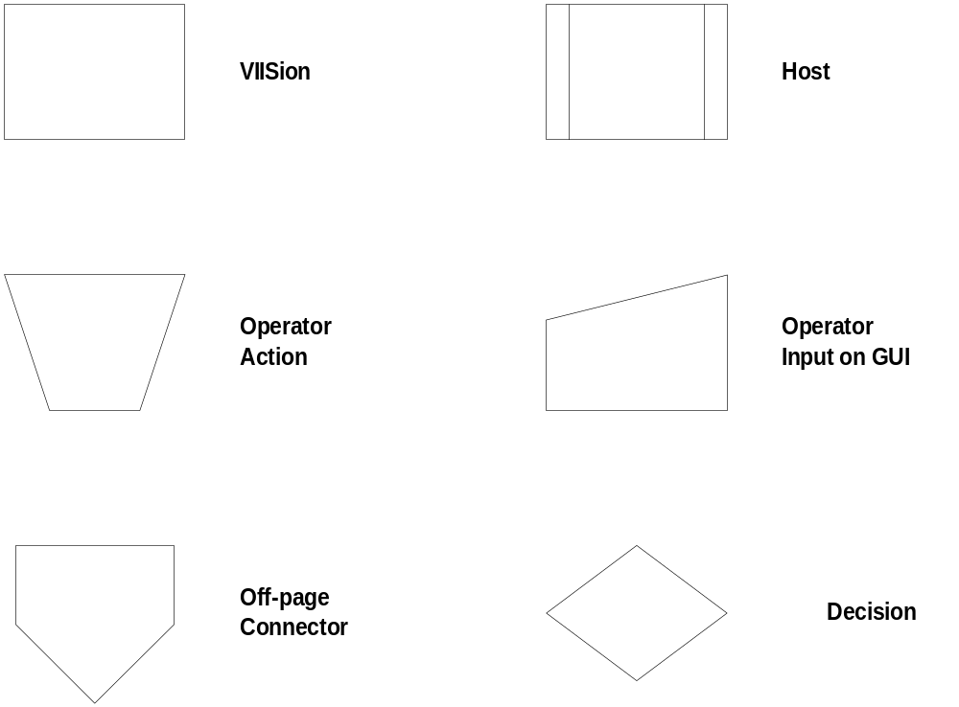

6.1 Operating Scenario: Operator Load Material

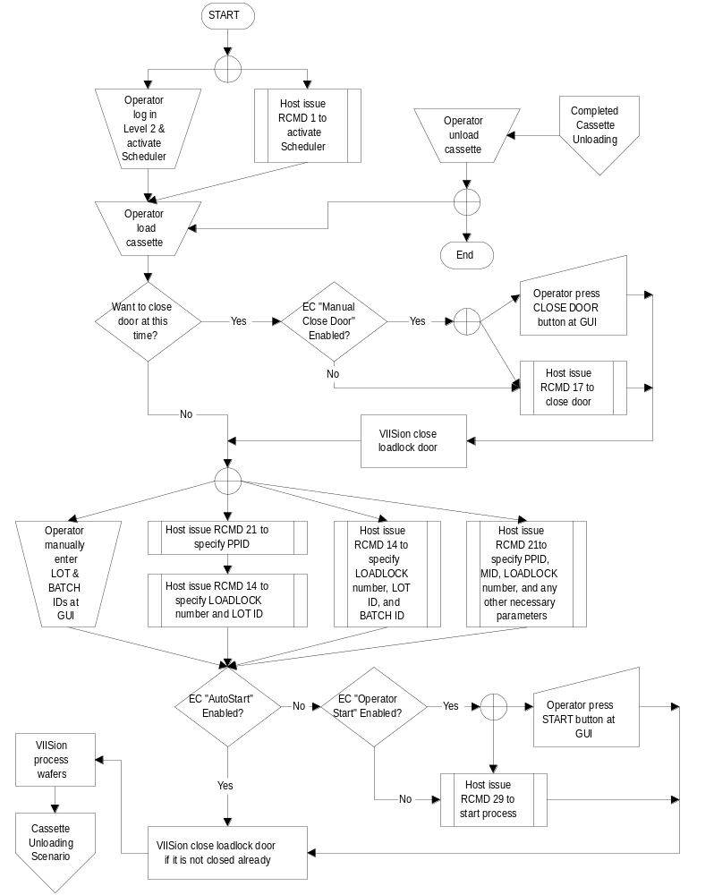

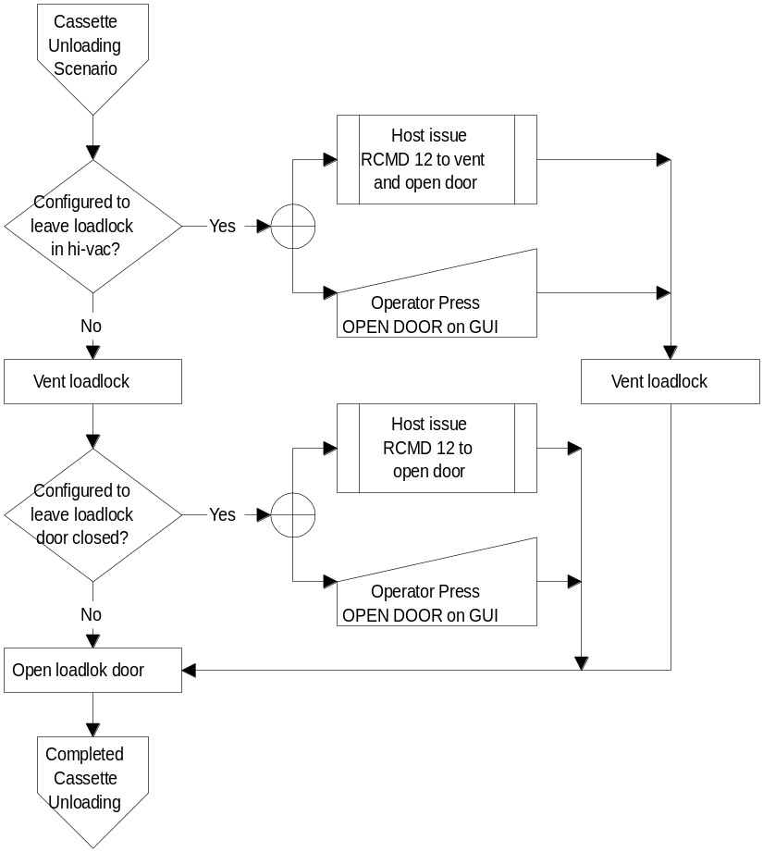

6.2 Operating Scenario: SMIF Load Material

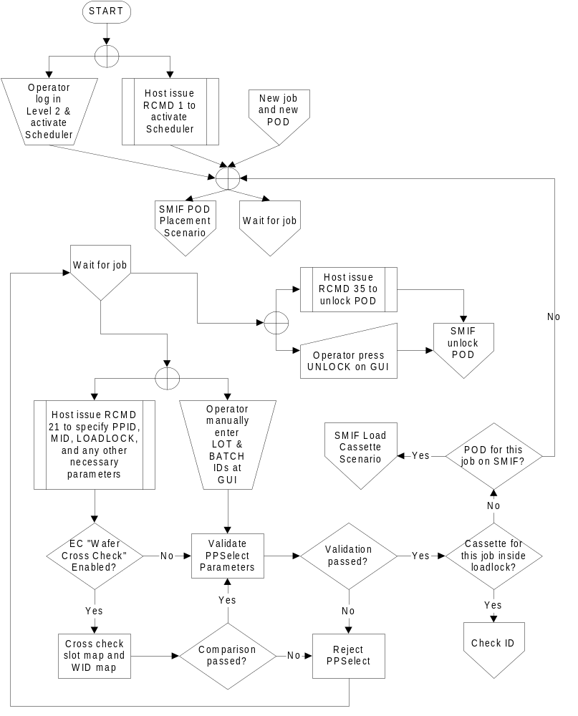
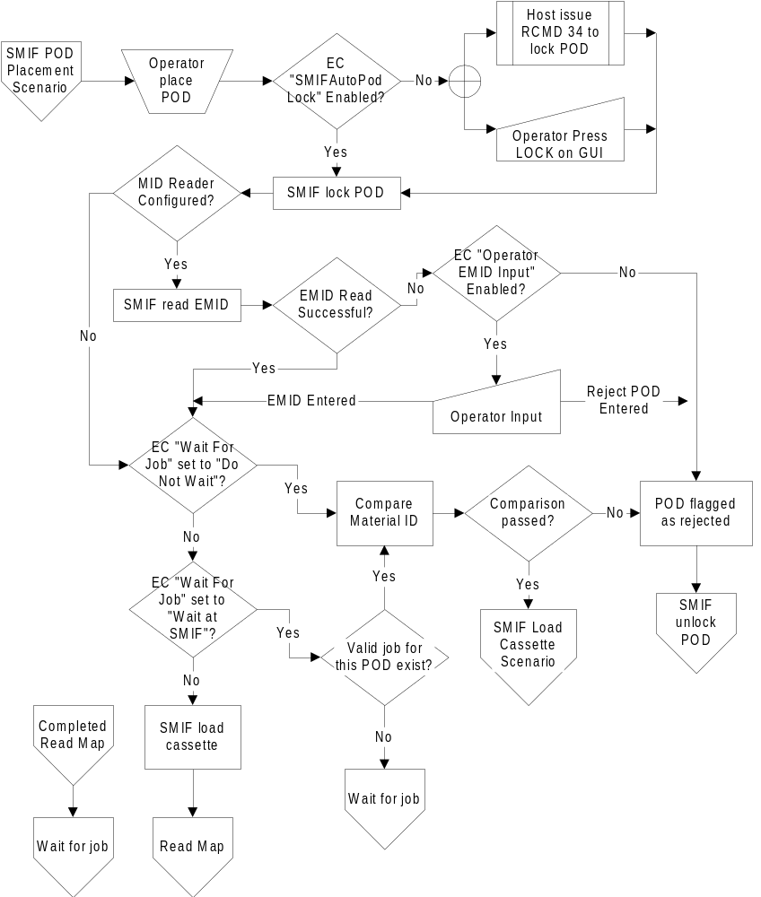
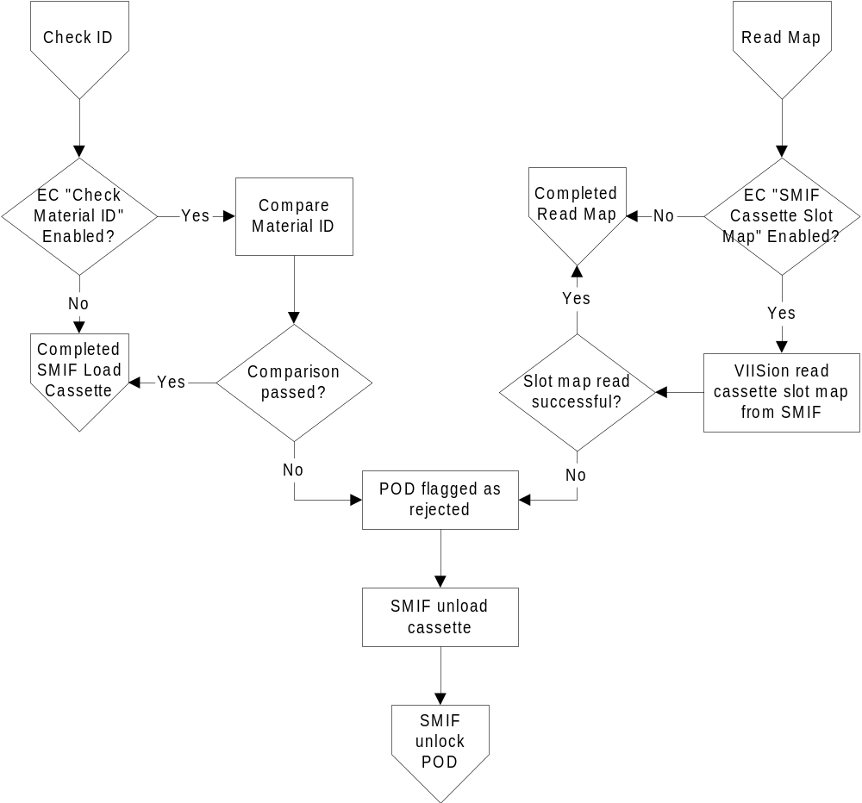
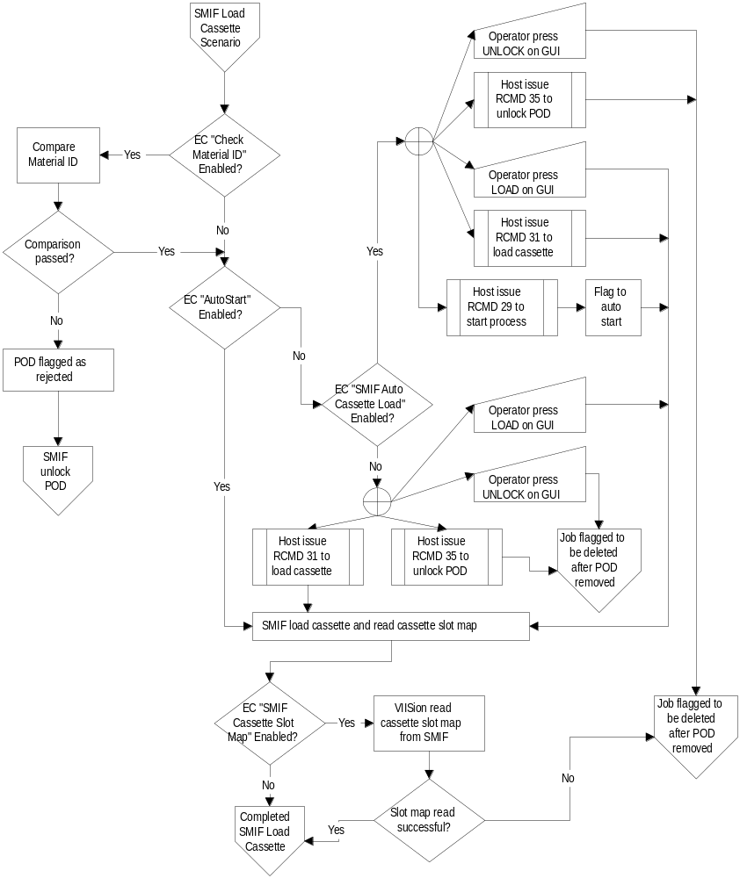

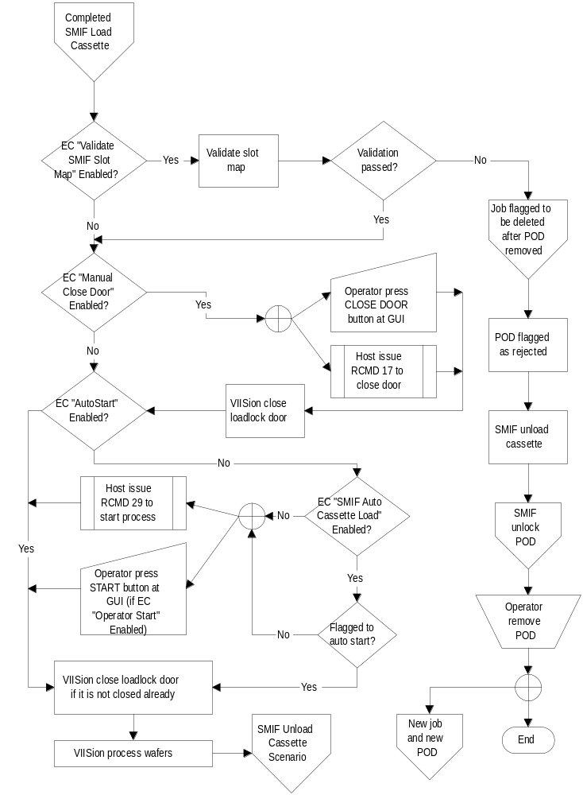

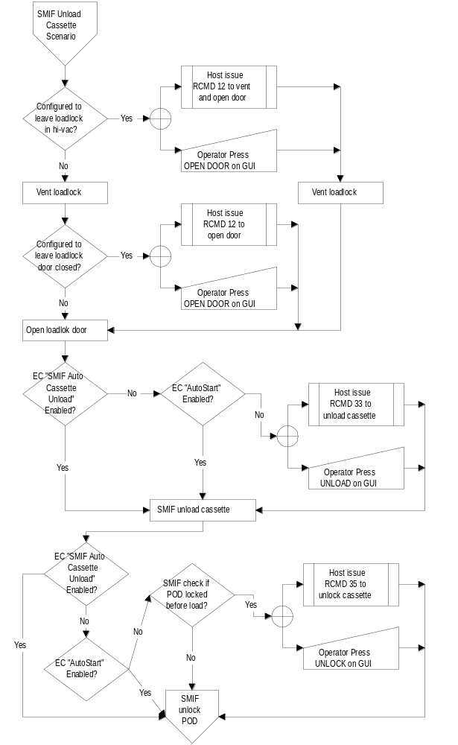

7. Message Scenarios
The following scenarios demonstrate a possible sequence of messages when the Equipment is in a specific operational state. They are not the only possible sequences. A number of indeterminate conditions affect the sequences.

Note: The left margin has been extended to the furthest point to allow use of the entire page for the following scenarios.

Scenario 1 Host Attempts to Establish Communications

The Equipment has completed initialization and is idle. The default communications states are ENABLED, OFF-LINE

COMMENT | HOST | EQUIPMENT | COMMENT
 |  |  | Communications state is Enabled (any sub-state)
Establish Communications Request | S1,F13→
 |  | ←S1,F14 | Reply COMMACK = Accept and Communications state = COMMUNICATING

Scenario 2 Equipment Attempts to Establish Communications after Power-On

The Communications default state is ENABLED. The Control default state is ON-LINE/REMOTE.

COMMENT | HOST | EQUIPMENT | COMMENT
[LOOP]
[LOOP] – SEND
 |  | ←S1,F13 | Establish Communications  Request
Reply COMMACK = Accept and Communications state = COMMUNICATING | S1,F14→
[IF] S1,F14 received without
time-outs
[THEN] exit loop – SEND
[ELSE]
Delay for interval in Establish Communications Timeout
[END IF]
[END LOOP] – SEND
[IF] COMMACK = Accept
[THEN]
CommunicationState =
Communicating
Exit Loop—SEND
[ELSE]
Reset timer for delay,
and delay for interval
specified in Establish
Communications Timeout
 |  |  | [END IF]
 |  |  | [END LOOP]
 |  | ←S1,F1 | ARE YOU THERE?
Acknowledge | S1,F2→
 |  | ←S6,F11 | [IF ENABLED]  EVENT: Control State REMOTE CEID = 31
Acknowledge | S6,F12→
 |  |  | [END IF]
OPERATOR TOUCHES OPERATOR ID FUNCTION IN THE SELECT WINDOW. LOG ON SCREEN APPEARS. EQUIPMENT WAITS FOR OPERATOR LOG-ON. OPERATOR LOGS ON.
 |  | ←S6,F11 | [IF ENABLED]  EVENT: Successful Operator Log in  CEID = 114(operator screen)  115(service screen)
Acknowledge | S6,F12→
 |  |  | [END IF]
[IF] ID is correct
[THEN]
Wafer Control Screen is displayed.
 |  |  | [END IF]
[IF] privilege Level 2
[THEN]
Query operator to start the
Scheduler.
 |  |  | [END IF]
 |  | ←S6,F11 | [IF ENABLED]  EVENT: Ready to Receive Material CEID = 23(Loadlock 1)  24(Loadlock 2)  25(Loadlock 3)
Acknowledge | S6,F12→
 |  |  | [END IF]

Scenario 3 Operator Attempts to Establish Communications

The operator switches to the GEM status/control screen. The status area of the Host Communication Status block will display the Communications State as DISABLED. The Control state is ON-LINE. Operator touches button icon labeled ENABLE COMM in status/control screen. The status label changes from DISABLED to ENABLED, NOT COMMUNICATING.

COMMENT | HOST | EQUIPMENT | COMMENT
[LOOP]
[LOOP] – SEND
 |  | ←S1,F13 | Establish Communications  Request
Reply COMMACK = Accept and Comm. State =  COMMUNICATING | S1,F14→
[IF] S1,F14 received
without time-outs
[THEN]
exit loop – SEND
[ELSE]
Delay for interval in
Establish Communications
Timeout
[END IF]
[END LOOP] – SEND

[IF] COMMACK = Accept
[THEN]
Communication State =
Communicating
exit loop - SEND
[ELSE]
Reset timer for delay, and delay for interval specified in Establish Communications Timeout
[END IF]
[END LOOP]
The status area in the Host Communication Status block now displays ON-LINE, COMMUNICATING.
 |  | ←S1,F1 | Are You There?
Acknowledge | S1,F2→
 |  | ←S6,F11 | [IF ENABLED]  EVENT: Equipment to Control State REMOTE (or LOCAL)  CEID = 30(local)  31(remote)
Acknowledge | S6,F12→
 |  |  | [END IF]
 |  | ←S6,F11 | [IF ENABLED]  EVENT: Ready to Receive Material CEID = 23(Loadlock 1)  24(Loadlock 2)  25(Loadlock 3)
 | S6,F12→ |  | [END IF]

Scenario 4 Simultaneous Attempts to Establish Communication

The Equipment is powered on. The Communication state is ENABLED, NOT COMMUNICATING. The Equipment receives S1,F14 from the Host before sending S1,F14.

COMMENT | HOST | EQUIPMENT | COMMENT
 |  | ←S1,F13 | Establish Communications Request
Establish Communications Request | S1,F13→
Reply  COMMACK = Accept | S1,F14→ |  | S1, F14 received from the Host and communications established and communications state = COMMUNICATING
 |  | ←S1,F14 | Reply COMMACK = Accept

Equipment sends S1, F14 to Host before receiving S1, F14
COMMENT | HOST | EQUIPMENT | COMMENT
 |  | ←S1,F13 | Establish Communications Request
Establish Communications Request | S1,F13→
 |  | ←S1,F14 | Reply COMMACK = Accept  Communication Established
and |  |  | Communication state = COMMUNICATING
Reply COMMACK = Accept | S1,F14→

Scenario 5 Host Attempts to Establish Communications, Equipment Disabled

The Equipment is powered on. The Communication state is DISABLED.

COMMENT | HOST | EQUIPMENT | COMMENT
Establish Communications Request | S1,F13→
HOST TIMEOUT

Scenario 6 Host initiated On-line Identification

The Equipment Communications state is ENABLED and COMMUNICATING; the Control state is ON-LINE. This does not change the communication status.

COMMENT | HOST | EQUIPMENT | COMMENT
Are you there? | S1,F1→
 |  | ←S1,F2 | Equipment replies with MDLN and SOFTREV.

Scenario 7 Host Accepts ON-LINE

The Equipment’s Communications state is ENABLED and COMMUNICATING; the Control state is OFF-LINE. The operator switches to GEM status/control screen. The operator touches icon labeled ON-LINE.

COMMENT | HOST | EQUIPMENT | COMMENT
 |  | ←S1,F1 | Equipment requests ON-LINE
Host grants ON-LINE | S1,F2→
 |  | ←S6,F11 | [IF ENABLED]  EVENT: Equipment to Control State REMOTE (or LOCAL)  CEID = 30(local)  31(remote)
 |  |  | [END IF]
Acknowledge | S6,F12→ |  | Host status block label changes from OFF-LINE to ON-LINE

Scenario 8 Host denies ON-LINE

The Equipment’s Communications state is ENABLED and COMMUNICATING; the Control state is OFF-LINE. The operator switches to GEM status/control screen. Operator touches icon labeled ON-LINE.

COMMENT | HOST | EQUIPMENT | COMMENT
 |  | ←S1,F1 | Equipment requests ON-LINE
Host denies ON-LINE | S1,F0→
 |  |  | Equipment displays message to operator “HOST DENIES ON-LINE”

Scenario 9 Operator Sets OFF-LINE

The Equipment’s Communications state is ENABLED and COMMUNICATING; the Control state is ON-LINE. The operator switches to GEM status/control screen. Operator touches icon labeled OFF-LINE.

COMMENT | HOST | EQUIPMENT | COMMENT
 |  | ←S6,F11 | [IF ENABLED]  EVENT: Equipment OFFLINE  CEID = 29
 |  |  | [END IF]
Acknowledge | S6,F12→ |  | An invalid response does not prevent the Equipment from changing state. Host status block label changes to OFF-LINE.

Scenario 10 Operator Sets REMOTE

The Equipment’s Communications state is ENABLED and COMMUNICATING; the Control state is ON-LINE and LOCAL. The operator switches to GEM status/control screen. The operator touches icon labeled REMOTE.

COMMENT | HOST | EQUIPMENT | COMMENT
 |  | ←S6,F11 | [IF ENABLED]  EVENT: Control State REMOTE  CEID = 31
 |  |  | [END IF]
Acknowledge | S6,F12→ |  | Host status block label changes from ON-LINE/ LOCAL, to ON-LINE/REMOTE

Scenario 11 Operator Sets LOCAL

The Equipment’s Communications state is ENABLED and COMMUNICATING; the Control state is ON-LINE and REMOTE. The operator switches to status/control screen then touches icon labeled LOCAL.

COMMENT | HOST | EQUIPMENT | COMMENT
 |  | ←S6,F11 | [IF ENABLED]  EVENT: Control State LOCAL  CEID = 30
Acknowledge | S6,F12→
 |  |  | [END IF]
 |  |  | An invalid response does not prevent the Equipment from changing state. Host status block label changes from ON-LINE/REMOTE, to ON-LINE/ LOCAL
 |  | ←S6,F11 | [IF ENABLED]  EVENT: Operator Command Issued  CEID = 95(operator screen)  96(service screen)
Acknowledge | S6,F12→
 |  |  | [END IF]

Scenario 12 Host Sets OFF-LINE

The Equipment’s Control state is ON-LINE.

COMMENT | HOST | EQUIPMENT | COMMENT
Host requests OFF-LINE. | S1,F15→
 |  | ←S1,F0  ←S1,F16 | [IF] Equipment is OFF-LINE  [THEN]  Equipment does not process  requests.  [ELSE]  Equipment acknowledges  request and transitions to  OFF-LINE.
 |  | ←S6,F11 | [IF ENABLED]  EVENT: Equipment to Control State OFF-LINE  CEID = 29
Acknowledge | S6,F12→
 |  |  | [END IF]
 |  |  | [END IF]

Scenario 13 Host Sets ON-LINE

The Equipment’s Control state is OFF-LINE.

COMMENT | HOST | EQUIPMENT | COMMENT
Host requests ON-LINE | S1,F17→
 |  | ←S1,F18  ←S1,F18 | [IF] Equipment is HOST  OFF-LINE (state not active)  [THEN]  Equipment denies request  (ONLACK != 0)  [ELSE]  Equipment HOST OFF-LINE  (state active)  Equipment acknowledges  request (ONLACK = 0)
 |  | ←S6,F11 | [IF ENABLED]  EVENT: Equipment to Control State LOCAL (or REMOTE)  CEID = 30(local)  31(remote)
Acknowledge | S6,F12→
 |  |  | [END IF]
 |  |  | [END IF]

Scenario 14 Request Equipment Status Report

The Equipment’s Communications state is ENABLED and COMMUNICATING; the Control state is ON-LINE.

COMMENT | HOST | EQUIPMENT | COMMENT
Host requests report of selected status variable values | S1,F3→
 |  | ←S1F4 | Equipment responds with the requested status variable data.

Scenario 15 Request Equipment Status Variable NameList

The Equipment’s Communications state is ENABLED and COMMUNICATING; the Control state is ON-LINE.

COMMENT | HOST | EQUIPMENT | COMMENT
Host requests Equipment to identify selected status variables | S1,F11→
 |  | ←S1F12 | Equipment responds with the requested status variable descriptions.

Scenario 16 Host Equipment Constants Request

The Equipment’s Communications state is ENABLED and COMMUNICATING; the Control state is ON-LINE.

COMMENT | HOST | EQUIPMENT | COMMENT
Host constant request | S2,F13→
 |  | ←S2F14 | Equipment constants data

Scenario 17 Host Sends Equipment Constants

The Equipment’s Communications state is ENABLED and COMMUNICATING; the Control state is ON-LINE.

COMMENT | HOST | EQUIPMENT | COMMENT
Host sends Equipment constants | S2,F15→
 |  | ←S2,F16 | Acknowledge EAC = 0 Equipment sets constants

Scenario 18 Host Equipment Constant NameList Request

The Equipment’s Communications state is ENABLED and COMMUNICATING; the Control state is ON-LINE.

COMMENT | HOST | EQUIPMENT | COMMENT
Host constant NameList request | S2,F29→
 |  | ←S2,F30 | Equipment constant NameList

Scenario 19 Operator Changes Equipment Constant

The Equipment’s Communications state is ENABLED and COMMUNICATING; the Control state is ON-LINE.

COMMENT | HOST | EQUIPMENT | COMMENT
 |  |  | Operator changes Equipment constant at Equipment’s operator console
 |  | ←S6,F11 | [IF ENABLED]  EVENT: Operator Equipment Constant Change  CEID = 99 (operator screen)  100(service screen)
Acknowledge | S6,F12→
 |  |  | [END IF]

Scenario 20 Equipment Requests TIME

The Equipment’s Communications state is ENABLED and COMMUNICATING; the Control state is ON-LINE. The operator touches icon labeled Request Date and Time in the GEM status/control screen page 2.

COMMENT | HOST | EQUIPMENT | COMMENT
 |  | ←S2,F17 | Equipment requests a time value from the host
Host responds with a time value | S2,F18→
 |  |  | Equipment sets its time reference to the value of TIME received from the host.

Scenario 21 Host Instructs Equipment to Set Time

The Equipment’s Communications state is ENABLED and COMMUNICATING; the Control state is ON-LINE.

COMMENT | HOST | EQUIPMENT | COMMENT
Host instructs Equipment to set its time | S2,F31→
 |  | ←S2,F32 | Equipment sets its internal time reference to the value of TIME received from the host and acknowledges completion.

Scenario 22 Host Requests Equipment’s Current Time Value

The Equipment’s Communications state is ENABLED and COMMUNICATING; the Control state is ON-LINE.

COMMENT | HOST | EQUIPMENT | COMMENT
Host requests Equipment time. | S2,F17→
 |  | ←S2,F18 | Equipment returns its internal time reference value to the host.

Scenario 23 Host Initiates Trace Report

The Equipment’s Communications state is ENABLED and COMMUNICATING; the Control state is ON-LINE.

COMMENT | HOST | EQUIPMENT | COMMENT
Trace Data Initialization requested | S2,F23→
 |  | ←S2,F24 | Acknowledge, trace initiated
[DO] TOTSMP REPGSZ times
[DO] REPSGZ many times:
collect SVID₁....SVID_{n} data,
delay time by DSPER.
[END DO]
 |  | ←S6,F1 | Send SV₁....SV_{n}
Acknowledge receipt | S6,F2→
 |  |  | [END DO]
OPTIONAL:
Request trace termination prior to completion (TOTSMP=0) | S2,F23→
 |  | ←S2,F24 | Acknowledge premature termination

Scenario 24 Host Initiates Event Report Setup

The Equipment’s Communications state is ENABLED and COMMUNICATING; the Control state is ON-LINE.

COMMENT | HOST | EQUIPMENT | COMMENT
[IF] Define Report is  Multi-Block  [THEN]  send Multi-Block  inquire | S2,F39→
 |  | ←S2,F40 | Multi-Block grant.
[END IF]
Send report definitions | S2,F33→ |  | DATAIDs, RPTIDs and VIDs are received
 |  | ←S2,F34 | DRACK = 0 the reports are OK
[IF] Link Event Report  Multi-Block  [THEN]  send Multi-Block  inquire | S2,F39→
 |  | ←S2,F40 | Multi-Block grant.
[END IF]
Link reports to events | S2,F35→ |  | CEID and the corresponding RPTIDs are received
 |  | ←S2,F36 | LRACK = 0 the event linkages are acceptable
Enable specific collection events | S2,F37→ |  | Enable/ Disable codes (CEEDs) and the respective event reporting CEIDs
 |  | ←S2,F38 | ERACK = 0 OK, will generate the specified reports when the appropriate collection event happens

Scenario 25 Host sends Remote Command

The Equipment’s Communications state is ENABLED and COMMUNICATING; the Control state is ON-LINE.

COMMENT | HOST | EQUIPMENT | COMMENT
Host Command Send | S2,F41→
 |  | ←S2,F42 | Host Command Acknowledge  HCACK = 0 (assumes command can be performed).
 |  | ←S6,F11 | [IF ENABLED]  EVENT: Host Command Received  CEID = 88
Acknowledge | S6,F12→
 |  |  | [END IF]
 |  | ←S6,F11 | [IF ENABLED]  EVENT: Host Command Start  CEID = 89
Acknowledge | S6,F12→
 |  |  | [END IF]
 |  |  | Equipment executes command
 |  | ←S6,F11 | [IF ENABLED]  EVENT: Host Command Complete (successful or unsuccessful)  CEID = 90
Acknowledge | S6,F12→
 |  |  | [END IF]

Scenario 26 Host defines Limit Attributes

The Equipment’s Communications state is ENABLED and COMMUNICATING; the Control state is ON-LINE.

COMMENT | HOST | EQUIPMENT | COMMENT
[IF] S2,F45 is Multi-block  [THEN]  Send Multi-block inquire | S2,F39→
 |  | ←S2,F40 | Multi-block Grant
[ENDIF]
Host defines variable limit attributes. | S2,F45→
 |  | ←S2,F46 | Equipment acknowledges host request.

Scenario 27 Host queries Equipment for current limit

The Equipment’s Communications state is ENABLED and COMMUNICATING; the Control state is ON-LINE.

COMMENT | HOST | EQUIPMENT | COMMENT
Host queries Equipment for current variable limit attribute definitions. | S2,F47→
 |  | ←S2,F48 | Equipment returns report containing requested variable limit attribute values/

Scenario 28 Zone Transition Event occurs in Equipment

The Equipment’s Communications state is ENABLED and COMMUNICATING; the Control state is ON-LINE.

COMMENT | HOST | EQUIPMENT | COMMENT
 |  | ←S6,F5 | [IF] Event Report is Multi-block  [THEN]  send Multi-block inquire
Multi-block Grant | S6,F6→
 |  |  | [ENDIF]
 |  | ←S6,F11 | [IF ENABLED]  Equipment sends Event Report
Acknowledge | S6,F12→
 |  |  | [END IF]

Scenario 29 Define the Messages to be Spooled

The Equipment’s Communications state is ENABLED and COMMUNICATING; the Control state is ON-LINE.

COMMENT | HOST | EQUIPMENT | COMMENT
Host defines messages to be spooled in case of communication failure. | S2,F43→
 |  | ←S2,F44 | Acknowledge

Scenario 30 Request or Delete Spooled Data(MaxSpoolTransmit =0)

The Equipment’s Communications state is ENABLED and COMMUNICATING; the Control state is ON-LINE.

COMMENT | HOST | EQUIPMENT | COMMENT
COMMUNICATIONS | IS | LOST | AND REESTABLISHED
Host requests data that includes spool related status variables | S1,F3→
 |  | ←S1,F4 | Send status data
Request spooled data | S6,F23→
 |  | ←S6,F24 | If RSDC = 0,  the Streams and Functions that were spooled are sent to the host. If RSDC = 1, Spool data is purged.
 |  | ←S6,F11 | [IF ENABLED]  EVENT: Spooling Deactivated  CEID = 86
Acknowledge | S6,F12→
 |  |  | [END IF]

Scenario 31 Request or Delete Spooled Data (MaxSpoolTransmit >0)

The Equipment’s Communications state is ENABLED and COMMUNICATING; the Control state is ON-LINE.

COMMENT | HOST | EQUIPMENT | COMMENT
Host sends equipment  constant MaxSpoolTransmit>0 | S2,F15→
 |  | ←S2,F16 | Acknowledge
COMMUNICATIONS | IS | LOST | AND REESTABLISHED
Host requests data that includes spool related status variables | S1,F3→
 |  | ←S1,F4 | Send status data
Request spooled data up to MaxSpoolTransmit (RSDC=0) | S6,F23→
 |  | ←S6,F24 | If RSDC = 0,  the Streams and Functions that were spooled are sent to the host.
Request spooled data up to MaxSpoolTransmit or end of spooled data | S6,F23→
 |  | ←S6,F24 | If RSDC = 0,  spooled Streams and Functions up to the MaxSpoolTransmit are sent to the host.
[IF] MaxSpoolTransmit  has been received  [THEN]  Request additional  spooled data(RSDC=0) | S6,F23→
 |  | ←S6,F24 | If RSDC = 0,  the Streams and Functions that were spooled are sent to the host.
[END IF]
 |  | ←S6,F11 | [IF ENABLED]  EVENT: Spooling Deactivated  CEID = 86
Acknowledge | S6,F12→
 |  |  | [END IF]

Scenario 32 Material Arrives/Departs Equipment

The Equipment’s Communications state is ENABLED and COMMUNICATING; the Control state is ON-LINE. The operator places a cassette on the input port (inside the load lock or on the tilt mechanism).

COMMENT | HOST | EQUIPMENT | COMMENT
 |  | ←S6,F5 | [IF] Event Report is Multi-block  [THEN]  Send Multi-block inquire
Multi-block Grant | S6,F6→
 |  |  | [ENDIF]
 |  | ←S6,F11 | [IF ENABLED]  EVENT: Material Received  CEID = 17(Loadlock 1)  18(Loadlock 2)  19(Loadlock 3)
Acknowledge | S6,F12→
 |  |  | [END IF]

Scenario 33 Enable/Disable Alarms

The Equipment’s Communications state is ENABLED and COMMUNICATING; the Control state is ON-LINE.

COMMENT | HOST | EQUIPMENT | COMMENT
Enable/disable Alarm | S5,F3→
 |  | ←S5,F4 | Acknowledge

Scenario 34 Upload Alarm Information

The Equipment’s Communications state is ENABLED and COMMUNICATING; the Control state is ON-LINE.

COMMENT | HOST | EQUIPMENT | COMMENT
Request alarm  data/text | S5,F5→
 |  | ←S5,F6 | Send alarm data/text

Scenario 35 Send Alarm Report

The Equipment’s Communications state is ENABLED and COMMUNICATING; the Control state is ON-LINE. Alarm occurrence is detected by the Equipment.

COMMENT | HOST | EQUIPMENT | COMMENT
 |  | ←S5,F1 | [IF ENABLED]  Send alarm report (Alarm set)
Acknowledge | S5,F2→
 |  |  | [END IF]
 |  | ←S6,F11 | [IF ENABLED]  EVENT: Alarm Generated  CEID = 35
Acknowledge | S6,F12→
 |  |  | [END IF]
Operator clears the generated equipment alarm

 |  | ←S5,F1 | [IF ENABLED]  Send alarm report (Alarm  Cleared)
Acknowledge | S5,F2→
 |  |  | [END IF]
 |  | ←S6,F11 | [IF ENABLED]  EVENT: Alarm Cleared  CEID = 36
Acknowledge | S6,F12→
 |  |  | [END IF]

Scenario 36 Host Requests Event Report

The Equipment’s Communication state is ENABLED and COMMUNICATING. The Equipment’s Control state is ON-LINE.

COMMENT | HOST | EQUIPMENT | COMMENT
Host requests an event report | S6,F15→
 |  | ←S6,F16 | Equipment sends Event Report

Scenario 37 Host Requests Report

The Equipment’s Communications state is ENABLED and COMMUNICATING; the Control state is ON-LINE.

COMMENT | HOST | EQUIPMENT | COMMENT
Host requests data variables contained in report RPTID | S6,F19→
 |  | ←S6,20 | Equipment responds with a list if variable data for the given RPTID

Scenario 38 Operator Initiated Process Program Upload - Unformatted

The Equipment’s Communications state is ENABLED and COMMUNICATING; the Control state is ON-LINE. The operator switches to the Recipe Control screen (see Screen 4 ), selects a process program within a group, and presses the button labeled UPLOAD TO HOST. The equipment constant ProcessProgramTransfer Format will determine the format and scenario utilized to upload a process program to the host.

COMMENT | HOST | EQUIPMENT | COMMENT
[IF] Process program is Multi-
block
[THEN]
 |  | ←S7,F1 | Process Program Load Inquire
 |  |  | [END IF]
Process Program Load Grant | S7,F2→
 |  | ←S7,F3 | Process Program Send
Process Program Acknowledge | S7,F4→
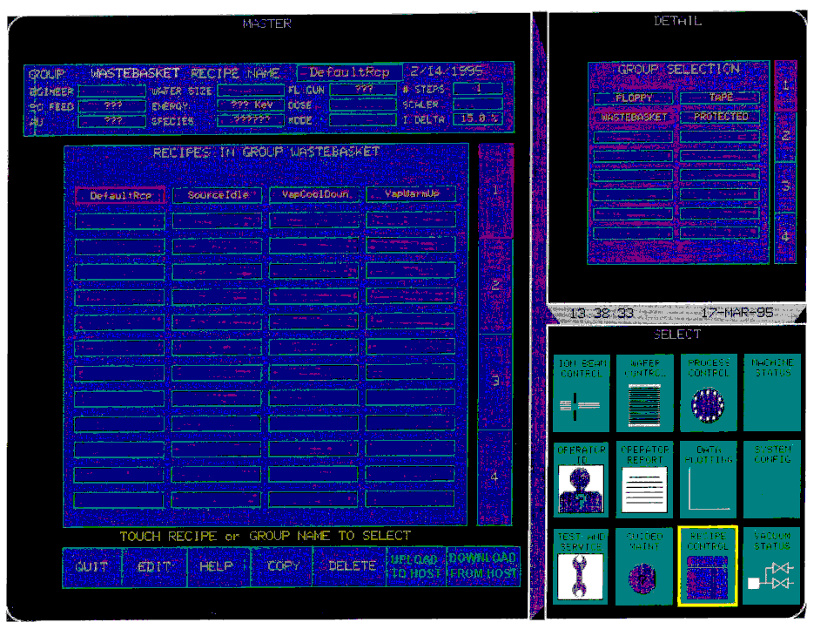
Screen 4 Recipe Control Screen Level 2

Scenario 39 Operator Initiated Process Program Upload - Formatted

The Equipment’s Communications state is ENABLED and COMMUNICATING; the Control state is ON-LINE. The operator switches to the Recipe Control screen, selects a process program, and presses the button labeled UPLOAD TO HOST (see Screen 4 ).

COMMENT | HOST | EQUIPMENT | COMMENT
[IF] Process program is Multi-
block
[THEN]
 |  | ←S7,F1 | Process Program Load Inquire
 |  |  | [END IF]
Process Program Load Grant | S7,F2→
 |  | ←S7,F23 | Formatted Process Program Send
Formatted Process Program Acknowledge | S7,F24→

Scenario 40 Host initiated Process Program Download - Unformatted

The Equipment’s Communications state is ENABLED and COMMUNICATING; the Control state is ON-LINE.

COMMENT | HOST | EQUIPMENT | COMMENT
[IF] Process program is
Multi-block
[THEN]
Process Program Load  Inquire | S7,F1→
 |  | ←S7,F2 | Process Program Load Grant
[END IF]
Process Program Send | S7,F3→
 |  | ←S7,F4 | Process Program Acknowledge

Scenario 41 Host-Initiated Process Program Download - Formatted

The Equipment’s Communications state is ENABLED and COMMUNICATING; the Control state is ON-LINE.

COMMENT | HOST | EQUIPMENT | COMMENT
[IF] Process Program is
Multi-block
[THEN]
Process Program Load  Inquire | S7,F1→
 |  | ←S7,F2 | Process Program Load Grant
[END IF]
Formatted Process Program Send | S7,F23→
 |  | ←S7,F24 | Formatted Process Program Acknowledge
 |  |  | Verify Process Program
[IF] S7,F27 is Multi-block
[THEN]
 |  | ←S7,F29 | Process Program Verification  Inquire
Process Program Verification Grant | S7,F30→
 |  |  | [END IF]
 |  | ←S7,F27 | Process Program Verification Send
Process Program Verification Acknowledge | S7,F28→

Scenario 42 Operator Initiated Process Program Download - Unformatted

The Equipment’s Communications state is ENABLED and COMMUNICATING; the Control state is ON-LINE. The operator switches to the Recipe Control screen (see Screen 4 ), enters a process program, and presses the button labeled DOWN LAOD FROM HOST. The Equipment constant ProcessProgramTransferFormat will determine the format and scenario utilized to download a process program from the host.

COMMENT | HOST | EQUIPMENT | COMMENT
 |  | ←S7,F5 | Process Program Request
Process Program Send | S7,F6→

Scenario 43 Operator Initiated Process Program Download - Formatted

The Equipment’s Communications state is ENABLED and COMMUNICATING; the Control state is ON-LINE. The operator switches to the Recipe Control screen, selects a process program, and presses the button labeled DOWNLOAD FROM HOST (see Screen 4 ).

COMMENT | HOST | EQUIPMENT | COMMENT
 |  | ←S7,F25 | Formatted Process Program Request
Formatted Process Program Data | S7,F26→
[IF] S7,F27 is Multi-block
[THEN]
 |  | ←S7,F29 | Process Program Verification  Inquire
Process Program Verification Grant | S7,F30→
 |  |  | [END IF]
 |  | ←S7,F27 | Process Program Verification Send
Process Program Verification Acknowledge | S7,F28→

Scenario 44 Host-Initiated Process Program Upload - Unformatted

The Equipment’s Communications state is ENABLED and COMMUNICATING; the Control state is ON-LINE. The Equipment is NOT PROCESSING.

COMMENT | HOST | EQUIPMENT | COMMENT
Process Program Request | S7,F5→
 |  | ←S7,F6 | Process Program Data (if process program does not exist zero-length list is sent).

Scenario 45 Host-Initiated Process Program Upload - Formatted

The Equipment’s Communications state is ENABLED and COMMUNICATING; the Control state is ON-LINE.

COMMENT | HOST | EQUIPMENT | COMMENT
Formatted Process Program Request | S7,F25→
 |  | ←S7,F26 | Formatted Process Program Data

Scenario 46 Process Program Created, Edited, or Deleted by Operator

The Equipment’s Communications state is ENABLED and COMMUNICATING; the Control state is ON-LINE.

COMMENT | HOST | EQUIPMENT | COMMENT
New process program created, edited, or deleted by operator at the Equipment.
PPChangeName = PPID
PPChangeStatus = 1 (Created)
2 (Edited)
3 (Deleted)
[IF] CEID for Process Program
Change Event enabled
[THEN]
 |  | ←S6,F11 | [IF ENABLED]  EVENT: Process Program Change  CEID = 91
Acknowledge | S6,F12→
 |  |  | [END IF]
 |  |  | [END IF]

Scenario 47 Process Program Deletion by Host

The Equipment’s Communications state is ENABLED and COMMUNICATING; the Control state is ON-LINE.

COMMENT | HOST | EQUIPMENT | COMMENT
Delete Process Program Send | S7,F17→
 |  | ←S7,F18 | Delete Process Program Acknowledge. The process program is removed from non-volatile storage.

Scenario 48 Process Program Directory Request

The Equipment’s Communications state is ENABLED and COMMUNICATING; the Control state is ON-LINE.

COMMENT | HOST | EQUIPMENT | COMMENT
Current EPPD Request | S7,F19→
 |  | ←S7,F20 | Current EPPD Data

Scenario 49 Message Fault Due to Unrecognized Device ID

The Equipment’s Communications state is ENABLED and COMMUNICATING; the Control state is ON-LINE.

COMMENT | HOST | EQUIPMENT | COMMENT
Host sends a message | Sx,Fx→
 |  |  | Equipment detects an unrecognized device ID within message from the host.
 |  | ←S9,F1 | Equipment reports to the host that an “unrecognized device ID” was detected in the received message

Scenario 50 Message Fault Due to Unrecognized Stream Type

The Equipment’s Communications state is ENABLED and COMMUNICATING; the Control state is ON-LINE.

COMMENT | HOST | EQUIPMENT | COMMENT
Host sends a message | Sx,Fx→
 |  |  | Equipment detects an unrecognized stream type within message from the host.
 |  | ←S9,F3 | Equipment reports to the host that an “unrecognized stream type” was detected in the receive message

Scenario 51 Message Fault Due to Unrecognized Function Type

The Equipment’s Communications state is ENABLED and COMMUNICATING; the Control state is ON-LINE.

COMMENT | HOST | EQUIPMENT | COMMENT
Host sends a message | Sx,Fy→
 |  |  | Equipment detects an unrecognized function type within message from the host.
 |  | ←S9,F5 | Equipment reports to the host that an “unrecognized function type” was detected in the receive message

Scenario 52 Message Fault Due to Illegal data format

The Equipment’s Communications state is ENABLED and COMMUNICATING; the Control state is ON-LINE.

COMMENT | HOST | EQUIPMENT | COMMENT
Host sends a message | Sx,Fy→
 |  |  | Equipment detects an illegal data format within message from the host.
 |  | ←S9,F7 | Equipment reports to the host that an “illegal data format” was detected in the receive message

Scenario 53 Message Fault Due to Transaction Timer Timeout

The Equipment’s Communications state is ENABLED and COMMUNICATING; the Control state is ON-LINE.

COMMENT | HOST | EQUIPMENT | COMMENT
 |  | ←Sx,Fy | Equipment sends a message that requires a reply from the host.
 |  |  | Equipment does not receive an expected reply message from the host and a transaction Timeout occurs.
 |  | ←S9,F9 | Equipment reports to the host that a transaction timer Timeout occurred.

Scenario 54 Message Fault Due to Data Too Long

The Equipment’s Communications state is ENABLED and COMMUNICATING; the Control state is ON-LINE.

COMMENT | HOST | EQUIPMENT | COMMENT
Host sends a message | Sx,Fy→
 |  |  | Equipment detects that the message from the host contains more data than it can handle.
 |  | ←S9,F11 | Equipment reports to the host that “data too long” was detected in the receive message.

Scenario 55 Message Fault Due to Conversation Timer Timeout

The Equipment’s Communications state is ENABLED and COMMUNICATING; the Control state is ON-LINE.

COMMENT | HOST | EQUIPMENT | COMMENT
Host sends a message | Sx,Fy→
 |  | ←Sx,Fy+1 | Equipment sends a reply  Equipment is now expecting a specific message from the host as a result of the previous transaction. Equipment has not received the expected message from the host and a conversation Timeout occurs.
 |  | ←S9,F13 | Equipment reports to the host that a conversation Timeout occurred.

Scenario 56 Host sends information to an Equipment’s display device

The Equipment’s Communications state is ENABLED and COMMUNICATING; the Control state is ON-LINE. The equipment will utilize a Yellow flashing bar in the FUNCTION SELECT window as the unrecognized message indicator.

COMMENT | HOST | EQUIPMENT | COMMENT
Host sends textual information to Equipment for display to the operator on terminal x. | S10,F3→
 |  | ←S10,F4 | Equipment acknowledges request to display text. Equipment sets unrecognized message indicator by flashing a bar in the Function Select window.  The operator will select Wafer Control screen then touches HOST MESSAGES button in the master window. At last he touches the ACKNOWLEDGE to display the message. The equipment will clear the unrecognized message indicator and stops the flashing bar.
 |  | ←S6,F11 | [IF ENABLED]  EVENT: Host Message Recognized  CEID = 93(operator screen)  94(service screen)
Acknowledge | S6,F12→
 |  |  | [END IF]
 |  | ←S10,F1 | Operator responds with text via terminal x.
Host acknowledges receipt of operator text. | S10, F2→

Scenario 57 Host sends information to the Equipment’s display device and then overwrites the information before operator recognizes message

The Equipment’s Communications state is ENABLED and COMMUNICATING; the Control state is ON-LINE.

COMMENT | HOST | EQUIPMENT | COMMENT
Host sends textual information to Equipment for display to the operator on terminal x. | S10,F3→
 |  | ←S10,F4 | Equipment acknowledges request to display text. Equipment sets unrecognized message indicator. A flashing bar in the Function Select window is displayed to alert the operator.
Host sends textual information to Equipment for display to the operator on terminal x. This message overwrites the first one sent by the host since it is still unrecognized. | S10,F3→
 |  | ←S10,F4 | Equipment acknowledges request to display text. (Equipment sets unrecognized message indicator.)  Operator indicates message recognition by touching the acknowledge button in Host Messages screen. (Equipment clears unrecognized message indicator.)
 |  | ←S6,F11 | [IF ENABLED]  EVENT: Host Message Recognized  CEID = 93(operator screen)  94(service screen)
Acknowledge | S6,F12→
 |  |  | [END IF]

Scenario 58 Operator sends information to the host

The Equipment’s Communications state is ENABLED and COMMUNICATING; the Control state is ON-LINE. The operator selects the Wafer Control function and touches HOST MESSAGES in the master window. The operator enters the desired message and touches SEND MESSAGE.

COMMENT | HOST | EQUIPMENT | COMMENT
 |  | ←S10,F1 | Operator sends textual information via Equipment terminal x.
Host acknowledges receipt of operator initiated message. | S10,F2→
Optional:  Host responds with information for display to the operator on terminal x. | S10,F3→
 |  | ←S10,F4 | Equipment acknowledges receipt of request to display text. (Equipment sets unrecognized message indicator by flashing a bar.)  Operator indicates message recognition.
 |  | ←S6,F11 | [IF ENABLED]  EVENT: Host Message Recognized  CEID = 93(operator screen)  94(service screen)
Acknowledge | S6,F12→
 |  |  | [END IF]

Scenario 59 Host sends a Multi-block display message

The Equipment’s Communications state is ENABLED and COMMUNICATING; the Control state is ON-LINE.

NOTE: CURRENTLY THIS GEM SCENARIO IS NOT IMPLEMENTED

COMMENT | HOST | EQUIPMENT | COMMENT
Send information | S10,F5→
 |  | ←S10,F6 | Accepted or denied
 |  | ←S10,F7 | Multi-Block Not Allowed

NOTE: THIS IS THE SCENARIO CURRENTLY IMPLEMENTED TO HANDLE S10F5
MULTI-BLOCK:

COMMENT | HOST | EQUIPMENT | COMMENT
Send information | S10,F5→
 |  | ←S9,F11 | Data Too Long

Scenario 60 Remote Process Control Scenario (Unformatted Process Program)

The Equipment’s Communications state is ENABLED and COMMUNICATING. The Control state is ON-LINE and REMOTE. The exchanges shown below may take place in a different sequence because of indeterminate timing between the various devices of the VIISion and E1000 systems. The operator switches to the Wafer Control screen.

COMMENT | HOST | EQUIPMENT | COMMENT
Equipment in IDLE State:
Loadlock/Jar vented
Door/Jar open
No material in Loadlock
 |  | ←S6,F11 | [IF ENABLED]  EVENT: Ready to Receive Material  CEID = 23(Port 1)  24(Port 2)  25(Port 3)
Acknowledge | S6,F12→
 |  |  | [END IF]
 |  |  | Equipment waiting for wafers
 |  |  | Wafers placed in Loadlock or on Tilter
 |  | ←S6,F11 | [IF ENABLED]  EVENT: Material Received  CEID = 17(Port 1)  18(Port 2)  19(Port 3)
Acknowledge | S6,F12→
 |  |  | [END IF]
 |  |  | Equipment waiting for command from Operator or Host
[IF] Operator inputs Lot ID to their Host system.
[THEN]
The Host will determine the process program to run and a Process Program request from HOST is initiated
Current EPPD Request | S7,F19→
 |  | ←S7,F20 | Current EPPD Data
[IF] Process Program not
present in EPPD
[THEN]
Process Program Load  Inquiry | S7,F1→
 |  | ←S7,F2 | Process Program Load Grant
Process Program Send | S7,F3→
 |  | ←S7,F4 | Process Program Acknowledge
[END IF]
[ELSE]
Operator inputs the LOT ID and BATCH on Equipment. The process program will be identified from the matrix schedule and selected.
 |  | ←S6,F11 | [IF ENABLED]  EVENT: Process Program Selected  CEID = 92
Acknowledge | S6,F12→
 |  |  | [END IF]
 |  |  | [END IF]
 |  | ←S6,F11 | [IF ENABLED]  EVENT: Process State Change (Equipment to Pre-Processing State)  CEID = 107
Acknowledge | S6,F12→
 |  |  | [END IF]
 |  |  | Equipment waiting for command from Operator or Host
Host Command Send  PPSelect | S2,F41→
 |  | ←S2,F42 | Host Command Acknowledge
 |  | ←S6,F11 | [IF ENABLED]  EVENT: Host Command Received  CEID = 88
Acknowledge | S6,F12→
 |  |  | [END IF]
 |  | ←S6,F11 | [IF ENABLED]  EVENT: Host Command Start  CEID = 89
Acknowledge | S6,F12→
 |  |  | [END IF]
 |  | ←S6,F11 | [IF ENABLED]  EVENT: Process Program Selected  CEID = 92
Acknowledge | S6,F12→
 |  |  | [END IF]
 |  | ←S6,F11 | [IF ENABLED]  EVENT: Host Command Complete  CEID = 90
Acknowledge | S6,F12→
 |  |  | [END IF]
 |  |  | Equipment displays PPID on Wafer Control screen
 |  |  | Operator verifies PPID with their Host.
 |  | ←S6,F11 | [IF] Operator touches START  icon on Wafer Control Screen  [THEN]  [IF ENABLED]  EVENT: Operator Command Issued  CEID = 95(operator screen)  96(service screen)
Acknowledge | S6,F12→
 |  |  | [END IF]
[ELSE]
Equipment waiting for a command from Host
Host Command Send  INITIATE PROCESSING | S2,F41→
 |  | ←S2,F42 | Host Command Acknowledge
 |  | ←S6,F11 | [IF ENABLED]  EVENT: Host Command Received  CEID = 88
Acknowledge | S6,F12→
 |  |  | [END IF]
 |  | ←S6,F11 | [IF ENABLED]  EVENT: Host Command Start  CEID = 89
Acknowledge | S6,F12→
 |  |  | [END IF]
 |  | ←S6,F11 | [IF ENABLED]  EVENT: Host Command Complete  CEID = 90
Acknowledge | S6,F12→
 |  |  | [END IF]
 |  |  | [END IF]
 |  |  | Equipment will wait for a start command from host to go to SETUP state.
 |  | ←S6,F11 | [IF] Operator touches START  on Wafer Control screen  [THEN]  [IF ENABLED]  EVENT: Operator Command Issued  CEID = 95(operator screen)  96(service screen)
Acknowledge | S6,F12→
 |  |  | [END IF]
 |  |  | [ELSE]
Host Command Send  START | S2,F41→
 |  | ←S2,F42 | Host Command Acknowledge
 |  | ←S6,F11 | [IF ENABLED]  EVENT: Host Command Received  CEID = 88
Acknowledge | S6,F12→
 |  |  | [END IF]
 |  | ←S6,F11 | [IF ENABLED]  EVENT: Host Command Start  CEID = 89
Acknowledge | S6,F12→
 |  |  | [END IF]
 |  | ←S6,F11 | [IF ENABLED]  EVENT: Host Command Complete  CEID = 90
Acknowledge | S6,F12→
 |  |  | [END IF]
 |  |  | [END IF]
 |  | ←S6,F11 | [IF ENABLED]  EVENT: Process State Change (Equipment to SETUP State)  CEID = 107
Acknowledge | S6,F12→
 |  |  | [END IF]
 |  | ←S6,F11 | [IF ENABLED]  EVENT: Processing Started  CEID = 103
Acknowledge | S6,F12→
 |  |  | [END IF]
 |  |  | Equipment begins setup for implanting wafer
 |  | ←S6,F11 | [IF ENABLED]  EVENT: Door/Jar Close Start  CEID = 43(Loadlock/jar 1)  44(Loadlock/jar 2)  45(Loadlock/jar 3)
Acknowledge | S6,F12→
 |  |  | [END IF]
 |  | ←S6,F11 | [IF ENABLED]  EVENT: Door/Jar Close Complete  CEID = 46(Loadlock/jar 1)  47(Loadlock/jar 2)  48(Loadlock/jar 3)
Acknowledge | S6,F12→
 |  |  | [END IF]
 |  | ←S6,F11 | [IF ENABLED]  EVENT: Loadlock/Jar Rough Start  CEID = 55(Loadlock/jar 1)  56(Loadlock/jar 2)  57(Loadlock/jar 3)
Acknowledge | S6,F12→
 |  |  | [END IF]
 |  |  | [IF VIISion]
 |  | ←S6,F11 | [IF ENABLED]  EVENT: Wafer Mapping Start  CEID = 67(Loadlock 1)  68(Loadlock 2)  69(1oadlock 3)
Acknowledge | S6,F12→
 |  |  | [END IF]
 |  | ←S6,F11 | [IF ENABLED]  EVENT: Wafer Mapping Complete  CEID = 70(Loadlock 1)  71(Loadlock 2)  72(Loadlock 3)
Acknowledge | S6,F12→
 |  |  | [END IF]
 |  |  | [END IF VIISion]
 |  | ←S6,F11 | [IF ENABLED]  EVENT: Loadlock/Jar Rough Complete  CEID = 58(Loadlock/jar 1)  59(Loadlock/jar 2)  60(Loadlock/jar 3)
Acknowledge | S6,F12→
 |  |  | [END IF]
 |  | ←S6,F11 | [IF ENABLED]  EVENT: Loadlock/Jar Hivac  Start  CEID = 61(Loadlock/jar 1)  62(Loadlock/jar 2)  63(Loadlock/jar 3)
Acknowledge | S6,F12→
 |  |  | [END IF]
 |  | ←S6,F11 | [IF ENABLED]  EVENT: Loadlock/Jar Hivac Complete  CEID = 64(Loadlock/jar 1)  65(Loadlock/jar 2)  66(Loadlock/jar 3)
Acknowledge | S6,F12→
 |  |  | [END IF]
 |  |  | [IF E1000]
 |  | ←S6,F11 | [IF ENABLED]  EVENT: Wafer Mapping Start  CEID = 67(Loadlock 1)  68(Loadlock 2)  69(Loadlock 3)
Acknowledge | S6,F12→
 |  |  | [END IF]
 |  | ←S6,F11 | [IF ENABLED]  EVENT: Wafer Mapping Complete  CEID = 70(Loadlock 1)  71(Loadlock 2)  72(Loadlock 3)
Acknowledge | S6,F12→
 |  |  | [END IF]
 |  |  | [END IF E1000]
 |  | ←S6,F11 | [IF ENABLED]  EVENT: Auto Source Setup Start  CEID = 13
Acknowledge | S6,F12→
 |  |  | [END IF]
 |  | ←S6,F11 | [IF ENABLED]  EVENT: Wafer Exchange Start  CEID = 11
Acknowledge | S6,F12→
 |  |  | [END IF]
[IF DISC LOADED]
Unload wafers from disc
 |  |  | [THEN]
 |  |  | Load wafers to disc
 |  |  | [END IF]
 |  | ←S6,F11 | [IF ENABLED]  EVENT: Wafer Exchange Complete  CEID = 12
Acknowledge | S6,F12→
 |  |  | [END IF]
 |  | ←S6,F11 | [IF ENABLED]  EVENT: Auto Source Setup Complete  CEID = 14
Acknowledge | S6,F12→
 |  |  | [END IF]
 |  | ←S6,F11 | [IF ENABLED]  EVENT: Preimplant Check Start  CEID = 15
Acknowledge | S6,F12→
 |  |  | [END IF]
 |  | ←S6,F11 | [IF ENABLED]  EVENT: Preimplant Check Complete  CEID = 16
Acknowledge | S6,F12→
 |  |  | [END IF]
 |  |  | [IF] SV ReadyStateWait set
 |  | ←S6,F11 | [IF ENABLED]  EVENT: Process State Change (Equipment to READY State)  CEID = 107
Acknowledge | S6,F12→
 |  |  | [END IF]
Equipment is idle waiting for Start
Executing Command
Host Command Send  START | S2,F41→
 |  | ←S2,F42 | Host Command Acknowledge  HCACK = 0 (assumes command  can be performed)
 |  | ←S6,F11 | [IF ENABLED]  EVENT: Host Command Received  CEID = 88
Acknowledge | S6,F12→
 |  |  | [END IF]
 |  | ←S6,F11 | [IF ENABLED]  EVENT: Host Command Start  CEID = 89
Acknowledge | S6,F12→
 |  |  | [END IF]
 |  | ←S6,F11 | [IF ENABLED]  EVENT: Host Command Complete  CEID = 90
Acknowledge | S6,F12→
 |  |  | [END IF]
 |  |  | [END IF] SV ReadyStateWait set
 |  | ←S6,F11 | [IF ENABLED]  EVENT: Process State Change (Equipment to EXECUTING State)  CEID = 107
Acknowledge | S6,F12→
 |  |  | [END IF]
 |  | ←S6,F11 | [IF ENABLED]  EVENT: Batch Start  CEID = 7
Acknowledge | S6,F12→
 |  |  | [END IF]
 |  |  | [LOOP] IMPLANTING
[IF] Pause Received From
Host or Operator
[THEN]
 |  | ←S6,F11 | [IF ENABLED]  EVENT: Process State Change (Equipment to PAUSED State)  CEID = 107
Acknowledge | S6,F12→
 |  |  | [END IF]
 |  | ←S6,F11 | [IF ENABLED]  EVENT: Processing Paused  CEID = 104
Acknowledge | S6,F12→
 |  |  | [END IF]
[LOOP] WAITING
[IF] Host Sends
S2,F41 or Operator
Presses CONTINUE
(START)
[THEN]
 |  | ←S6,F11 | [IF ENABLED]  EVENT: Batch RESUMED  CEID = 108
Acknowledge | S6,F12
 |  |  | [END IF]
 |  | ←S6,F11 | [IF ENABLED]  EVENT: Process State Change (Equipment to Executing State)  CEID = 107
Acknowledge | S6,F12→
 |  |  | [END IF]
Exit Loop WAITING
[END IF]
 |  |  | [END LOOP WAITING]
[IF] Final Scan
[THEN]
Exit Loop IMPLANTING
[ELSE IF]
Critical Monitored
Parameter out of Range
[THEN]
[IF] Exceeded Beam
Recovery Limit Count
[THEN]
 |  | ←S6,F11 | [IF ENABLED]  EVENT: Batch ABORT  CEID = 3
Acknowledge | S6,F12→
 |  |  | [END IF]
 |  |  | Exit Loop IMPLANTING
 |  | ←S6,F11 | [ELSE]  [IF ENABLED]  EVENT: Processing PAUSED  CEID = 104
Acknowledge | S6,F12→
 |  |  | [END IF]
 |  | ←S6,F11 | [IF ENABLED]  EVENT: Auto Source Setup (Retune Beam) Start  CEID = 13
Acknowledge | S6,F12→
 |  |  | [END IF]
 |  | ←S6,F11 | [IF ENABLED]  EVENT: Auto Source Setup Complete  CEID = 14
Acknowledge | S6,F12→
 |  |  | [END IF]
[IF] Auto Source Setup
Successful
[THEN]
 |  | ←S6,F11 | [IF ENABLED]  EVENT: Process State Change (Equipment to EXECUTING State)  CEID = 107
Acknowledge | S6,F12→
 |  |  | [END IF]
 |  |  | [END IF]
[IF] Final Scan
[THEN]
Exit Loop IMPLANTING
[END IF]
 |  |  | [END IF]
 |  |  | [END IF]
 |  |  | [END IF]
 |  |  | [END LOOP IMPLANTING]
 |  | ←S6,F11 | [IF ENABLED]  EVENT: Batch Complete  CEID = 1
Acknowledge | S6,F12→
 |  |  | [END IF]
 |  | ←S6,F11 | [IF ENABLED]  EVENT: Process State Change (Equipment to Setup Post-Processing)  CEID = 107
Acknowledge | S6,F12→
 |  |  | [END IF]
 |  |  | Unload Wafers from Disc
 |  | ←S6,F11 | [IF ENABLED]  EVENT: Wafer Exchange Start  CEID = 11
Acknowledge | S6,F12→
 |  |  | [END IF]
[IF DISC LOADED]
Unload wafers from disc
 |  |  | [THEN]
 |  |  | Load wafers to disc
 |  |  | [END IF]
 |  | ←S6,F11 | [IF ENABLED]  EVENT: Wafer Exchange Complete  CEID = 12
Acknowledge | S6,F12→
 |  |  | [END IF]
 |  | ←S6,F11 | [IF ENABLED]  EVENT: Loadlock/Jar Vent Start  CEID = 79(Loadlock/jar 1)  80(Loadlock/jar 2)  81(Loadlock/jar 3)
Acknowledge | S6,F12→
 |  |  | [END IF]
 |  | ←S6,F11 | [IF ENABLED]  EVENT: Loadlock/Jar Vent Complete  CEID = 82(Loadlock/jar 1)  83(Loadlock/jar 2)  84(Loadlock/jar 3)
Acknowledge | S6,F12→
 |  |  | [END IF]
 |  | ←S6,F11 | [IF ENABLED]  EVENT: Door/Jar Open Start  CEID = 49(Loadlock 1)  50(Loadlock 2)  51(Loadlock 3)
Acknowledge | S6,F12→
 |  |  | [END IF]
 |  | ←S6,F11 | [IF ENABLED]  EVENT: Door/Jar Open Complete  CEID = 52(Loadlock 1)  53(Loadlock 2)  54(Loadlock 3)
Acknowledge | S6,F12→
 |  |  | [END IF]
 |  | ←S6,F11 | [IF ENABLED]  EVENT: Processing Complete  CEID = 106
Acknowledge | S6,F12→
 |  |  | [END IF]
 |  | ←S6,F11 | [IF ENABLED]  EVENT: Ready to Remove Material  CEID = 26(Port 1)  27(Port 2)  28(Port 3)
Acknowledge | S6,F12→
 |  |  | [END IF]
 |  |  | Wafers Removed from Loadlock
 |  | ←S6,F11 | [IF ENABLED]  EVENT: Material Removed  CEID = 20(Port 1)  21(Port 2)  22(Port 3)
Acknowledge | S6,F12→
 |  |  | [END IF]
 |  | ←S6,F11 | [IF ENABLED]  EVENT: Process State Change  (Equipment to IDLE State)  CEID = 107
Acknowledge | S6,F12→
 |  |  | [END IF]
 |  | ←S6,F11 | [IF ENABLED]  EVENT: Ready to Receive Material  CEID = 23(Port 1)  24(Port 2)  25(Port 3)
Acknowledge | S6,F12→
 |  |  | [END IF]
 |  |  | Equipment Waiting for Wafers

Scenario 61. Remote Process Control Scenario (Formatted Process Program)

Equipment’s Communications state is ENABLED and COMMUNICATING. The Control state is ON-LINE and REMOTE. The exchanges shown below may take place in a different sequence because of indeterminate timing between the various devices of the VIISion and E1000 systems.

Operator switches to Host Control screen.

COMMENT | HOST | EQUIPMENT | COMMENT
 |  |  | Equipment in IDLE State:
Loadlock/Jar vented
Door/Jar open
No wafers in Loadlock
 |  | ←S6,F11 | [IF ENABLED]  EVENT: Ready to Receive Material  CEID = 23(Port 1)  24(Port 2)  25(Port 3)
Acknowledge | S6,F12→
 |  |  | [END IF]
 |  |  | Equipment waiting for wafers
 |  |  | Wafers placed in Loadlock or on Tilter
 |  | ←S6,F11 | [IF ENABLED]  EVENT: Material Received  CEID = 17(Port 1)  18(Port 2)  19(Port 3)
Acknowledge | S6,F12→
 |  |  | [END IF]
 |  |  | Equipment waiting for command from Operator or Host
[IF] Operator inputs Lot ID to their Host system
[THEN]
The Host will determine the process program to run and a Process Program request from HOST is initiated
Current EPPD Request | S7F19→
 |  | ←S7F20 | Current EPPD Data
[IF] Process Program not
present in EPPD
[THEN]
[IF] Process Program is
Multi-block
[THEN]
Process Program  Load Inquire | S7,F1→
 |  | ←S7,F2 | Process Program Load Grant
[END IF]
Formatted Process  Program Send | S7,F23→
 |  | ←S7,F24 | Acknowledge
 |  |  | Verify Process Program
[IF]S7,F27 is Multi-block
[THEN]
 |  | ←S7,F29 | Process Program Verification  Inquire
Process Program  Verification Grant | S7,F30→
 |  |  | [END IF]
 |  | ←S7,F27 | Process Program Verification  Send
Process Program  Verification Acknowledge | S7,F28→
[ELSE]
Operator inputs the LOT ID and BATCH on Equipment. The process program will be identified from the matrix schedule and selected.
 |  | ←S6,F11 | [IF ENABLED]  EVENT: Process Program Selected  CEID = 92
Acknowledge | S6,F12→
 |  |  | [END IF]
 |  |  | [END IF]
 |  | ←S6,F11 | [IF ENABLED]  EVENT: Process State Change (Equipment to Pre-Processing State)  CEID = 107
Acknowledge | S6,F12→
 |  |  | [END IF]
 |  |  | Equipment waiting for command from Host
Host Command Send  PPSelect | S2,F41→
 |  | ←S2,F42 | Host Command Acknowledge
 |  | ←S6,F11 | [IF ENABLED]  EVENT: Host Command Received  CEID = 88
Acknowledge | S6,F12→
 |  |  | [END IF]
 |  | ←S6,F11 | [IF ENABLED]  EVENT: Host Command Start  CEID = 89
Acknowledge | S6,F12→
 |  |  | [END IF]
 |  | ←S6,F11 | [IF ENABLED]  EVENT: Process Program Selected  CEID = 92
Acknowledge | S6,F12→
 |  |  | [END IF]
 |  | ←S6,F11 | [IF ENABLED]  EVENT: Host Command Complete  CEID = 90
Acknowledge | S6,F12→
 |  |  | [END IF]
 |  |  | Equipment displays PPID on Wafer Control screen
 |  |  | Operator verifies PPID
 |  | ←S6,F11 | [IF] Operator touches START  icon on Wafer Control Screen  [THEN]  [IF ENABLED]  EVENT: Operator Command Issued  CEID = 95(operator screen)  96(service screen)
Acknowledge | S6,F12→ |  | Equipment will ready the cassette by closing the door and pumping the lock.
 |  |  | [END IF]
[ELSE]
Equipment waiting for a command from Host
Host Command Send  INITIATE PROCESSING | S2,F41→
 |  | ←S2,F42 | Host Command Acknowledge
 |  | ←S6,F11 | [IF ENABLED]  EVENT: Host Command Received  CEID = 88
Acknowledge | S6,F12→
 |  |  | [END IF]
 |  | ←S6,F11 | [IF ENABLED]  EVENT: Host Command Start  CEID = 89
Acknowledge | S6,F12→
 |  |  | [END IF]
 |  | ←S6,F11 | [IF ENABLED]  EVENT: Host Command Complete  CEID = 90
Acknowledge | S6,F12→
 |  |  | [END IF]
 |  |  | [END IF]
 |  |  | Equipment will wait for a start command from host to go to SETUP state.
 |  | ←S6,F11 | [IF] Operator touches START  on Wafer Control screen  [THEN]  [IF ENABLED]  EVENT: Operator Command Issued  CEID = 95(operator screen)  96(service screen)
Acknowledge | S6,F12→
 |  |  | [END IF]
 |  |  | [ELSE]
Host Command Send  START | S2,F41→
 |  | ←S2,F42 | Host Command Acknowledge
 |  | ←S6,F11 | [IF ENABLED]  EVENT: Host Command Received  CEID = 88
Acknowledge | S6,F12→
 |  |  | [END IF]
 |  | ←S6,F11 | [IF ENABLED]  EVENT: Host Command Start  CEID = 89
Acknowledge | S6,F12→
 |  |  | [END IF]
 |  | ←S6,F11 | [IF ENABLED]  EVENT: Host Command Complete  CEID = 90
Acknowledge | S6,F12→
 |  |  | [END IF]
 |  |  | [END IF]
 |  | ←S6,F11 | [IF ENABLED]  EVENT: Process State Change (Equipment to SETUP State)  CEID = 107
Acknowledge | S6,F12→
 |  |  | [END IF]
 |  | ←S6,F11 | [IF ENABLED]  EVENT: Processing Started  CEID = 103
Acknowledge | S6,F12→
 |  |  | [END IF]
 |  |  | Equipment begins setup for implanting wafer
 |  | ←S6,F11 | [IF ENABLED]  EVENT: Door/Jar Close Start  CEID = 43(Loadlock 1)  44(Loadlock 2)  45(Loadlock 3)
Acknowledge | S6,F12→
 |  |  | [END IF]
 |  | ←S6,F11 | [IF ENABLED]  EVENT: Door/Jar Close Complete  CEID = 46(Loadlock 1)  47(Loadlock 2)  48(Loadlock 3)
Acknowledge | S6,F12→
 |  |  | [END IF]
 |  | ←S6,F11 | [IF ENABLED]  EVENT: Loadlock/Jar Rough Start  CEID = 55(Loadlock/jar 1)  56(Loadlock/jar 2)  57(Loadlock/jar 3)
Acknowledge | S6,F12→
 |  |  | [END IF]
 |  |  | [IF VIISion]
 |  | ←S6,F11 | [IF ENABLED]  EVENT: Wafer Mapping Start  CEID = 67(Loadlock 1)  68(Loadlock 2)  69(Loadlock 3)
Acknowledge | S6,F12→
 |  |  | [END IF]
 |  | ←S6,F11 | [IF ENABLED]  EVENT: Wafer Mapping Complete  CEID = 70(Loadlock 1)  71(Loadlock 2)  72(Loadlock 3)
Acknowledge | S6,F12→
 |  |  | [END IF]
 |  |  | [END IF VIISion]
 |  | ←S6,F11 | [IF ENABLED]  EVENT: Loadlock/Jar Rough Complete  CEID = 58(Loadlock/jar 1)  59(Loadlock/jar 2)  60(Loadlock/jar 3)
Acknowledge | S6,F12→
 |  |  | [END IF]
 |  | ←S6,F11 | [IF ENABLED]  EVENT: Loadlock/Jar Hivac Start  CEID = 61(Loadlock/jar 1)  62(Loadlock/jar 2)  63(Loadlock/jar 3)
Acknowledge | S6,F12→
 |  |  | [END IF]
 |  | ←S6,F11 | [IF ENABLED]  EVENT: Loadlock/Jar Hivac Complete  CEID = 64(Loadlock/jar 1)  65(Loadlock/jar 2)  66(Loadlock/jar 3)
Acknowledge | S6,F12→
 |  |  | [END IF]
 |  |  | [IF E1000]
 |  | ←S6,F11 | [IF ENABLED]  EVENT: Wafer Mapping Start  CEID = 67(Loadlock 1)  68(Loadlock 2)  69(Loadlock 3)
Acknowledge | S6,F12→
 |  |  | [END IF]
 |  | ←S6,F11 | [IF ENABLED]  EVENT: Wafer Mapping Complete  CEID = 70(Loadlock 1)  71(Loadlock 2)  72(Loadlock 3)
Acknowledge | S6,F12→
 |  |  | [END IF]
 |  |  | [END IF E1000]
 |  | ←S6,F11 | [IF ENABLED]  EVENT: Auto Source Setup Start  CEID = 13
Acknowledge | S6,F12→
 |  |  | [END IF]
 |  | ←S6,F11 | [IF ENABLED]  EVENT: Wafer Exchange Start  CEID = 11
Acknowledge | S6,F12→
 |  |  | [END IF]
[IF DISC LOADED]
Unload wafers from disc
 |  |  | [THEN]
 |  |  | Load wafers to disc
 |  |  | [END IF]
 |  | ←S6,F11 | [IF ENABLED]  EVENT: Wafer Exchange Complete  CEID = 12
Acknowledge | S6,F12→
 |  |  | [END IF]
 |  | ←S6,F11 | [IF ENABLED]  EVENT: Auto Source Setup Complete  CEID = 14
Acknowledge | S6,F12→
 |  |  | [END IF]
 |  | ←S6,F11 | [IF ENABLED]  EVENT: Preimplant Check Start  CEID = 15
Acknowledge | S6,F12→
 |  |  | [END IF]
 |  | ←S6,F11 | [IF ENABLED]  EVENT: Preimplant Check Complete  CEID = 16
Acknowledge | S6,F12→
 |  |  | [END IF]
 |  |  | [IF} SV ReadyStateWait set
 |  | ←S6,F11 | [IF ENABLED]  EVENT: Process State Change Equipment to READY State  CEID = 107
Acknowledge | S6,F12→
 |  |  | [END IF]
Equipment waiting for Start
Command
Host Command Send  START | S2,F41→
 |  | ←S2,F42 | Host Command Acknowledge  HCACK = 0 (assumes command can be performed)
 |  | ←S6,F11 | [IF ENABLED]  EVENT: Host Command Received  CEID = 88
Acknowledge | S6,F12→
 |  |  | [END IF]
 |  | ←S6,F11 | [IF ENABLED]  EVENT: Host Command Start  CEID = 89
Acknowledge | S6,F12→
 |  |  | [END IF]
 |  | ←S6,F11 | [IF ENABLED]  EVENT: Host Command Complete  CEID = 90
Acknowledge | S6,F12→
 |  |  | [END IF]
 |  |  | [END IF] ReadyStateWait set
 |  | ←S6,F11 | [IF ENABLED]  EVENT: Process State Change (Equipment to EXECUTING State)  CEID = 107
Acknowledge | S6,F12→
 |  |  | [END IF]
 |  | ←S6,F11 | [IF ENABLED]  EVENT: Batch Start  CEID = 7
Acknowledge | S6,F12→
 |  |  | [END IF]
 |  |  | [LOOP] IMPLANTING
[IF] Pause Received From
Host or Operator
[THEN]
 |  | ←S6,F11 | [IF ENABLED]  EVENT: Process State Change (Equipment to PAUSED State)  CEID = 107
Acknowledge | S6,F12→
 |  |  | [END IF]
 |  | ←S6,F11 | [IF ENABLED]  EVENT: Processing Paused  CEID = 104
Acknowledge | S6,F12→
 |  |  | [END IF]
[LOOP] WAITING
[IF] Host Sends S2,F41 or
Operator Presses CONTINUE(START)
[THEN]
 |  | ←S6,F11 | [IF ENABLED]  EVENT: Batch RESUMED  CEID = 108
Acknowledge | S6,F12→
 |  |  | [END IF]
 |  | ←S6,F11 | [IF ENABLED]  EVENT: Process State Change (Equipment to Executing State)  CEID = 107
Acknowledge | S6,F12→
 |  |  | [END IF]
 |  |  | Exit Loop WAITING
 |  |  | [END IF]
 |  |  | [END LOOP WAITING]
[IF] Final Scan
[THEN]
Exit Loop IMPLANTING
[ELSE IF]
Critical Monitored
Parameter out of Range
[THEN]
[IF]Exceeded Beam
Recovery Limit Count
[THEN]
 |  | ←S6,F11 | [IF ENABLED]  EVENT: Batch ABORT  CEID = 3
Acknowledge | S6,F12→
 |  |  | [END IF]
 |  | ←S6,F11 | [ELSE]  [IF ENABLED]  EVENT: Processing PAUSED  CEID = 104
Acknowledge | S6,F12→
 |  |  | [END IF]
 |  | ←S6,F11 | [IF ENABLED]  EVENT: Auto Source Setup (Retune Beam) Start  CEID = 13
Acknowledge | S6,F12→
 |  |  | [END IF]
 |  | ←S6,F11 | [IF ENABLED]  EVENT: Auto Source Setup Complete  CEID = 14
Acknowledge | S6,F12→
 |  |  | [END IF]
[IF] Auto Source Setup
Successful
[THEN]
 |  | ←S6,F11 | [IF ENABLED]  EVENT: Process State Change (Equipment to  EXECUTING State)  CEID = 107
Acknowledge | S6,F12→
 |  |  | [END IF]
 |  |  | [END IF]
[IF] Final Scan
[THEN]
Exit Loop IMPLANTING
[END IF]
 |  |  | [END IF]
 |  |  | [END IF]
 |  |  | [END IF]
 |  |  | [END LOOP IMPLANTING]
 |  | ←S6,F11 | [IF ENABLED]  EVENT: Batch Complete  CEID = 1
Acknowledge | S6,F12→
 |  |  | [END IF]
 |  | ←S6,F11 | [IF ENABLED]  EVENT: Processing Complete  CEID = 106
Acknowledge | S6,F12→
 |  |  | [END IF]
 |  | ←S6,F11 | [IF ENABLED]  EVENT: Process State Change (Equipment to Setup Post-Processing)  CEID = 107
Acknowledge | S6,F12→
 |  |  | [END IF]
 |  |  | Unload Wafers from Disc
 |  | ←S6,F11 | [IF ENABLED]  EVENT: Wafer Exchange Start  CEID = 11
Acknowledge | S6,F12→
 |  |  | [END IF]
[IF NEW WAFERS READY]
Load wafers to disc
 |  |  | [END IF]
 |  | ←S6,F11 | [IF ENABLED]  EVENT: Wafer Exchange Complete  CEID = 12
Acknowledge | S6,F12→
 |  |  | [END IF]
 |  | ←S6,F11 | [IF ENABLED]  EVENT: Loadlock/Jar Vent Start  CEID = 79(Loadlock/jar 1)  80(Loadlock/jar 2)  81(Loadlock/jar 3)
Acknowledge | S6,F12→
 |  |  | [END IF]
 |  | ←S6,F11 | [IF ENABLED]  EVENT: Loadlock/Jar Vent Complete  CEID = 82(Loadlock/jar 1)  83(Loadlock/jar 2)  84(Loadlock/jar 3)
Acknowledge | S6,F12→
 |  |  | [END IF]
 |  | ←S6,F11 | [IF ENABLED]  EVENT: Door/Jar Open Start  CEID = 49(Loadlock 1)  50(Loadlock 2)  51(Loadlock 3)
Acknowledge | S6,F12→
 |  |  | [END IF]
 |  | ←S6,F11 | [IF ENABLED]  EVENT: Door/Jar Open Complete  CEID = 52(Loadlock 1)  53(Loadlock 2)  54(Loadlock 3)
Acknowledge | S6,F12→
 |  |  | [END IF]
 |  | ←S6,F11 | [IF ENABLED]  EVENT: Processing Complete  CEID = 106
Acknowledge | S6,F12→
 |  |  | [END IF]
 |  | ←S6,F11 | [IF ENABLED]  EVENT: Ready to Remove Material  CEID = 26(Port 1)  27(Port 2)  28(Port 3)
Acknowledge | S6,F12→
 |  |  | [END IF]
 |  |  | Wafers removed from Loadlock or Tilter
 |  | ←S6,F11 | [IF ENABLED]  EVENT: Material Removed  CEID = 20(Port 1)  21(Port 2)  22(Port 3)
Acknowledge | S6,F12→
 |  |  | [END IF]
 |  | ←S6,F11 | [IF ENABLED]  EVENT: Equipment to IDLE State  CEID = 133
Acknowledge | S6,F12→
 |  |  | [END IF]
 |  | ←S6,F11 | [IF ENABLED]  EVENT: Ready to Receive Material  CEID = 23(Port 1)  24(Port 2)  25(Port 3)
Acknowledge | S6,F12→
 |  |  | [END IF]
 |  |  | Equipment Idle, waiting for wafers

Scenario 62. Local Process Control Scenario

The Equipment’s Communications state is ENABLED and COMMUNICATING. The Control state is ON-LINE and LOCAL. The Host shall be prohibited from the use of remote commands that cause physical movement or initiate processing by operator switching to LOCAL mode. Also, the Host shall not modify Equipment constants that could affect a process in progress. The exchanges shown below may not take place in the order shown because of timing considerations between the various devices which are part of the VIISion and E1000 systems. Operator switches to Wafer Control screen.

COMMENT | HOST | EQUIPMENT | COMMENT
Equipment in IDLE State:
Loadlock/Jar vented
Door/jar open
No wafers in Loadlock or Tilter
 |  | ←S6,F11 | [IF ENABLED]  EVENT: Ready to Receive Material  CEID = 23(Port 1)  24(Port 2)  25(Port 3)
Acknowledge | S6,F12→
 |  |  | [END IF]
 |  |  | Equipment waiting for wafers
 |  |  | Operator places wafers in Loadlock or Tilter
 |  | ←S6,F11 | [IF ENABLED]  EVENT: Material Received  CEID = 17(Port 1)  18(Port 2)  19(Port 3)
Acknowledge | S6,F12→
 |  |  | [END IF]
 |  |  | Operator inputs the LOT ID and BATCH on Equipment. The process program will be identified from the matrix schedule and selected.
 |  | ←S6,F11 | [IF ENABLED]  EVENT: Process Program Selected  CEID = 92
Acknowledge | S6,F12→
 |  |  | [END IF]
 |  | ←S6,F11 | [IF ENABLED]  EVENT: Process State Change (Equipment to Pre-Processing State)  CEID = 104
Acknowledge | S6,F12→
 |  |  | [END IF]
 |  |  | Equipment will wait for a start command from the operator. The Operator presses START button
 |  |  | Equipment begins setup for implanting wafers
 |  | ←S6,F11 | [IF ENABLED]  EVENT: Operator Command Issued  CEID = 95(operator screen)  96(service screen)
Acknowledge | S6,F12→
 |  |  | [END IF]
 |  | ←S6,F11 | [IF ENABLED]  EVENT: Process State Change (Equipment to SETUP State)  CEID = 104
Acknowledge | S6,F12→
 |  |  | [END IF]
 |  | ←S6,F11 | [IF ENABLED]  EVENT: Processing Started  CEID = 100
Acknowledge | S6,F12→
 |  |  | [END IF]
 |  |  | Equipment begins setup for implanting wafer
 |  | ←S6,F11 | [IF ENABLED]  EVENT: Door/Jar Close Start  CEID = 43(Loadlock/jar 1)  44(Loadlock/jar 2)  45(Loadlock/jar 3)
Acknowledge | S6,F12→
 |  |  | [END IF]
 |  | ←S6,F11 | [IF ENABLED]  EVENT: Door/Jar Close Complete  CEID = 46(Loadlock/jar 1)  47(Loadlock/jar 2)  48(Loadlock/jar 3)
Acknowledge | S6,F12→
 |  |  | [END IF]
 |  | ←S6,F11 | [IF ENABLED]  EVENT: Loadlock/Jar Rough Start  CEID = 55(Loadlock/jar 1)  56(Loadlock/jar 2)  57(Loadlock/jar 3)
Acknowledge | S6,F12→
 |  |  | [END IF]
 |  |  | [IF VIISion]
 |  | ←S6,F11 | [IF ENABLED]  EVENT: Wafer Mapping Start  CEID = 67(Loadlock 1)  68(Loadlock 2)  69(Loadlock 3)
Acknowledge | S6,F12→
 |  |  | [END IF]
 |  | ←S6,F11 | [IF ENABLED]  EVENT: Wafer Mapping Complete  CEID = 70(Loadlock 1)  71(Loadlock 2)  72(Loadlock 3)
Acknowledge | S6,F12→
 |  |  | [END IF]
 |  |  | [END IF VIISion]
 |  | ←S6,F11 | [IF ENABLED]  EVENT: Loadlock/Jar Rough Complete  CEID = 58(Loadlock/jar 1)  59(Loadlock/jar 2)  60(Loadlock/jar 3)
Acknowledge | S6,F12→
 |  |  | [END IF]
 |  | ←S6,F11 | [IF ENABLED]  EVENT: Loadlock/Jar Hivac Start  CEID = 61(Loadlock/jar 1)  62(Loadlock/jar 2)  63(Loadlock/jar 3)
Acknowledge | S6,F12→
 |  |  | [END IF]
 |  | ←S6,F11 | [IF ENABLED]  EVENT: Loadlock/Jar Hivac Complete  CEID = 64(Loadlock/jar 1)  65(Loadlock/jar 2)  66(Loadlock/jar 3)
Acknowledge | S6,F12→
 |  |  | [END IF]
 |  |  | [IF E1000]
 |  | ←S6,F11 | [IF ENABLED]  EVENT: Wafer Mapping Start  CEID = 67(Loadlock 1)  68(Loadlock 2)  69(Loadlock 3)
Acknowledge | S6,F12→
 |  |  | [END IF]
 |  | ←S6,F11 | [IF ENABLED]  EVENT: Wafer Mapping Complete  CEID = 70(Loadlock 1)  71(Loadlock 2)  72(Loadlock 3)
Acknowledge | S6,F12→
 |  |  | [END IF]
 |  |  | [END IF E1000]
 |  | ←S6,F11 | [IF ENABLED]  EVENT: Auto Source Setup Start  CEID = 13
Acknowledge | S6,F12→
 |  |  | [END IF]
 |  | ←S6,F11 | [IF ENABLED]  EVENT: Wafer Exchange Start  CEID = 11
Acknowledge | S6,F12→
 |  |  | [END IF]
[IF DISC LOADED]
Unload wafers from disc
 |  |  | [THEN]
 |  |  | Load wafers to disc
 |  |  | [END IF]
 |  | ←S6,F11 | [IF ENABLED]  EVENT: Wafer Exchange Complete  CEID = 12
Acknowledge | S6,F12→
 |  |  | [END IF]
 |  | ←S6,F11 | [IF ENABLED]  EVENT: Auto Source Setup Complete  CEID = 14
Acknowledge | S6,F12→
 |  |  | [END IF]
 |  | ←S6,F11 | [IF ENABLED]  EVENT: Preimplant Check Start  CEID = 15
Acknowledge | S6,F12→
 |  |  | [END IF]
 |  | ←S6,F11 | [IF ENABLED]  EVENT: Preimplant Check Complete  CEID = 16
Acknowledge | S6,F12→
 |  |  | [END IF]
 |  |  | [IF] SV ReadyStateWait set
 |  | ←S6,F11 | [IF ENABLED]  EVENT: Process State Change (Equipment to READY State)  CEID = 104
Acknowledge | S6,F12→
 |  |  | [END IF]
 |  |  | Equipment is waiting for operator to press Ready acknowledge button
Operator presses Ready
acknowledge button
 |  |  | [END IF] SV ReadyStateWait set
 |  | ←S6,F11 | [IF ENABLED]  EVENT: Process State Change (Equipment to EXECUTING State)  CEID = 104
Acknowledge | S6,F12→
 |  |  | [END IF]
 |  | ←S6,F11 | [IF ENABLED]  EVENT: Batch Started  CEID = 7
Acknowledge | S6,F12→
 |  |  | [END IF]
 |  |  | [LOOP] IMPLANTING
[IF] Pause Received From
Host or Operator
[THEN]
 |  | ←S6,F11 | [IF ENABLED]  EVENT: Process State Change (Equipment to PAUSED State)  CEID = 104
Acknowledge | S6,F12→
 |  |  | [END IF]
 |  | ←S6,F11 | [IF ENABLED]  EVENT: Processing Paused  CEID = 101
Acknowledge | S6,F12→
 |  |  | [END IF]
[LOOP] WAITING
[IF] Host Sends
S2,F41 or Operator
Presses CONTINUE
(START)
[THEN]
 |  | ←S6,F11 | [IF ENABLED]  EVENT: Batch Resumed  CEID = 105
Acknowledge | S6,F12→
 |  |  | [END IF]
 |  | ←S6,F11 | [IF ENABLED]  EVENT: Process State Change (Equipment to Executing State)  CEID = 104
Acknowledge | S6,F12→
 |  |  | [END IF]
Exit Loop WAITING
[END IF]
 |  |  | [END LOOP WAITING]
[IF] Final Scan
[THEN]
Exit Loop IMPLANTING
[END IF]
[ELSE IF]
Critical Monitored
Parameter out of Range
[THEN]
[IF] Exceeded Beam Recovery
Limit Count
[THEN]
 |  | ←S6,F11 | [IF ENABLED]  EVENT: Batch ABORT  CEID = 3
Acknowledge | S6,F12→
 |  |  | [END IF]
 |  | ←S6,F11 | [ELSE]  [IF ENABLED]  EVENT: Processing PAUSED  CEID = 101
Acknowledge | S6,F12→
 |  |  | [END IF]
 |  | ←S6,F11 | [IF ENABLED]  EVENT: Auto Source Setup (Retune Beam) Start  CEID = 13
Acknowledge | S6,F12→
 |  |  | [END IF]
 |  | ←S6,F11 | [IF ENABLED]  EVENT: Auto Source Setup Complete  CEID = 14
Acknowledge | S6,F12→
 |  |  | [END IF]
[IF] Auto Source Setup
Successful
[THEN]
 |  | ←S6,F11 | [IF ENABLED]  EVENT: Process State Change (Equipment to  EXECUTING State)  CEID = 104
Acknowledge | S6,F12→
 |  |  | [END IF]
 |  |  | [END IF]
[IF] Final Scan
[THEN]
Exit Loop IMPLANTING
[END IF]
 |  |  | [END IF]
 |  |  | [END LOOP IMPLANTING]
 |  | ←S6,F11 | [IF ENABLED]  EVENT: Batch Complete  CEID = 1
Acknowledge | S6,F12→
 |  |  | [END IF]
 |  | ←S6,F11 | [IF ENABLED]  EVENT: Process State Change (Equipment to Setup Post-Processing)  CEID = 104
Acknowledge | S6,F12→
 |  |  | [END IF]
 |  |  | Unload Wafers from Disc
 |  | ←S6,F11 | [IF ENABLED]  EVENT: Wafer Exchange Start  CEID = 11
Acknowledge | S6,F12→
 |  |  | [END IF]
[IF NEW WAFERS READY]
Load wafers to disc
 |  |  | [END IF]
 |  | ←S6,F11 | [IF ENABLED]  EVENT: Wafer Exchange Complete  CEID = 12
Acknowledge | S6,F12→
 |  |  | [END IF]
 |  | ←S6,F11 | [IF ENABLED]  EVENT: Loadlock/Jar Vent Start  CEID = 79(Loadlock/jar 1)  80(Loadlock/jar 2)  81(Loadlock/jar 3)
Acknowledge | S6,F12→
 |  |  | [END IF]
 |  | ←S6,F11 | [IF ENABLED]  EVENT: Loadlock/Jar Vent Complete  CEID = 82(Loadlock/jar 1)  83(Loadlock/jar 2)  84(Loadlock/jar 3)
Acknowledge | S6,F12→
 |  |  | [END IF]
 |  | ←S6,F11 | [IF ENABLED]  EVENT: Door/Jar Open Start  CEID = 49(Loadlock/jar 1)  50(Loadlock/jar 2)  51(Loadlock/jar 3)
Acknowledge | S6,F12→
 |  |  | [END IF]
 |  | ←S6,F11 | [IF ENABLED]  EVENT: Door/Jar Open Complete  CEID = 52(Loadlock/jar 1)  53(Loadlock/jar 2)  54(Loadlock/jar 3)
Acknowledge | S6,F12→
 |  |  | [END IF]
 |  | ←S6,F11 | [IF ENABLED]  EVENT: Processing Complete  CEID = 103
Acknowledge | S6,F12→
 |  |  | [END IF]
 |  |  | Equipment waiting for wafers to be removed from Loadlock or Tilter
 |  | ←S6,F11 | [IF ENABLED]  EVENT: Ready to Remove Material  CEID = 26(Port 1)  27(Port 2)  28(Port 3)
Acknowledge | S6,F12→
 |  |  | [END IF]
 |  |  | Operator removes wafers from Loadlock or Tilter
 |  | ←S6,F11 | [IF ENABLED]  EVENT: Material Removed  CEID = 20(Port 1)  21(Port 2)  22(Port 3)
Acknowledge | S6,F12-→
 |  |  | [END IF]
 |  | ←S6,F11 | [IF ENABLED]  EVENT: Equipment to IDLE State  CEID = 133
Acknowledge | S6,F12→
 |  |  | [END IF]
 |  | ←S6,F11 | [IF ENABLED]  EVENT: Ready to Receive Material  CEID = 23(Port 1)  24(Port 2)  25(Port 3)
Acknowledge | S6,F12→
 |  |  | [END IF]
 |  |  | Equipment Idle, waiting for wafers

Scenario 63. OFF-LINE Process Control Scenario

Equipment’s Communications state is DISABLED.

COMMENT | HOST | EQUIPMENT | COMMENT
Equipment in IDLE State, waiting for
wafers
 |  |  | Wafers placed in Loadlock
Operator enters Lot ID
Operator selects process program from recipe control screen
The process program is loaded
 |  |  | Operator presses START
 |  |  | Equipment begins setup for implanting wafer
 |  |  | Door/Jar close start
 |  |  | Door/Jar close complete
 |  |  | Loadlock/Jar rough start
 |  |  | [IF VIISion]
 |  |  | Wafer mapping start
 |  |  | Wafer mapping complete
 |  |  | [END IF VIISion]
 |  |  | Loadlock/Jar rough complete
 |  |  | Loadlock/Jar Hivac start
 |  |  | Loadlock/Jar Hivac complete
 |  |  | [IF E1000]
 |  |  | Wafer mapping start
 |  |  | Wafer mapping complete
 |  |  | [END IF E1000]
 |  |  | Auto source setup start
 |  |  | Wafer Exchange Start
 |  |  | Wafer Exchange Complete
 |  |  | Auto source setup complete
 |  |  | Preimplant check start
 |  |  | Preimplant check complete
[IF] SV ReadyStateWait set
Equipment is idle while waiting for
operator to press Ready
acknowledge button
Operator presses Ready
Acknowledge button
 |  |  | [END IF] SV ReadyStateWait set
 |  |  | Batch start
 |  |  | Batch Complete
 |  |  | Loadlock/Jar vent start
 |  |  | Loadlock/Jar vent complete
 |  |  | Door/Jar open start
 |  |  | Door/Jar open complete
 |  |  | Wafers removed from Loadlock or Tilter
Equipment in IDLE State, waiting for
wafers

8. STATE DIAGRAMS

8.1 Purpose
These state models describe the behavior of equipment from a host perspective in a graphical format. In compliance to the GEM standard the following diagrams document the operational behavior of the VIISion and E1000. The documentation includes:
A state diagram - using Harel notation
A transition table - listing each transition
A definition of each state - specifying system behavior when the state is active.

8.2 Communication state
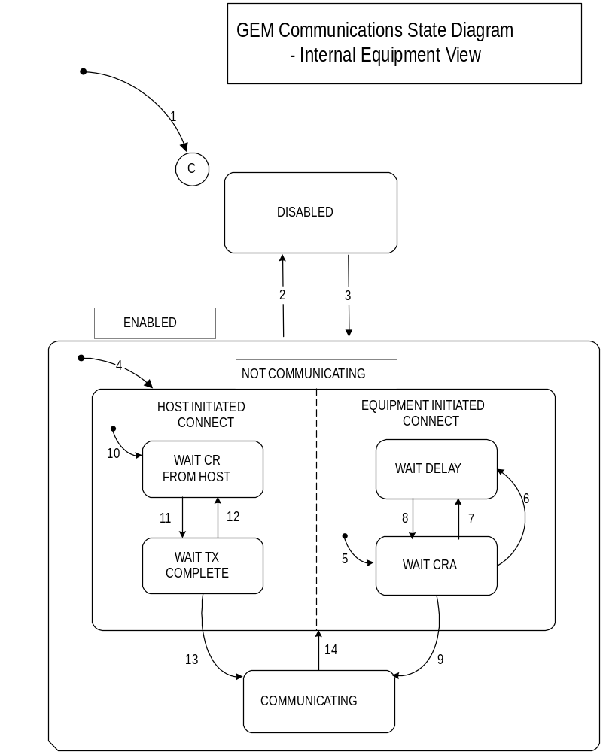
Figure 2 Communication State Model

# | Current State | Trigger | New State | Action | Comment
 | (Entry to Communication) | System Initialization. | System Default | None | The system default may be set to DISABLED or ENABLED.
 | DISABLED | Operator switches from DISABLED to ENABLED. | ENABLED | None | SECS-II communications are enabled.
 | ENABLED | Operator switched from ENABLED to DISABLED | DISABLED | Discard any messages queued to send. | SECS-II communications are prohibited.
 | (Entry to Enabled) | Any entry to ENABLED state. | NOT COMMUNICATING | None | May enter from system initialization to ENABLED or through operator touching switch in GEM configuration screen.
 | Entry to EQUIPMENT INITIATED CONNECT | Any entry to NOT COMMUNICATING | WAIT CRA | Initialize communication. Set CommDelay timer “expired”. Send S1,F13. | Begin the attempt to establish communication.
 | WAIT CRA | Connection transaction failure. | WAIT DELAY | Initialize CommDelay timer. | Wait for timer to expire.
 | WAIT DELAY | CommDelay timer expired | WAIT CRA | Send S1,F13 | Wait for S1,F14. May receive S1,F13 from Host
 | WAIT DELAY | Received a message other than S1,F13. | WAIT CRA | Discard message. No reply. Set CommDelay timer “expired” Send S1,F13. | Indicates opportunity to establish communications
 | WAIT CRA | Received expected S1,F14 with COMMACK = 0. | COMMUNICATING | None. | Communications established. Normal Path.
 | Entry to HOST INITIATED CONNECT | Any entry to NOT COMMUNICATING | WAIT CR FROM HOST | None | Wait for S1,F13 from Host.
 | WAIT CR FROM HOST | Received S1,F13 | WAIT TX COMPLETE | Send S1,F14 with COMMACK = 0 | Host seeks to establish communications.
 | WAIT TX COMPLETE | S1,F14 transmission failed. | WAIT CR from Host | None | Wait for S1,F13 from Host.
 | WAIT TX COMPLETE | S1,F14 transmission completed successfully. | COMMUNICATING | GEM Status is displays as COMMUNICATING. | Communications established. Normal path to completion.
 | COMMUNICATING | Communications failure. | NOT COMMUNICATING | De-queue all messages queued to send. | De-queued messages may be placed in spool buffer as appropriate.
Table 17 Communication State Transition Table

8.3 Control state
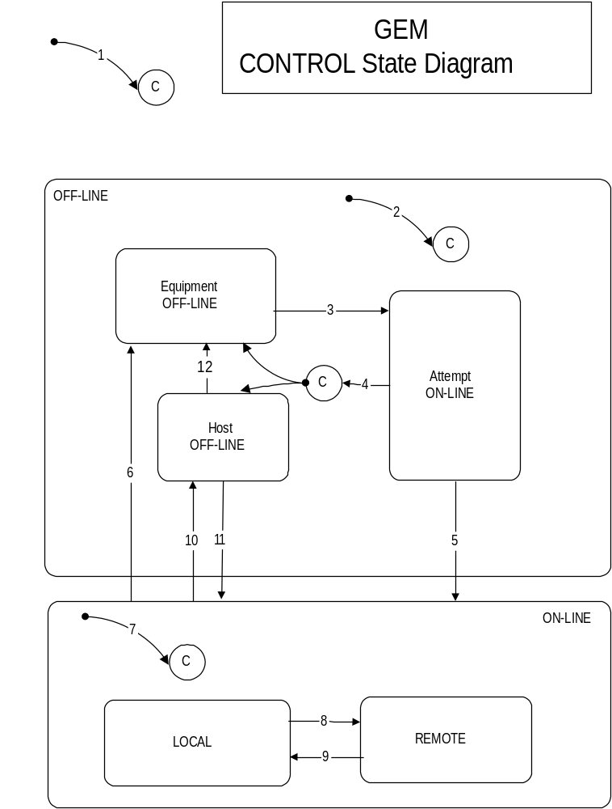
Figure 3 Control State Model

# | Current State | Trigger | New State | Action | Comment
 | Undefined - System Initialization | Entry into CONTROL state (System Initialization) | CONTROL (Substate conditional on configuration) | Display of GEM status screen Highlights default state. | An Equipment Constant will be used at initialization for the default state.
 | Undefined | Entry into OFF-LINE state | OFF-LINE (Substate conditional on configuration: OFF-LINE states = EQUIPMENT OFF-LINE, HOST OFF-LINE, ATTEMPT ON-LINE | Display of GEM status screen Highlights OFF-LINE | Equipment Constants used at initialization will be used for the default state.
 | EQUIPMENT OFF-LINE | Operator ENABLES communication and ON-LINE | ATTEMPT ON-LINE | GEM status screen highlights active states.. | S1,F1 is sent whenever ATTEMPT ON-LINE is activated
 | ATTEMPT ON-LINE | S1,F2 Not received or Receipt of S1,F0 | EQUIPMENT OFF-LINE or HOST OFF-LINE | GEM status screen highlights active states | This may be due to retry limit (RTY) is exceeded while sending the message, a reply time-out or receipt of S1,F0.
 | ATTEMPT ON-LINE | Equipment receives expected S1,F2 from the Host. | ON-LINE | GEM status screen highlights active states | Host is notified of transition to ON-LINE at transition 7.
 | ON-LINE | Operator touches OFF-LINE switch | EQUIPMENT OFF-LINE | Host interface screen highlights active states | Equipment OFF-LINE event occurs. Event reply will be discarded while OFF-LINE is active.
 | Undefined | Entry to ON-LINE state | ON-LINE (Substate conditional on REMOTE/LOCAL equipment constant | GEM status screen highlights active states | Control state LOCAL or Control state REMOTE event is sent to Host.
 | LOCAL | Operator touches REMOTE switch | REMOTE | GEM status screen highlights active states | Control state REMOTE event is sent to Host
 | REMOTE | Operator touches LOCAL switch | LOCAL | GEM status screen highlights active states | Control state LOCAL event is sent to Host
 | ON-LINE | Equipment accepts OFF-LINE message from Host (S1,F15) | HOST OFF-LINE | GEM status screen highlights active states | Equipment OFF-LINE event occurs
 | HOST OFF-LINE | Equipment accepts host request to go  ON-LINE | ON-LINE | None | Host is notified of transition to ON-LINE at transition 7.
 | HOST-OFFLINE | Operator touches OFF-LINE switch | EQUIPMENT  OFF-LINE | None | Equipment  OFF_LINE event occurs
Table 18 Control State Transition Table

Process state
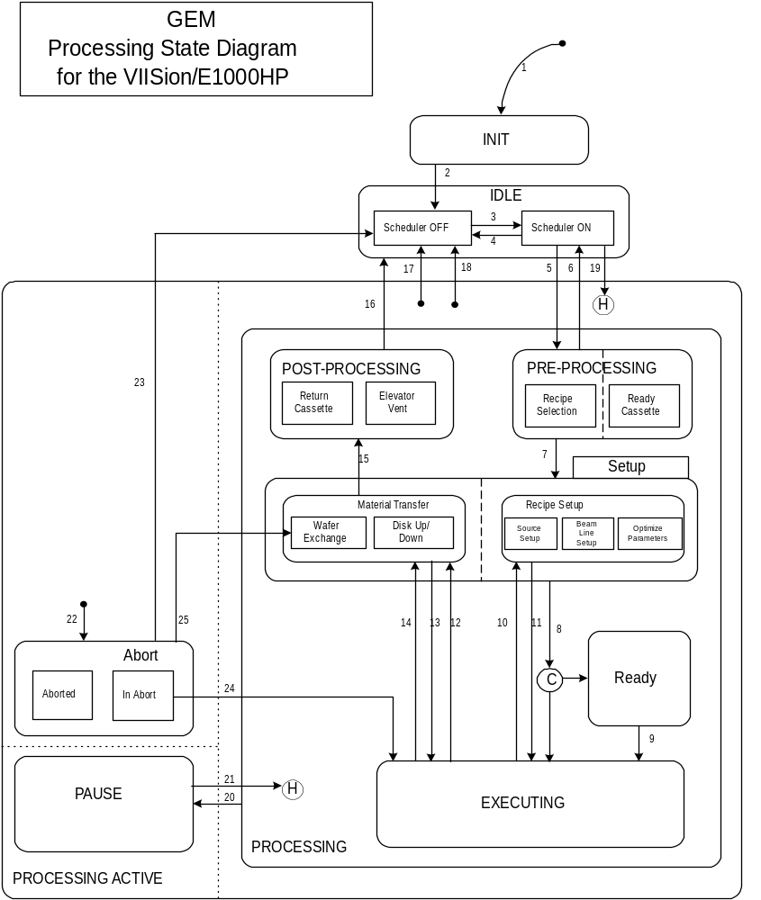
Figure 4 Processing State Model

# | Current State | Trigger | New State | Actions | Comments
 | Undefined | Machine Power Up | INIT | None. | None.
 | INIT | Equipment initialization complete | IDLE-Scheduler OFF | Set operator privilege level. | Operator Log in is required.
 | IDLE-Scheduler OFF | Scheduler start command form the operator or host | IDLE-Scheduler ON | Determine the next state to restart. | None.
 | IDLE-Scheduler ON | Scheduler stop command form the operator or host | IDLE-Scheduler OFF | Stop the current state actions. | Current processing will be stopped.
 | IDLE | One of the following conditions is met:  - A Cassette was Placed in the load lock(or on auto tilt) by the operator or AGV.  - The recipe has been selected from host or using the matrix schedule.  - When running in On-Line Remote, Initiate Process command should also be received . | PREPROCESSING | The scheduler will prompt for the identification of the cassette. | The scheduler has to be active. The required lot information and load lock to utilize can be sent from the host or entered by the operator.
 | PREPROCESSING | Ready cassette could not detect enough wafers (including dummies) to load the disk for processing. Also Abort command issued before the wafer exchange has started. | IDLE-Scheduler ON |  | The scheduler will stay active waiting for another cassette to be introduced
 | PREPROCESSING | A START command was received. | SETUP | Auto Recipe setup will start. | Cassette Ready has completed and enough wafers are available to load the disk.
 | SETUP | The following conditions are met.  - Recipe Setup has completed.  - Wafers were loaded to the disk. | READY or EXECUTING | Wait for start command from host or operator if ready state was enabled. | Equipment Constant ReadyEnable will determine which state to use for transition.
 | READY | Start Processing Command or Start has been pressed by the operator | EXECUTING | Equipment begins implanting | None.
 | EXECUTING | Recipe parameter goes out off window | SETUP Recipe setup | Action to be taken will depend on the recipe setting. | None
 | SETUP Recipe Setup | Recipe parameter was adjusted to window value | EXECUTING |  | None.
 | EXECUTING | Implant Complete and Wafers finished processing. | SETUP Material Transfer (Disk Down) | Stop Disk scan and flip down the disk. | None
 | SETUP Material Transfer (Disk Up) | Wafers repositioning for the next implant (QUAD or cascade implant) . | EXECUTING | None | None
 | EXECUTING | Scheduler start after an abort command was issued previously during implant | SETUP Disk Down | None | None
 | SETUP Material Transfer | Wafer Exchange from disk to cassette has completed | POSTPROCESSING | None | None
 | POST-PROCESSING | Load Vented and Door Opened and material removed. | IDLE Scheduler ON |  | Material is removed and new lot can be introduced.
 | Any Processing Active state | Scheduler off command issued by the operator or host | IDLE Scheduler OFF | Processing will stop | None
 | Any Processing Active state | An error was generated while performing a state | IDLE Scheduler OFF | Processing will stop | None
 | IDLE Scheduler ON | Scheduler start command | Active state before the scheduler was stopped. | Continue the stopped process. | This is a transitional state after the scheduler is activated.
 | PROCESSING | A STOP command was received from the host or STOP button is pressed or a recipe parameter deviated outside a window . | PAUSE | implant held event will be sent to the host | None
 | PAUSE | Equipment has received a restart command from Host or operator console | Running state before pause was issued. | The suspended state will be resumed. | None
 | Any Processing Active state. | Abort command received from the host or button pressed by the operator | Abort | Confirm abort command if it was issued by the operator. | None
 | Abort | Operator confirmed an abort. | IDLE Scheduler OFF | Stop Processing and stop Scheduler | None
 | Abort | Operator did not confirm the abort during implant | EXECUTING | Resume implant | None
 | Abort | Operator or Host aborted wafer exchanged | SETUP Material Transfer | Wafers will be removed from the disk back to the cassette and the cassette will be returned. | The scheduler will stay active.
Table 19 Processing State Transition Table

8.5 Limit state

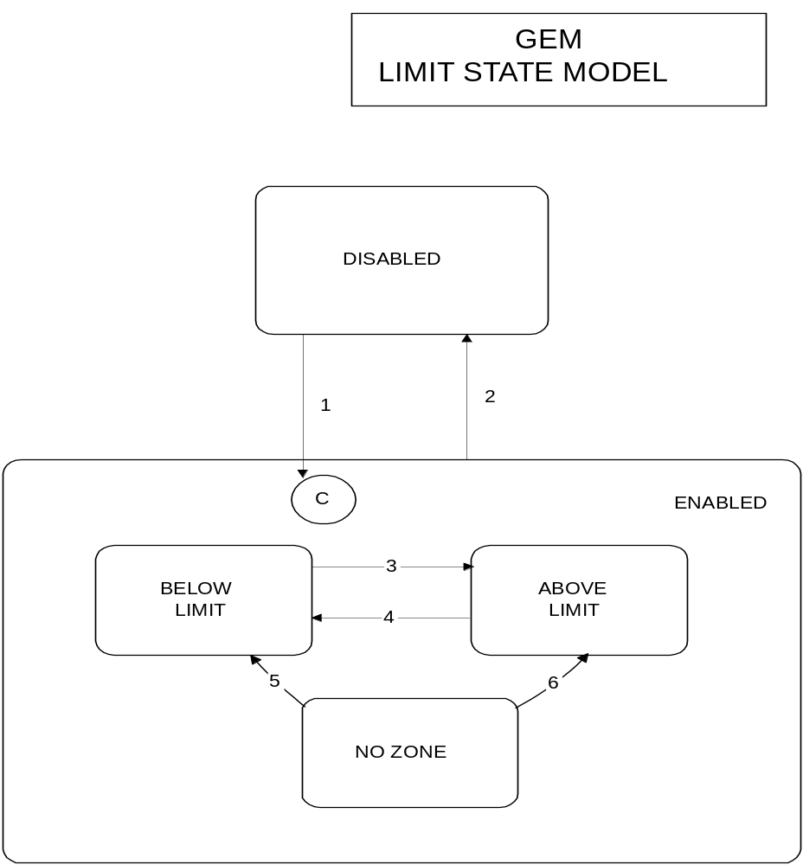
Figure 5 Limit State Model

# | Current State | Trigger | New State | Actions | Comments
 | DISABLED | Limit attributes defined w/S2,F45. | ENABLED | None | The Substate is determined by the current value of the monitored variable.
 | ENABLED | Limit attributes set undefined w/S2,F45. | DISABLED | None | None
 | BELOW LIMIT | Variable Increases to > UPPERDB. | ABOVE LIMIT | None | Zone Transition.
 | ABOVE LIMIT | Variable Decreases to < LOWERDB | BELOW LIMIT | None | Zone Transition
 | NO ZONE | Variable Decreases to < LOWERDB | BELOW LIMIT | None | Zone Transition
 | NO ZONE | Variable Increases to > UPPERDB. | ABOVE LIMIT | None | Zone Transition.
Table 20 Limit State Transition Table

8.6 Alarm state

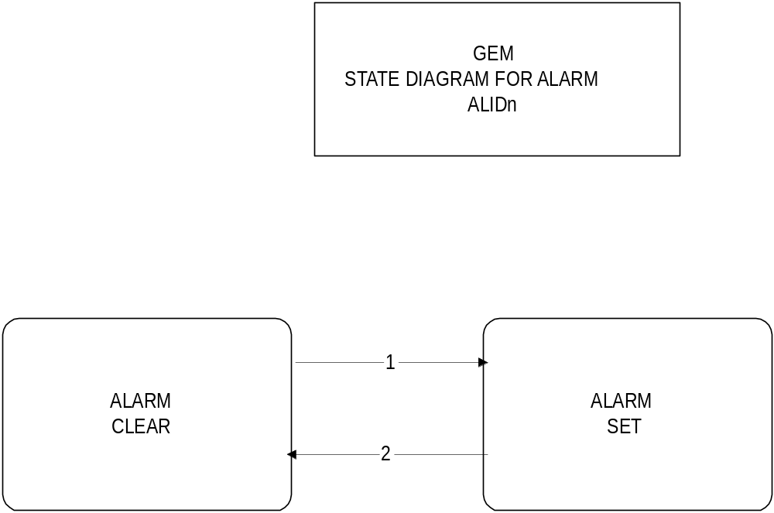
Figure 6 Alarm State Model

# | Current State | Trigger | New State | Actions | Comments
1 | ALARM_{n} CLEAR | Alarm_{n} is detected on the equipment. | ALARM_{n} SET | Initiate local actions (if any) to ensure safety. Update AlarmsSet and ALCD_{n} values. Generate and issue alarm message if enabled. | Inhibited activities require operator or Host intervention prior to resuming.
2 | ALARM_{n} SET | Alarm_{n} is no longer detected on the equipment | ALARM_{n} CLEAR | Update AlarmsSet and ALCD_{n} values. Generate and issue alarm message if enabled. | Inhibited activities require operator or Host intervention prior to resuming.
Table 21 Alarm State Transition Table

8.7 Spooling State
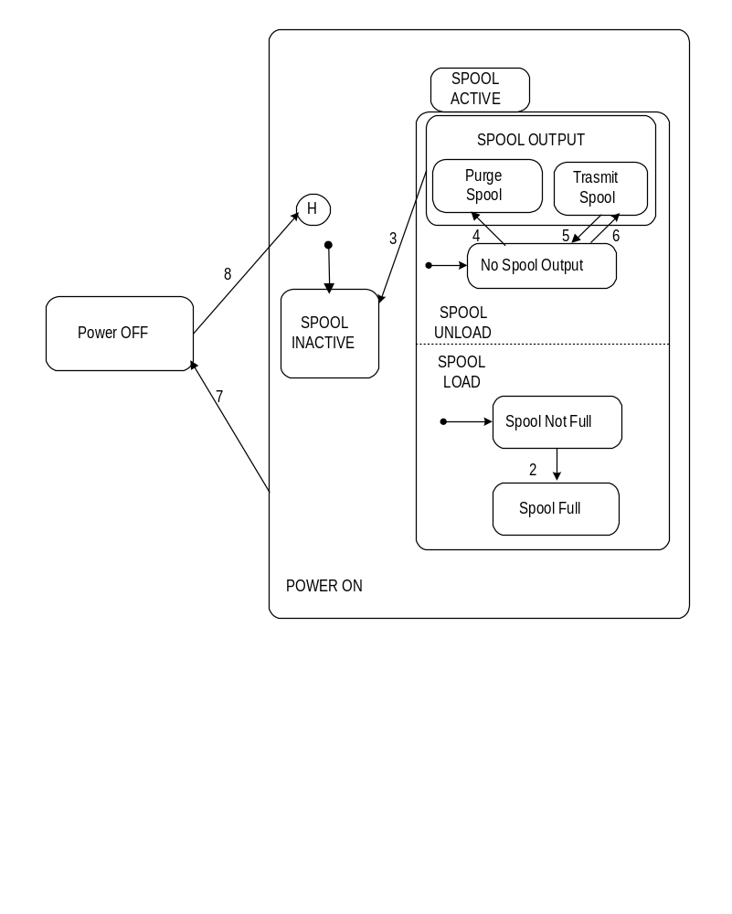
Figure 7 Spooling State Model

# | Current State | Trigger | New State | Action | Comment
 | SPOOL INACTIVE | Communication failure detected | SPOOL ACTIVE | SpoolCountActual and SpoolCountTotal are initialized to 0. Any open transactions with Host are aborted. SpoolStartTime is set to current time. Alert operator that spooling is active. | The default state in each OR Substate is entered. The message which could not be sent remains in the send queue and is dealt with in Spool Active State. The collection event Spooling Activated has occurred.
 | SPOOL NOT FULL | Message generated which will not fit into spool area | SPOOL FULL | SpoolFullTime is set to current time. Alert operator that spool is full. | The message which would not fit into the spooling area is dealt with after the transition. No collection event is generated.
 | SPOOL OUTPUT | Spool area emptied | SPOOL INACTIVE | Spooling process disabled. Alert operator that spooling has been terminated. | The collection event Spooling Deactivated has occurred. Transition from the OR Substate Spool Load component occurs.
 | NO SPOOL OUTPUT | S6,F23 received w/ RSDC = 1 | PURGE SPOOL | No action | Initiates purging process. No collection event is generated since this is based on host request..
 | NO SPOOL OUTPUT | S6,F23 received w/ RSDC = 0 | TRANSMIT SPOOL | No action | Initiates message transmission from spool. No collection event is generated since this is based on host request.
 | TRANSMIT SPOOL | Comm failure or MaxSpoolTransmit reached | NO SPOOL OUTPUT | Spool transmission process suspended. | If communications failure, the event Spool Transmission Failure has occurred. No collection event generated for MaxSpoolTransmit reached.
 | POWER ON | Equipment power discontinued | POWER OFF | No action | Spooling context has been maintained in non volatile storage before this transition.
 | POWER OFF | Equipment power source restored | POWER ON | Spooling context restored from non volatile memory. | If spooling was active prior to power down, it shall continue. If TRANSMIT SPOOL was active at power down, transition #6 is expected to follow since communication state is initially NOT COMMUNICATING.
Table 22 Spooling State Transition

Variable available on E1000 only.
Variable available on VIISion only.
Variable available on VIISion 80 only.
Variable available on E1000 and VIISion 200Kv only.
When header parameter count =13
Variable available on E1000 only.
Variable available on VIISion only.
Variable available on E1000 and VIISion 200Kv only.
Variable Available on HP end station only.

